**MINISTRY OF EDUCATION AND TRAINING**

**FPT UNIVERSITY**

Capstone Project Document

**Management program for martial arts tournament countervailing.**

|  |  |
| --- | --- |
| **Nhóm 1** | |
| **Group members** | Nguyễn Duy Nhất – SE60927  Dương Trung Kiên – SE60978  Phạm Hoàng Trúc Vy - SE60945  Vũ Nguyên Việt Tiến - SE61121 (Dropped out) |
| **Supervisor** | Ngô Đăng Hà An |
| **Ext. Supervisor** | N/A |
| **Capstone Project code** | MATC |

-Ho Chi Minh City, May 11th, 2015

*This page is intentionally left blank*

# Table of Contents

Table of Contents 3

List of Tables 6

List of Figures 6

Definitions, Acronyms, and Abbreviations 8

A. Report No. 1 Introduction 10

1. Project Information 10

2. Introduction 10

3. Current Situation 10

4. Problem Definition 10

5. Proposed Solution 10

5.1 Feature functions 11

5.2 Advantages and disadvantages 11

6. Functional Requirements 11

6.1 . Searching 11

6.2 . User management 11

6.3 . Athlete management 11

6.4 . League management 11

6.5 . Scheduling and Planning 11

6.6 . Contact 11

7. Role and Responsibility 12

B. Report No.2 Software Project Management Plan 13

1. Problem Definition 13

1.1 Name of this Capstone Project 13

1.2 Problem Abstract 13

1.3 Project Overview 13

2. Project organization 14

2.1 Software Process Model 14

2.2 Roles and responsibilities 15

2.3 Tools and Techniques 16

3. Project Management Plan 16

3.1 Software development life cycle 16

3.2 Phase Detail 17

3.3 All Meeting Minutes 18

4. Coding Convention 18

C. Report No. 3 Software Requirement Specification 19

1. User Requirement Specification 19

1.1 Guest Requirement 19

1.2 Employee Requirement 19

1.3 Admin Requirement 20

2. System Requirement Specification 20

2.1 External Interface Requirement 20

2.2 System Overview Use Case 20

2.3 List of Use Case 22

a. Table includes: 32

b. “Chi tiết” table includes: 33

3. Software System Attribute 94

3.1 Usability 94

3.2 Reliability 95

3.3 Availability 95

3.4 Security 95

3.5 Maintainability 95

3.6 Portability 95

3.7 Performance 95

4. Conceptual Diagram 95

D. Report No. 4 Software Design Description 98

1. Design Overview 98

2. System Architectural Design 99

2.1 Web application architecture description 99

3. Component Diagram 100

4. Detailed Description 100

4.1 Class Diagram 100

4.2 Class Diagram Explanation 102

4.3 Interaction Diagram 107

5. User Interface Design 124

5.1 Guest Interface Design 125

5.2 Employee Interface Design 129

5.3 Admin Interface Design 146

6. Database Design 149

6.1 Logical Diagram 149

6.2 Data Dictionary 151

7. Algorithms 156

7.1 Random swap 156

7.2 Draw number 157

7.3 Round number calculation 158

7.4 Maximum exempt calculation 158

7.5 League Schedule 161

7.6 Plan time 164

7.7 Draw diagram 166

7.8 Arrange possion match in highest round 167

E. System Implementation & Test 169

1. Introduction 169

1.1 Overview 169

1.2 Test Approach 169

2. Database Relationship Diagram 169

2.1 Physical Diagram 169

2.2 Data Dictionary 171

3. Performance Measures 176

3.1 Schedule League 176

4. Test Plan 176

4.1 Features to be tested 176

4.2 Features not to be tested 176

5. System Testing Test Case 176

5.1 Guest Test Case 178

5.2 Employee Test Case 180

F. Software User’s Manual 186

1. Installation Guide 186

1.1 Setting up environment at server side 186

1.2 Deployment at server side 186

1.3 Setting up the environment at client side 187

2. User Guide 187

2.1 Guest 187

2.2 Employee 188

G. ソフトウェアユーザーズマニュアル 195

1. インストレーションガイド 195

1.1 サーバ側の環境を設定 195

1.2 サーバ側で展開 195

1.3 クライアント側の環境の設定 196

2. ユーザーガイド 197

2.1 ゲスト 197

2.2 従業員 197

H. Appendix 199

# List of Tables

Table 1: Roles and Responsibilities 12

Table 2: Hardware Requirement for Server 14

Table 3: Roles and Responsibilities Details 16

Table 4: Software Development Life Cycle Detail 17

Table 5: Phase 1: Requirement Analysis 17

Table 6: Phase 2: Design 17

Table 7: Phase 3: Implementation 18

Table 8: Phase 4: Testing 18

Table 9: Entity Data Dictionary 151

Table 10: Detail Data Dictionary 155

Table 11: Data Dictionary 171

Table 12: Attribute Data Dictionary 175

# List of Figures

Figure 1: Waterfall Development Model 15

Figure 2: System Overview Use Case 21

Figure 3: <Guest> Overview Use Case 22

**Figure 4: <Employee, Guest> Search League use case diagram.** 23

**Figure 5: <Employee, Guest> Search Athlete use case diagram.** 25

**Figure 6: <Guest, Employee> View Athlete Profile use case diagram.** 27

Figure 7: <Guest, Employee>View League Information use case diagram 28

Figure 8: <Guest, Employee>View Organizers Contact use case diagram 30

Figure 9: <Guest, Employee>View Result use case diagram 32

Figure 10: <Guest, Employee>View Image use case diagram 33

Figure 11: <Guest, Employee>View Video use case diagram 35

**Figure 12: <Guest, Employee> View Play Schedule** 36

**Figure 13: <Guest, Employee> View Play Diagram** 38

**Figure 14: <Guest, Employee> View Match Information** 39

**Figure 15: <Guest, Employee> View Athletes in League** 42

Figure 16: <Employee> Overview Use Case 44

**Figure 17: <Employee> Create Athlete use case diagram** 45

**Figure 18: <Employee> Update Athlete** 46

**Figure 19: <Employee> Delete Athlete** 48

Figure 20: <Employee>Create League use case diagram 50

Figure 21: <Employee>Update League use case diagram 54

Figure 22: <Employee>Delete League use case diagram 58

**Figure 23: <Employee> Draw number and Schedule League** 59

**Figure 24: <Employee> Check Valid Subleague** 61

**Figure 25: <Employee> Set Priority for Athlete** 63

**Figure 26: <Employee> Update Match Information** 65

**Figure 27: <Employee> Add Athlete into League use case diagram** 68

**Figure 28: <Employee> Update Athlete in League** 71

**Figure 29: <Employee> Delete Athlete from League** 73

**Figure 30: <Employee> Export Excel File** 74

**Figure 31: <Employee> Import Excel File use case diagram** 76

**Figure 32: <Employee> Choose unit use case diagram** 79

**Figure 33: <Employee> Create Unit use case diagram** 81

**Figure 34: <Employee> Download Template File use case diagram** 82

Figure 35: <Employee> Add Image use case diagram 84

Figure 36: <Employee> Update Image use case diagram 85

Figure 37: <Employee> Add Video use case diagram 87

Figure 38: <Employee> Update Video use case diagram 88

Figure 39: <Guest> Overview Use Case 89

**Figure 40: <Admin> Change Account Status** 90

Figure 41: <Admin> Create Employee Account use case diagram 91

Figure 42: <Admin> Config System 93

Figure 43: Conceptual Diagram 96

Figure 44: System Architectural Design 99

Figure 45: Component Diagram 100

Figure 46: Class Diagram 101

Figure 47: < Guest, Employee > View Play Schedule sequence diagram 108

Figure 48: < Guest, Employee > View Athletes in League sequence diagram 108

Figure 49: < Guest > View League Information sequence diagram 109

Figure 50: < Guest > Search Athlete sequence diagram 109

Figure 51: < Guest > Search League sequence diagram 110

Figure 52: < Guest > View Athlete Profile sequence diagram 110

Figure 53: < Guest > View Match sequence diagram 111

Figure 54: < Guest > View Play Diagram sequence diagram 111

Figure 55: < Employee > Create Athlete sequence diagram 112

Figure 56: < Employee > Create League sequence diagram 113

Figure 57: < Employee > Update League Information sequence diagram 114

Figure 58: < Employee > Delete League sequence diagram 115

Figure 59: < Employee > Check Valid Subleague sequence diagram 116

Figure 60: < Employee > Draw number and Schedule league sequence diagram 117

Figure 61: < Employee > Set Priority sequence diagram 117

Figure 62: < Employee > Update Match sequence diagram 118

Figure 63: < Employee > Add Athlete into League sequence diagram 119

Figure 64: < Employee > Update Athlete in League sequence diagram 120

Figure 65: < Employee > Delete Athlete from League sequence diagram 120

Figure 66: < Employee > Import Excel File sequence diagram 121

Figure 67: < Employee > Choose unit sequence diagram 122

Figure 68: < Employee > Create Unit sequence diagram 123

Figure 69: < Employee > Delete Athlete sequence diagram 124

Figure 70: < Employee > Update Athlete sequence diagram 124

Figure 71: Search League page 125

Figure 72: Search Athlete page 126

Figure 73: View Athlete Profile popup 126

Figure 74: View league information page 127

Figure 75: View organizer contact popup 128

Figure 76: View Play Diagram page 128

Figure 77: View result page 129

Figure 78: Create athlete page 129

Figure 79: Manage Athlete page 130

Figure 80: Update Athlete Profile popup 131

Figure 81: View Play Schedule page 132

Figure 82: Update match information popup 133

Figure 83: Create league_tab 1 134

Figure 84: Create league_tab 2 135

Figure 85: Create league_tab 3 136

Figure 86: Create league_tab 4 137

Figure 87: Manage league page 138

Figure 88: Manage Athlete in League page 139

Figure 89: Add athlete to league page 140

Figure 90: Update athlete in league page 141

Figure 91: Import Excel tab 142

Figure 92: Choose unit pop up 143

Figure 93: Create unit popup 144

Figure 94: Draw number and Schedule League page 145

Figure 95: Check Valid Subleague popup 145

Figure 96: Set priority for Athlete page 146

Figure 97: Create employee account page 147

Figure 98: Change account status page 148

Figure 99: Change config system page 149

Figure 100: Logical Diagram 150

Figure 101: Physical Database Diagram 170

Figure 102: Core flow 177

# Definitions, Acronyms, and Abbreviations

|  |  |
| --- | --- |
| **Name** | **Definition** |
| MATC | Martial arts tournament countervailing |
| OS | Operating System |
| Admin | Administrator |
| HTTP | Hyper Text Transfer Protocol |
| Subleague | The tournament for each weight division in a league |

# Report No. 1 Introduction

## Project Information

* Project name: **Management program for martial arts tournament countervailing.**
* Project Code: **MATC**
* Product Type: **Website**
* Start Date: **May 11th, 2015**
* End Date: **August 16th, 2015**

## Introduction

Nowadays, the management of martial arts tournament countervailing is still manual. It is time-consuming and difficult for employee to input data and manage them. Moreover, it is easy to cause mistakes if there are amount of the information about the tournament.

In this project, we will provide one website that allows users to create and manage the countervailing martial arts tournament. It provides features for employee to schedule league, plan time and manage information of each match. It also allows viewers to track the match and have a visual look of the league.

## Current Situation

At present, there are some websites also support to manage league. Such as <http://www.konkuri.com/> which can be applied on a variety of sports competitions of all different genres.

This system implementation:

* User creates tournaments with information such as the subject, the number of participants and form of league.
* User or system will automatically arrange couples for each match and showing off the diagram.
* Users can arrange the corresponding playing time and update result for each match.

## Problem Definition

Disadvantages of this website:

* Not specifical for martial arts countervailing
* Cannot search information of athletes.
* Not have specific information of each match.
* Not arrange time for each match automatically.
* Anyone can register and create leagues so cannot warrant the accuracy of tournament information.
* Not set priority for athlete.
* Not allow user to add list of athlete by import excel.
* Not divide weight division.

## Proposed Solution

We propose new system to solve those disadvantages.

In more details, our system has the following functions.

### **Feature functions**

* Employee can create by import excel and manage information of athletes.
* Employee can create leagues with specific weight division and manage information.
* Employee can manage information of each match.
* User can view the play schedule and the play diagram.
* User can search to find information about athlete or league.
* System can schedule leagues include time of each match after employee add the list of athlete, draw number and set priority of athletes.
* Admin will create account and send account’s information to employee’s mail.

### Advantages and disadvantages

* Advantages:
* Specifical for martial arts countervailing.
* User can search information of athletes.
* Has specific information of each match.
* Can arrange time for each match automatically.
* Only employees can create leagues so we can warrant the accuracy of tournament information
* Can set priority for athlete.
* Allow user to add list of athlete by import excel.
* Has specific weight division.
* Disadvantages:
* Not manage martial arts and correlative weight dision.
* Match’s start time is fixed after league has scheduled and employee cannot change it.

## Functional Requirements

Function requirements of the system are listed as below:

### . Searching

* User can search athletes or leagues by filter content

### . User management

* Admin can manage account: create an account, active, de-active.

### . Athlete management

* Employee can manage athlete: create, update, delete.

### . League management

* Employee can manage league: create, update, delete.

### . Scheduling and Planning

* System can schedule and plan leagues include time of each match after employee adds the list of athlete, draw number and set priority of athletes.

### . Contact

* Guest can contact organizers via email, telephone, fax, address.

## Role and Responsibility

|  |  |  |  |  |
| --- | --- | --- | --- | --- |
| No | Full Name | Role | Position | Contact |
| 1 | Ngô Đăng Hà An | Project Manager | Instructor | [anndh@fpt.edu.vn](mailto:anndh@fpt.edu.vn) |
| 2 | Nguyễn Duy Nhất | Developer | Leader | [nhatndse60927@fpt.edu.vn](mailto:nhatndse60927@fpt.edu.vn) |
| 3 | Dương Trung Kiên | Developer | Member | [kiendt60978@fpt.edu.vn](mailto:kiendt60978@fpt.edu.vn) |
| 4 | Phạm Hoàng Trúc Vy | Developer | Member | [vyphtse60945@fpt.edu.vn](mailto:vyphtse60945@fpt.edu.vn) |

Table 1: Roles and Responsibilities

# Report No.2 Software Project Management Plan

## Problem Definition

### Name of this Capstone Project

* Management program for martial arts tournament countervailing (MATC)

### Problem Abstract

On this day, management system for countervailing martial arts league are not detail or clearly and not enough of information. Some websites do not support obvious view for people, who care about the league. Besides that, some of those do not support people for automatically input data, the employee may cost a lots of time to input huge data and make some mistakes.

To solve these problems, we want to create a new system which combines pros of others and develop more features to user can easily use by some of simple manipulation.

### Project Overview

#### Current Situation

At present, employee wants to reduce amount of manipulation and automatically process to not only manage information about league and athletes but also schedule and planning league and matches. However, current systems don’t have enough of features to meet the above need. So it causes some of difficulty for users. Such as:

* Waste time for inputting data and may make mistake.
* Take a lots of time to arrange time for matches in a properly way.
* Limited in searching information about leagues and athletes.
* Do not support setting priority for athletes.

After research we have had orientation for our product, such as what function system will perform with the interface, we are considering about:

* How to schedule rounds and matches logically with number of athletes.
* Necessary criterions for planning time for each match exactly and logically.
* Technology to import and export excel file and send mail automatically.
* Rule of some martial art such as boxing, vovinam, taekwondo, karatedo...

#### The Proposed System

We propose a system to solve above problem. This system includes a web application to help employee manage countervailing martial arts tournament.

##### Web Site

* Admin can manage account
* User can search information about league and athletes.
* User can view play schedule, play diagram and track match happening
* User can get organizer’s contact: address, telephone, fax, email.
* Employee can manage information of athlete, league.
* Employee can update matches result.
* System can schedule leagues include time of each match after employee add the list of athlete, draw number and set priority of athletes.

#### Boundaries of the System

* The system can be used by everyone has laptop/ computer with Internet connection.
* Language of system is Vietnamese.
* The completed product includes:
  + Website for admin, employees and guests.
  + All the project document involved.

#### Development Environment

##### Hardware requirements

**For server**

|  |  |  |
| --- | --- | --- |
| Windows | Minimum Requirements | Recommended |
| Internet Connection | Cable, Wi-Fi (4 Mbps) | Cable, Wi-Fi (8 Mbps) |
| Operating System | Window Server 2008 | Window Server 2008 |
| Computer Processor | Intel® Xeon ® 1.4GHz | Intel® Xeon ® Quad Core (12M Cache, 2.50 GHz) |
| Computer Memory | 1GB RAM | 2GB or more |

Table 2: Hardware Requirement for Server

##### Software requirements

* Window Server 2008: operating system and platform for development.
* SQL Server 2008 Enterprise R2: used to create and manage the database for system.
* Visual Studio 2013: used to implement website and web service.
* Git & TortoiseGit: used for source control.
* StarUML: used to create models and diagrams.
* [www.gliffy.com](http://www.gliffy.com): used to create models and diagram.

## Project organization

### Software Process Model

Project is developed under waterfall model. While the requirements of this system are well understood with specific law and unlikely to change radically during system development, this model is suitable. Moreover, it clearly defines stages so easy to arrange and manage tasks.

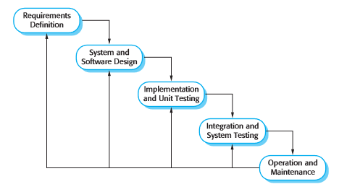

Figure 1: Waterfall Development Model

For more information: Chapter 2 – Software processes in Software Engineering 9th Book – Ian Sommerville.

### Roles and responsibilities

|  |  |  |  |
| --- | --- | --- | --- |
| **No** | **Full name** | **Role in Group** | **Responsibilities** |
| **1** | Ngô Đăng Hà An | Project manager | * Specify user requirement * Control the development process * Give out technique and business analysis support |
| **2** | Nguyễn Duy Nhất | Team Leader, BA, DEV, Tester | * Managing process * Designing database * Clarifying requirements * Prepare documents * GUI Design * Create test plan * Coding * Testing |
| **3** | Dương Trung Kiên | BA,DEV, Tester | * Designing database * Clarifying requirements * Prepare documents * GUI Design * Create test plan * Coding * Testing |
| **4** | Phạm Hoàng Trúc Vy | BA, DEV, Tester | * Designing database * Clarifying requirements * Prepare documents * GUI Design * Create test plan * Coding * Testing |

Table 3: Roles and Responsibilities Details

### Tools and Techniques

* Front-end technologies: HTML5, CSS3, JavaScript, jQuery, AJAX.
* Back-end technologies: Website: ASP.NET MVC5 + Entity Framework 6.
* Web Server: Microsoft IIS 7.5 with .Net Framework 4.5.1 enable.
* Database Management System: MSSQL Server 2008 R2 Enterprise

## Project Management Plan

### Software development life cycle

|  |  |  |  |  |  |
| --- | --- | --- | --- | --- | --- |
| **Phase** | **Description** | **Deliverables** | **Resource needed** | **Dependencies and Constrains** | **Risks** |
| **Requirement Analysis** | - Study similar existing systems.  - Collect requirements from customer.  -Identify and clarify requirements for the system in general. | -Introduction of proposed system.  -Software requirement specification.  -Project Task Plan.  - Prototypes | 20 man-days | N/A | - Missing requirement  - Unclear scope of project  - Lack of member share of understand |
| **Design** | - Architecture design for the system  - Detail design using top-down break down  - Choose Architecture style | - Software Design Document  - Base code structure  - Technology notes | 20 man-days | Depend on “Requirement Analysis” | - Lack of experience.  - Technology is difficult to use  - Not fulfill requirement. |
| **Implementation** | - Coding system core functions and other feature with GUI  - Unit test | - Main user’s functions on web.  - Unit test document | 50 man-days | Depend on “Design”. | - Lack of experience and knowledge.  - Human mistake. |
| **Testing** | - Integration test the system  - Alpha test  - Correct bug  - Beta test  - Acceptance test | - Test document  - Defect log | 20 man-days | Depend on “Implementation” | - Lack of experience  - Missing test case, test case not cover all situation. |
| **Maintenance** | - Deploy on sever | - Installation guide  - User Manual | 10 man-days | Depend on “Testing” | - Lack of experience. |

Table 4: Software Development Life Cycle Detail

### Phase Detail

#### Phase 1: Requirement Analysis

|  |  |  |
| --- | --- | --- |
| **Task** | **Description** | **Author** |
| **1. Collect requirements** | Find which systems currently provide similar service, their strengths and weakness.  Collect requirements from user. | NhatND, KienDT, VyPHT |
| **2. Identify and clarify main functions.** | Define which main functions system will provide. | NhatND, KienDT, VyPHT |
| **3. Create System Introduction.** | Complete Introduction Report. | NhatND |
| **4. Software Project Management Plan.** | Prepare Project Management Plan. | NhatND |
| **5. Website Prototype.** | Build a prototype of proposed system. | NhatND, KienDT, VyPHT |
| **6. SRS** | Create SRS document. | NhatND, KienDT, VyPHT |

Table 5: Phase 1: Requirement Analysis

#### Phase 2: Design

|  |  |  |
| --- | --- | --- |
| **Task** | **Description** | **Author** |
| **1. Architecture Design** | Implement function import and breakdown data from docx files. | NhatND, KienDT, VyPHT |
| **2. Detailed Design** | Compare new document with existed documents of system. | NhatND, KienDT, VyPHT |
| **3. Database Design** | Get jobs from other server to recommendation. | NhatND, KienDT, VyPHT |
| **4. Technology research** | Create search engine for basic search and advance search. | NhatND, KienDT, VyPHT |
| **5. Design Document** | Create software design document | NhatND, KienDT, VyPHT |

Table 6: Phase 2: Design

#### Phase 3: Implementation

|  |  |  |
| --- | --- | --- |
| **Task** | **Description** | **Author** |
| **1. Front-end web functions** | Implement front-end functions on web | NhatND, KienDT, VyPHT |
| **2. Back-end web functions** | Implement back-end functions on web | NhatND, KienDT, VyPHT |
| **3. Suggestion algorithms** | Research and implement suggestion algorithms | NhatND |
| **4. Unit testing** | Write test case and testing for web functions | NhatND, KienDT, VyPHT |

Table 7: Phase 3: Implementation

#### Phase 4: Testing

|  |  |  |
| --- | --- | --- |
| **Task** | **Description** | **Author** |
| **1. Integration testing** | Write test case and testing system | NhatND, KienDT, VyPHT |
| **2. Alpha testing** | Do alpha test with customer | NhatND, KienDT, VyPHT |

Table 8: Phase 4: Testing

#### Phase 5: Maintenance

|  |  |  |
| --- | --- | --- |
| **Task** | **Description** | **Author** |
| **1. Installation guide** | Complete installation guide | NhatND |
| **2. User Manual** | Complete user manual | NhatND, KienDT, VyPHT |

Table 9: Phase 5: Maintenance

### All Meeting Minutes

Refer to Meeting Minutes folder.

## Coding Convention

C#: Using to develop website.

Summary:

* Naming Convention:
  + For variable’s name, use camel case. Ex: weightDevision, startDate…
  + For function name, class name, use Pascal case. Ex: AddAthlete, SearchLeague…
* Layout Convention:
  + Write only one statement/declaration per line.
  + Indent continuation one tab stop (four spaces).
  + Use parentheses to make clauses in an expression apparent.
* Commenting Convention:
  + Insert one space between the comment delimiter (//) and the comment text.
  + Begin comment text with an uppercase letter.
  + Place the comment on a separate line, not at the end of a line of code.
  + End comment text with a period.
* Language Guidelines:

Using C# Code Convention From:

<http://msdn.microsoft.com/en-us/library/vstudio/ff926074.aspx>

# Report No. 3 Software Requirement Specification

## User Requirement Specification

### Guest Requirement

Guest is the person who does not have access to the system. Guest can use some functions in the system. To use all functions, guest must login. These are some functions guest can use:

* Login
* Search League or Athlete
* View Athlete Profile
* View League Information
* View Organizers Contact
* View Result
* View Image
* View Video
* View Play Schedule
* View Play Diagram
* View Match Information
* View Athletes in League

### Employee Requirement

Employee is the person who uses our service to create leagues and manage them. Employee can use these functions:

* Search League or Athlete
* Manage Athlete
* Manage Athlete into League
* Manage League Image
* Manage League Video
* Manage League
* Check Valid Subleague
* Set Priority for Athlete
* View League Information
* View Organizers Contact
* View Result
* View Athletes in League
* View Play Schedule
* View Play Diagram
* Update Match Information
* Import Excel File
* Download Template File
* Choose Unit
* Create Unit
* Change First Time Password
* Change Password

### Admin Requirement

Admin is the person who manages the system. Admin is super user who can use following function:

* Change Account Status
* Create Employee Account
* Configure System
* Change password

## System Requirement Specification

### External Interface Requirement

#### User Interface

* General requirement for graphics user interface is the GUI should be simple, clear, intuitive, and reminiscent.
* Some design principles will be taken into consideration:
  + UI for businesss web applications - Janko Jovanovic [Ref: <http://www.smashingmagazine.com/2010/02/25/designing-user-interfaces-for-business-web-applications/>]
  + Ten principles of effective web design – Vitaly Friedman [Ref: <http://www.smashingmagazine.com/2008/01/31/10-principles-of-effective-web-design/>]

#### Hardware Interface

* N/A.

#### Software Interface

* Firefox Browser (version 4 onward), Google Chrome Browser (version 11 onward) with Resolution (1024 x 768) or bigger and must support JavaScript and HTML5.

#### Communication Protocol

* Using HTTP/HTTPS protocol

### System Overview Use Case

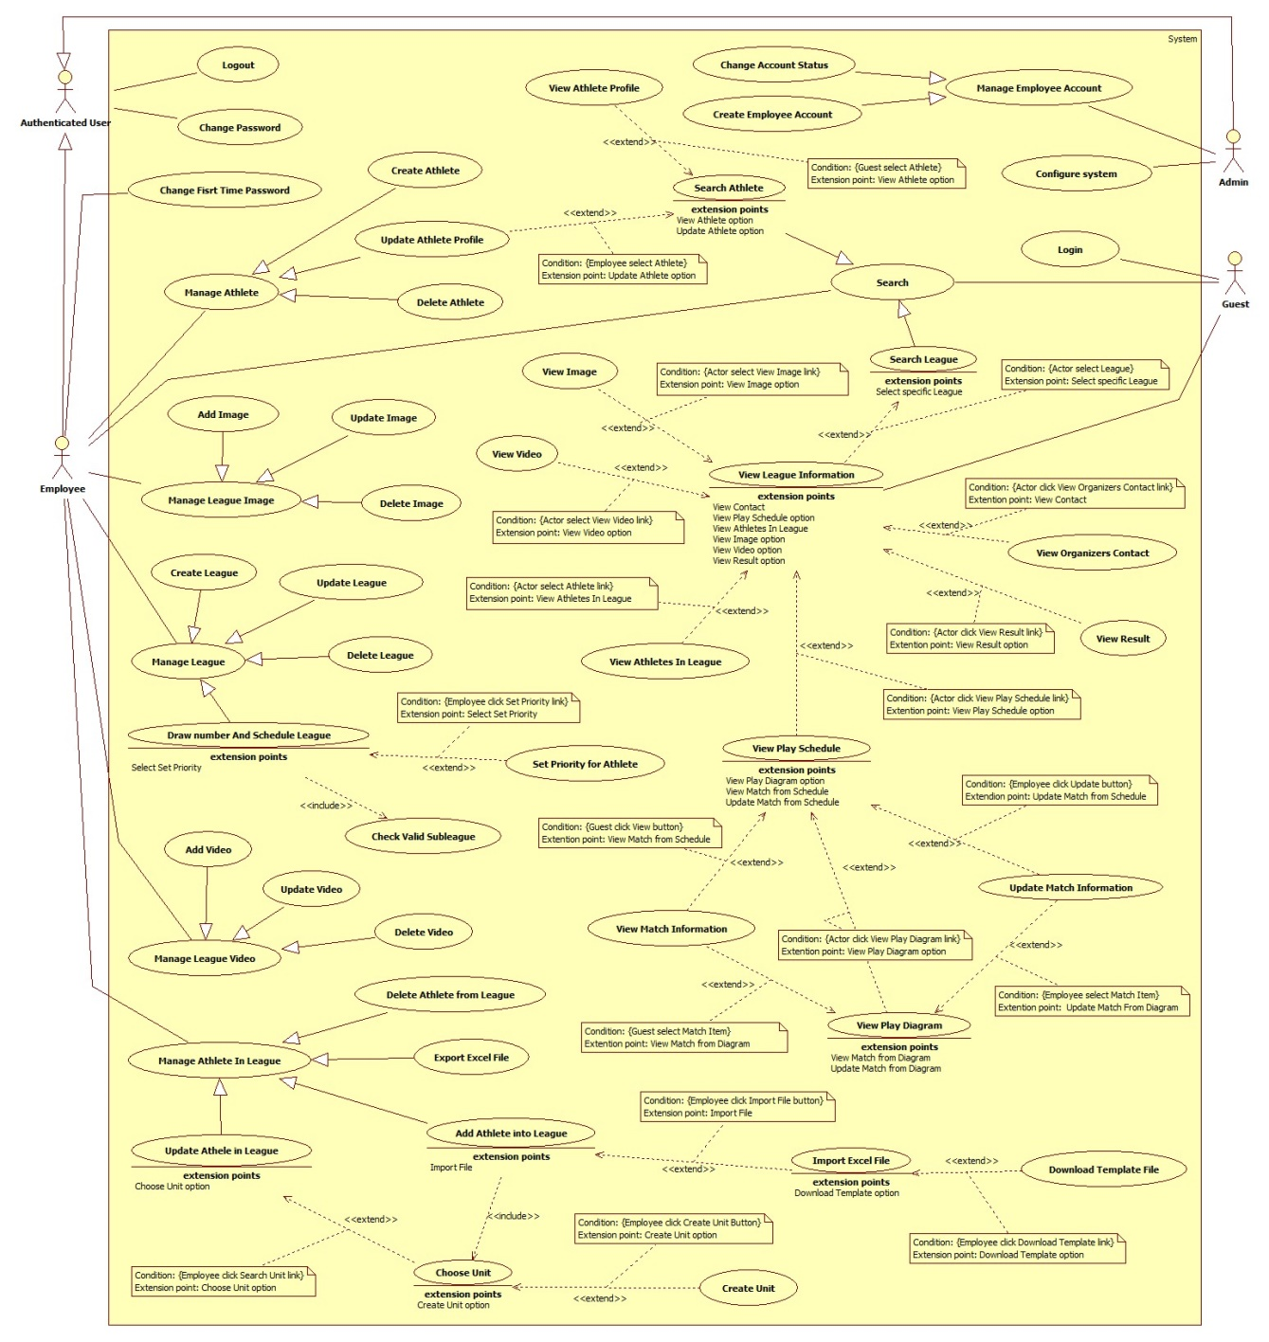

Figure 2: System Overview Use Case

### List of Use Case

#### <Guest> Overview Use Case

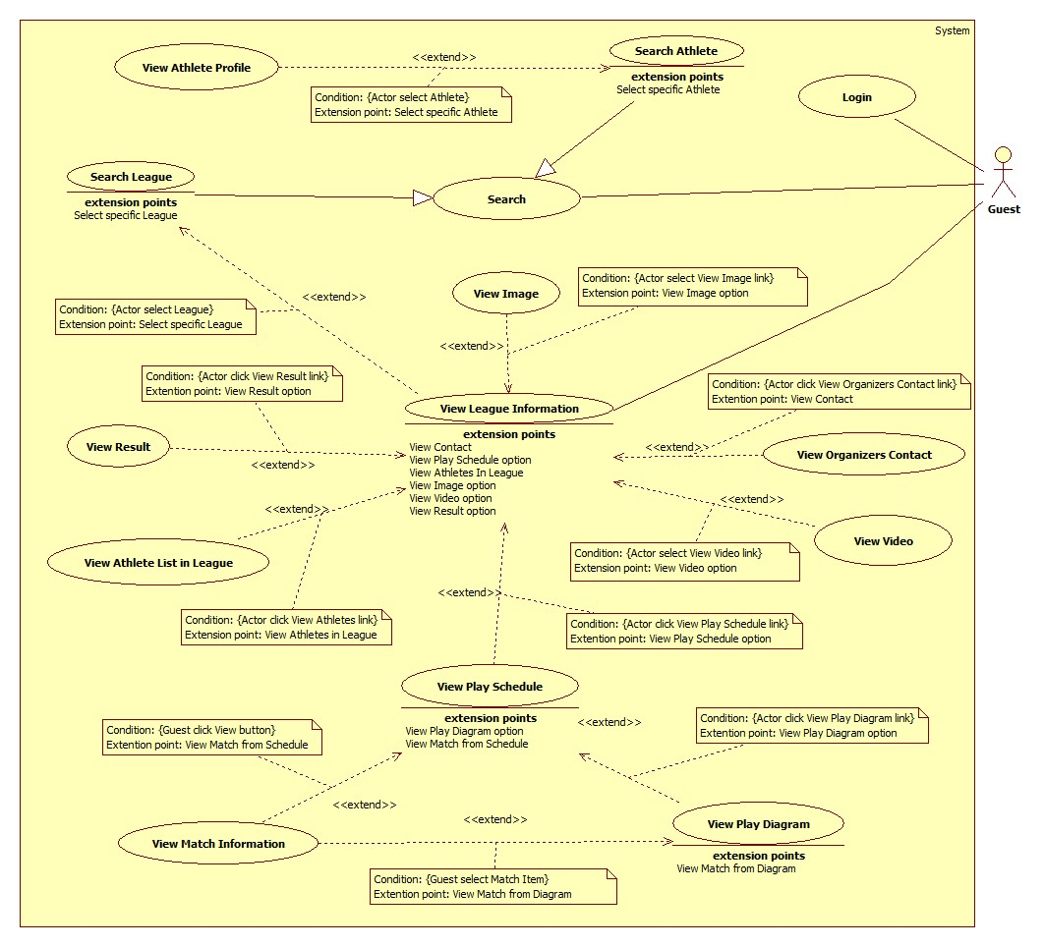

Figure 3: <Guest> Overview Use Case

##### <Guest> Search League

**Figure 4: <Employee, Guest> Search League use case diagram.**

**Use Case Specification**

|  |  |  |  |
| --- | --- | --- | --- |
| **USE CASE – MATC002** | | | |
| **Use Case No.** | MATC002 | **Use Case Version** | 2.0 |
| **Use Case Name** | Search League | | |
| **Author** | Dương Trung Kiên | | |
| **Date** | 25/05/2015 | **Priority** | high |
| **Actor:**   * Employee, Guest   **Summary:**   * This use case helps user find information of League.   **Goal:**   * Show result information of League   **Triggers:**   * Actor choose “Giải đấu” select box and clicks “Tìm kiếm” button on Layout page. * Actor choose “Giải đấu” select box and clicks “Tìm kiếm” link on layout menu.   **Preconditions:**N/A  **Post Conditions:**   * **Success:** Show table result. * **Fail:** Nothing will be shown. Show message error with specified content.   **Main Success Scenario:**   |  |  |  | | --- | --- | --- | | Step | Actor Action | System Response | | 1 | Actor chooses “Giải đấu” in selectbox on Layout page, input keyword and click “Tìm kiếm” button.  [Alternative 1] | Each result system will show a table which contains 3 column:  First column:   * Logo môn võ: image.   Second column:   * Tên giải đấu: link * Ban tổ chức: label. * Địa điểm thi đấu: label.   Third column:   * Thời gian diễn ra: startDate – finishedDate: label.   [Alternative 2]  [Exception 1] |   **Alternative Scenario:**   |  |  |  | | --- | --- | --- | | No | * Actor Action | System Response | | 1 | Actor clicks “Tìm kiếm” link on layout menu.  Actor inputs keyword, select playing place, martial art, playing time and clicks “Tìm kiếm” button on Search page. | Go to Detail Search page include:   * Textbox, placeHolder:”Tên giải đấu”. * Khu vực diễn ra: DropDownList, value from City table in database. * Môn võ: DropDownList, value from MartialArt table in database. * Thời gian diễn ra: Datetimepicker. * “Tìm kiếm” button.   Each result system will show a table which contains 3 column:  First column:   * Logo môn võ: image.   Second column:   * Tên giải đấu: link . * Ban tổ chức: label. * Địa điểm thi đấu: label.   Third column:   * Thời gian diễn ra: startDate – finishedDate: label.   [Alternative 2]  [Exception 1] | | 2 | Result return is null | System will show message: “Không có kết quả nào phù hợp!” |   **Exceptions:**   |  |  |  | | --- | --- | --- | | No | Actor Action | System Response | | 1 | Connect to server is failed. | Show message error:” Đã xảy ra lỗi”. |   **Relationships:** Extend to View League Information (Select specific league)  **Business Rules:**   * Actor can search detail in Search page. Search frame on layout just only search by name of league. * Ignore case sensitive and diacritic while searching by league name. * Show results follow latest time. * Default value of “Khu vực diễn ra”, “Môn võ” is “Tất cả”. * Default value of “Thời gian diễn ra” is current date. * Records of result table are paginated with ***N*** records per page. (***N*** is get from configure file which is managed by admin) | | | |

##### <Guest> Search Athlete

**Figure 5: <Employee, Guest> Search Athlete use case diagram.**

**Use Case Specification**

|  |  |  |  |
| --- | --- | --- | --- |
| **USE CASE – MATC002** | | | |
| **Use Case No.** | MATC002 | **Use Case Version** | 2.0 |
| **Use Case Name** | Search Athlete | | |
| **Author** | Dương Trung Kiên | | |
| **Date** | 25/05/2015 | **Priority** | high |
| **Actor:**   * Employee, Guest   **Summary:**   * This use case helps user find information of Athlete.   **Goal:**   * Show result information of Athletes   **Triggers:**   * Actor choose “Vận động viên” select box and clicks “Tìm kiếm” button on Layout page. * Actor choose “Vận động viên” select box and clicks “Tìm kiếm” link on layout menu.   **Preconditions:**N/A  **Post Conditions:**   * **Success:** Show table. * **Fail:** Nothing will be shown. Show message error with specified content.   **Main Success Scenario:**   |  |  |  | | --- | --- | --- | | Step | Actor Action | System Response | | 1 | Actor chooses “Vận động viên” in selectbox on Layout page, input keyword and click “Tìm kiếm” button.  [Alternative 1] | Each result system will show a table which contains 3 column:  First column:   * Tên vận động viên: label.   Second column:   * Ngày sinh: label .   Third column:   * Giới tính: label.   Four column:   * Xem thông tin: button   [Alternative 2, 3]  [Exception 1] |   **Alternative Scenario:**   |  |  |  | | --- | --- | --- | | No | Actor Action | System Response | | 1 | Actor clicks “Tìm kiếm” link on layout menu.  Actor inputs keyword, select Year of birth range, gender, joined league, and clicks “Tìm kiếm” button on Layout page. | Go to Detail Search page include:   * Textbox, placeHolder:”Tên vận động viên”. * Năm sinh: DropDownList, value depend on age config file. * Giới tính: DropDownList, value: “Nam”, “Nữ”. * Giải đấu đã tham gia: DropDownList, value from League table. * Đơn vị: DropDownList, value from Unit table and depend on League selected. * “Tìm kiếm” button.   Each result system will show a table which contains 3 column:  First column:   * Tên vận động viên: label.   Second column:   * Ngày sinh: label .   Third column:   * Giới tính: label.   Four column:   * Xem thông tin: button   [Alternative 2, 3]  [Exception 1] | | 2 | User submit without input keyword | Show Athlete list. | | 3 | Result return is null | System will show message: “Không có kết quả nào phù hợp!” |   **Exceptions:**   |  |  |  | | --- | --- | --- | | No | Actor Action | System Response | | 1 | Connect to server is failed. | Show message error:” Đã xảy ra lỗi”. |   **Relationships:** Extend to View Athlete Profile (Select specific Athlete).  **Business Rules:**   * Actor can search detail in Search page. Search frame on layout just only search by name of athlete. * Ignore case sensitive and diacritic while searching by athlete name. * Check role when show result page, if employee click in “Xem thông tin” button will show update athlete pop-up. Admin and guest just show athlete profile pop-up. * Result sort by “Họ Tên” follow alphabet order. * Default value of “Năm sinh”, “Giới tính”,”Giải đấu đã tham gia”, “Đơn vị” is “Tất cả”. * “Đơn vị” always disable until “Giải đấu đã tham gia” are selected. * List of “Đơn vị” depend on unit join in selected League. * Records of result table are paginated with ***N*** records per page. (***N*** is get from configure file which is managed by admin) | | | |
|  | | | |

##### <Guest> View Athlete Profile

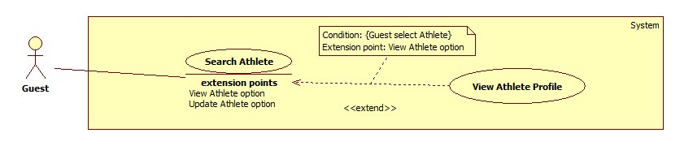

**Figure 6: <Guest, Employee> View Athlete Profile use case diagram.**

**Use Case Specification**

|  |  |  |  |
| --- | --- | --- | --- |
| **USE CASE – MATC004** | | | |
| **Use Case No.** | MATC004 | **Use Case Version** | 1.0 |
| **Use Case Name** | View Athlete Profile | | |
| **Author** | Dương Trung Kiên | | |
| **Date** | 25/05/2014 | **Priority** | Normal |
| **Actor:**   * Guest.   **Summary:**   * View profile of an athlete.   **Goal:**   * View profile information.   **Triggers:**   * Clicks “Xem thông tin” button in Athlete Search Result table.   **Preconditions:**   * User is a guest.   **Post Conditions:**   * **Success:** Athlete’s information will be showed. * **Fail:** Show error message. Content of the message will be specified in exception section.   **Main Success Scenario:**   |  |  |  | | --- | --- | --- | | Step | Actor Action | System Response | | 1 | Actor clicks “Xem thông tin” button. | Show “Popup” include:   * Ảnh đại diện: image, value: athlete avatar. * Họ tên: label, value: athlete name. * Ngày sinh: label, value: athlete date of birth * Giới tính: radio button, readonly,value: athlete gender . * Từng tham gia: table include: joined league name, subleague name, weight devision, result   [Exception 1] |   **Alternative Scenario:** N/A  **Exceptions:**   |  |  |  | | --- | --- | --- | | No | Actor Action | System Response | | 1 | Connect to database fail | Show message: “Đã xảy ra lỗi, vui lòng thử lại sau.” |   **Relationships:**   * Extended by Search Athlete (Guest select Athlete).   **Business Rules:**   * List of joined league get from participation table sort by latest date. * If joined league is not available will show joined league name, subleague name, weight devision, result are “chưa có”. * If athlete avatar is not available will show default avatar. | | | |

##### <Guest> View League Information

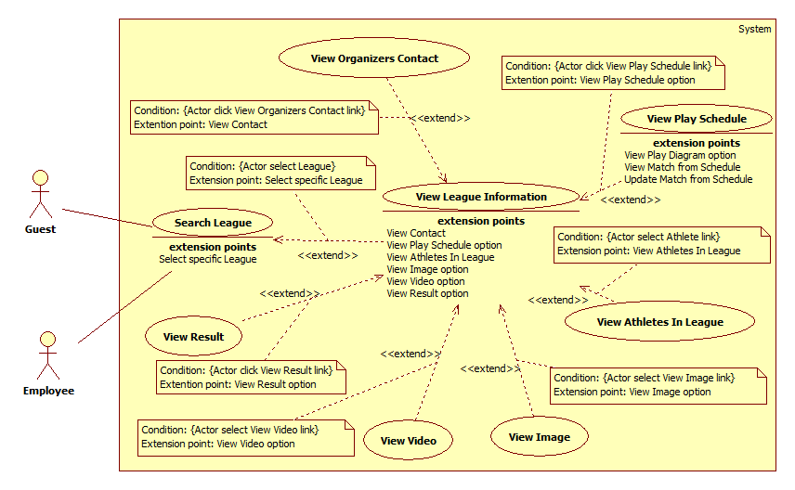

Figure 7: <Guest, Employee>View League Information use case diagram

Use Case Specification

|  |  |  |  |
| --- | --- | --- | --- |
| **USE CASE – MATC004** | | | |
| **Use Case No.** | MATC004 | **Use Case Version** | 1.0 |
| **Use Case Name** | View League Information | | |
| **Author** | Pham Hoang Truc Vy | | |
| **Date** | 24/5/2015 | **Priority** | High |
| **Actor:**   * Guest, Employee   **Summary:**   * This use case allows user to view league information.   **Goal:**   * Show league information.   **Triggers:**   * User clicks League name link on Search League page or Home page.   **Preconditions:**   * N/A   **Post Conditions:**   * **Success:** League information will be showed. * **Fail:** No league information will be showed, show error message.   **Main Success Scenario:**   |  |  |  | | --- | --- | --- | | Step | Actor Action | System Response | | 1 | User clicks league name link on Search League page or Home page. | Navigate to View League information page which contains:   1. League name: label. 2. Menu includes:  * “Thông tin giải”: link * “Danh sách VĐV”: link * “Lịch thi đấu”: link * “Kết quả”: link * “Hình ảnh”: link * “Video”: link  1. Content: “Thông tin giải” includes:  * Martial Arts Name: label. * League content: label. * Weight Division: table includes below columns: * Weight division name: label. * Male: label, format: min weight – max weight. * Female: label, format: min weight – max weight. * Registration deadline: label. * First round start date: label. * Place: label. * Organizer name: label. * “Thông tin liên hệ”: link.   [Exception 1] |   **Alternative Scenario:** N/A  **Exceptions:**   |  |  |  | | --- | --- | --- | | No | Actor Action | System Response | | 1 | Cannot show league information | Show error message: “Đã xảy ra lỗi. Vui lòng thử lại sau”. |   **Relationships:**   * Extended by Search League (Actor select league). * Extends to View Organizers Contact (Actor select View Organizers Contact link). * Extends to View Play Schedule (Actor click View Play Schedule link). * Extends to View Athlete in League (Actor click View Athletes link). * Extends to View Image (Actor select View Image link). * Extends to View Video (Actor select View Video link). * Extends to View Result (Actor click View Result link).   **Business Rules:**   * “Lịch thi đấu” link will be showed when league has schedule. * “Kết quả” link, “Hình ảnh” link and “Video” link will be showed when league started. * League content label will be showed if it is available. * Weight division name will be showed if it is available. | | | |

##### <Guest> View Organizers Contact

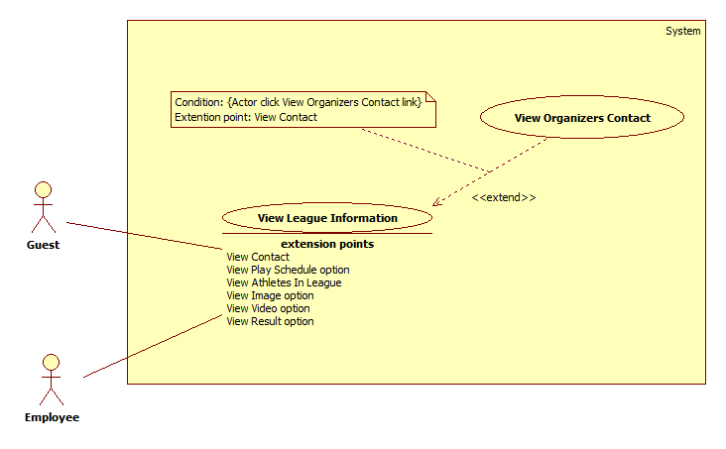

Figure 8: <Guest, Employee>View Organizers Contact use case diagram

Use Case Specification

|  |  |  |  |
| --- | --- | --- | --- |
| **USE CASE – MATC005** | | | |
| **Use Case No.** | MATC005 | **Use Case Version** | 1.0 |
| **Use Case Name** | View Organizers Contact | | |
| **Author** | Pham Hoang Truc Vy | | |
| **Date** | 24/5/2015 | **Priority** | Normal |
| **Actor:**   * Guest, Employee   **Summary:**   * This use case allows user to view organizers contact.   **Goal:**   * Show league organizers contact.   **Triggers:**   * User clicks “Thông tin liên hệ” link on View League Information page.   **Preconditions:** N/A  **Post Conditions:**   * **Success:** League organizers contact will be showed. * **Fail:** No contact will be showed, show error message.   **Main Success Scenario:**   |  |  |  | | --- | --- | --- | | Step | Actor Action | System Response | | 1 | User clicks “Thông tin liên hệ” link on View League Information page. | Show League organizers contact popup which contains:   * Organizers name * Email * Fax * Telephone * Address.   [Exception 1] |   **Alternative Scenario:** N/A  **Exceptions:**   |  |  |  | | --- | --- | --- | | No | Actor Action | System Response | | 1 | Cannot show organizers contact | Show error message: “Đã xảy ra lỗi. Vui lòng thử lại sau”. |   **Relationships:** Extended by View League Information (Actor select View Organizers Contact link)  **Business Rules:** N/A | | | |

##### <Guest> View Result

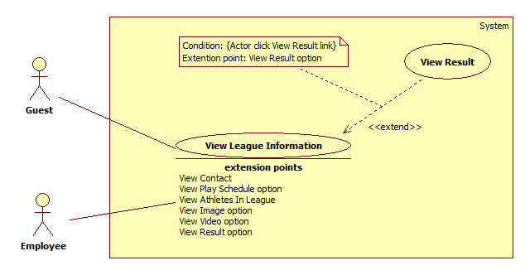

Figure 9: <Guest, Employee>View Result use case diagram

Use Case Specification

|  |  |  |  |
| --- | --- | --- | --- |
| **USE CASE – MATC006** | | | |
| **Use Case No.** | MATC006 | **Use Case Version** | 1.0 |
| **Use Case Name** | View Result | | |
| **Author** | Pham Hoang Truc Vy | | |
| **Date** | 3/6/2015 | **Priority** | Normal |
| **Actor:**   * Guest, Employee   **Summary:**   * This use case allows user to view league result.   **Goal:**   * Show league result.   **Triggers:**   * User clicks “Kết quả” link on Menu of View League Information page.   **Preconditions:** N/A  **Post Conditions:**   * **Success:** League result will be showed. * **Fail:** No result will be showed, show error message.   **Main Success Scenario:**   |  |  |  | | --- | --- | --- | | Step | Actor Action | System Response | | 1 | User clicks “Kết quả” link on Menu of View League Information page.  [Alternative 1] | Navigate to View Result page which contains: Table includes:  * Unit name: label * Number of gold medals: label * Number of silver medals: label * Number of bronze medals: label  “Chi tiết” table includes:  * Weight division: label, format: weight division name (min weight – max weight). * Name of athlete who won gold medal: label. * Name of athlete who won silver medal: label. * Names of athletes who won bronze medal: label.   [Exception 1] |   **Alternative Scenario:**   |  |  |  | | --- | --- | --- | | No | Actor Action | System Response | | 1 | League has not had result yet. | Show message: “Chưa có kết quả”. |   **Exceptions:**   |  |  |  | | --- | --- | --- | | No | Actor Action | System Response | | 1 | Cannot show league result | Show error message: “Đã xảy ra lỗi. Vui lòng thử lại sau”. |   **Relationships:**   * Extended by View League Information (Actor click View Result link)   **Business Rules:** N/A | | | |

##### <Guest> View Image

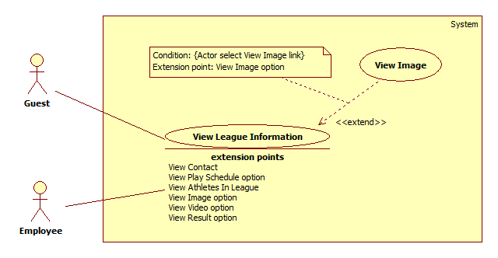

Figure 10: <Guest, Employee>View Image use case diagram

Use Case Specification

|  |  |  |  |
| --- | --- | --- | --- |
| **USE CASE – MATC007** | | | |
| **Use Case No.** | MATC007 | **Use Case Version** | 1.0 |
| **Use Case Name** | View Image | | |
| **Author** | Pham Hoang Truc Vy | | |
| **Date** | 3/6/2015 | **Priority** | Normal |
| **Actor:**   * Guest, Employee   **Summary:**   * This use case allows user to view league images.   **Goal:**   * Show league images.   **Triggers:**   * User clicks “Hình ảnh” link on Menu of View League Information page.   **Preconditions:** N/A  **Post Conditions:**   * **Success:** League images will be showed. * **Fail:** No image will be showed, show error message.   **Main Success Scenario:**   |  |  |  | | --- | --- | --- | | Step | Actor Action | System Response | | 1 | User clicks “Hình ảnh” link on Menu of View League Information page.  [Alternative 1] | Navigate to View Image page which contains:   * Image * Description: label   [Exception 1] |   **Alternative Scenario:**   |  |  |  | | --- | --- | --- | | No | Actor Action | System Response | | 1 | League has not had image yet. | Show message: “Chưa có hình ảnh”. |   **Exceptions:**   |  |  |  | | --- | --- | --- | | No | Actor Action | System Response | | 1 | Cannot show league image | Show error message: “Đã xảy ra lỗi. Vui lòng thử lại sau”. |   **Relationships:**   * Extended by View League Information (Actor select View Image link)   **Business Rules:**   * Description of each image will be show below that image. * Description will be showed if it is available. * Table records are paginated with ***N*** records per page. (***N*** is get from configure file which is managed by admin) | | | |

##### <Guest> View Video

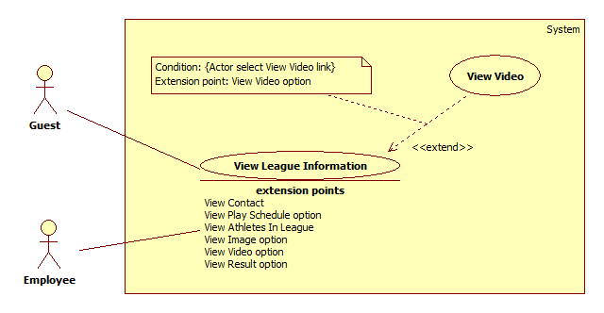

Figure 11: <Guest, Employee>View Video use case diagram

Use Case Specification

|  |  |  |  |
| --- | --- | --- | --- |
| **USE CASE – MATC008** | | | |
| **Use Case No.** | MATC008 | **Use Case Version** | 1.0 |
| **Use Case Name** | View Video | | |
| **Author** | Pham Hoang Truc Vy | | |
| **Date** | 3/6/2015 | **Priority** | Normal |
| **Actor:**   * Guest, Employee   **Summary:**   * This use case allows user to view league videos.   **Goal:**   * Show league videos.   **Triggers:**   * User clicks “Video” link on Menu of View League Information page.   **Preconditions:** N/A  **Post Conditions:**   * **Success:** League videos will be showed. * **Fail:** No video will be showed, show error message.   **Main Success Scenario:**   |  |  |  | | --- | --- | --- | | Step | Actor Action | System Response | | 1 | User clicks “Video” link on Menu of View League Information page.  [Alternative 1] | Navigate to View Video page which contains:   * Video * Description: label   [Exception 1] |   **Alternative Scenario:**   |  |  |  | | --- | --- | --- | | No | Actor Action | System Response | | 1 | League has not had video yet. | Show message: “Chưa có Video”. |   **Exceptions:**   |  |  |  | | --- | --- | --- | | No | Actor Action | System Response | | 1 | Cannot show league video | Show error message: “Đã xảy ra lỗi. Vui lòng thử lại sau”. |   **Relationships:**   * Extended by View League Information (Actor select View Video link)   **Business Rules:**   * Description of each video will be show below that video. * Description will be showed if it is available. * Table records are paginated with ***N*** records per page. (***N*** is get from configure file which is managed by admin) | | | |

##### <Guest> View Play Schedule

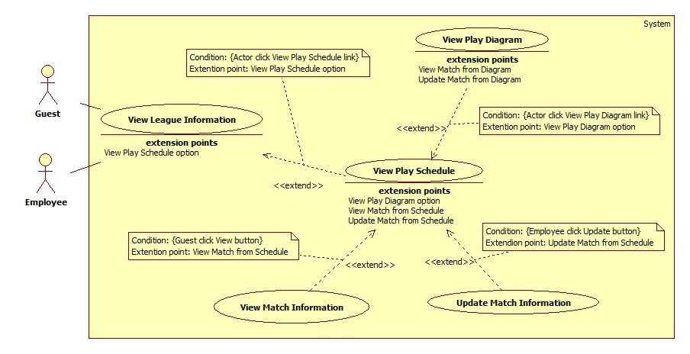

**Figure 12: <Guest, Employee> View Play Schedule**

**Use Case Specification**

|  |  |  |  |
| --- | --- | --- | --- |
| **USE CASE – MATC009** | | | |
| **Use Case No.** | MATC009 | **Use Case Version** | 1.0 |
| **Use Case Name** | View Play Schedule | | |
| **Author** | Nguyễn Duy Nhất | | |
| **Date** | 25/5/2015 | **Priority** | High |
| **Actor:**   * Employee, Guest   **Summary:**   * This use case allows Employee or Guest to view play schedule of league.   **Goal:**   * Employee or Guest can view play schedule of league.   **Triggers:**   * Actor clicks “Lịch thi đấu” link on League Information screen.   **Preconditions:**   * League must have been scheduled already.   **Post Conditions:**   * **Success:** Show match list in league. * **Fail:** Show error message. Content of the message will be specified in exception section.   **Main Success Scenario:**   |  |  |  | | --- | --- | --- | | Step | Actor Action | System Response | | 1 | Actor clicks “Lịch thi đấu” link | Navigate to View Schedule page which contains:   * “Xem sơ đồ thi đấu”: link * Match table which contains: * “Vòng đấu”: label * “Thời gian bắt đầu”: label, format: “hh:mm tt - dd/MM/yyyy” * “Vận động viên 1”: label * “Vận động viên 2”: label * “Người thắng”: label * “Xem”: button * “Cập nhật” button   [Exception 1, 2] |   **Alternative Scenario: N/A**  **Exceptions:**   |  |  |  | | --- | --- | --- | | No | Actor Action | System Response | | 1 | League has not been scheduled | Show message “Không có kết quả phù hợp” | | 2 | Connect to database fail | Show message “Đã xảy ra lỗi, xin vui lòng thử lại sau” |   **Relationships:** extended by View League Information (View Play Schedule option),  extends to View Match Information (View Match from Schedule), extends to Update Match Information (Update Match from Schedule), extends to View Play Diagram (View Diagram option)  **Business Rules:**   * User can view play schedule of a league after the league is scheduled. * Match list is sorted by weight division from low to high. In each weight division, matches are sorted in ascending order of start time, from external round to internal round. * Search bar on the top helps user to find match faster. Parameters for finding include gender, weight division and round. * If match has no result, the field "Vận động viên thắng" of the table will show "Chưa xác định". * If athletes of the match have not defined, the field "Vận động viên 1" and “Vận động viên 2” of the table will be shown "Chưa xác định" respectively. * If user logins with employee role who manages the league, “Cập nhật” button will be visible. Otherwise, “Cập nhật” button will be hidden. | | | |

##### <Guest> View Play Diagram

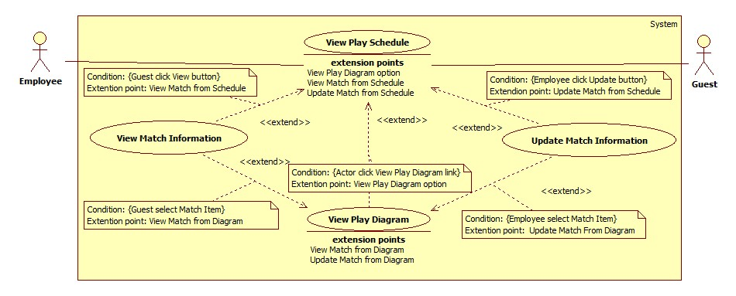

**Figure 13: <Guest, Employee> View Play Diagram**

**Use Case Specification**

|  |  |  |  |
| --- | --- | --- | --- |
| **USE CASE – MATC0010** | | | |
| **Use Case No.** | MATC0010 | **Use Case Version** | 1.0 |
| **Use Case Name** | View Play Diagram | | |
| **Author** | Dương Trung Kiên | | |
| **Date** | 25/05/2014 | **Priority** | High |
| **Actor:**   * Guest, Employee.   **Summary:**   * This use case allows to employee and guest can view play diagram.   **Goal:**   * View play diagram.   **Triggers:**   * Click “Xem sơ đồ thi đấu” link on table of View Schedule page.   **Preconditions:**   * N/A   **Post Conditions:**   * **Success:** Show View Play Diagram page. * **Fail:** Show error message. Content of the message will be specified in exception section.   **Main Success Scenario:**   |  |  |  | | --- | --- | --- | | Step | Actor Action | System Response | | 1 | Click “Xem sơ đồ thi đấu” link | Show View Play Diagram page express League name, round name, match, athlete, score, zoom button, result table(if third place or final winner was defined)  [Exceptio 1] |   **Alternative Scenario:** N/A  **Exceptions:**   |  |  |  | | --- | --- | --- | | No | Actor Action | System Response | | 1 | Connect to database fail | Show message: “Đã xảy ra lỗi, vui lòng thử lại sau.” |   **Relationships:**   * Extended by View Play Schedule (View Play Diagram option) * Extends to View Match Information (View match from diagram) * Extends to Update Match Information (Update match from diagram)   **Business Rules:**   * If athlete number from 4 to 16 will show Play Diagram include: * Vòng loại * Tứ kết * Bán kết * Tranh hạng 3 (if exist) * Chung kết * If athlete number more than 16 will show Play Diagram include: * Vòng loại 1 * Vòng loại 2 * Tứ kết * Bán kết * Tranh hạng 3 (if exist) * Chung kết * Winner name will be high light. * If win reason is not by score, score column will show “✓” for winner and “×” for looser. * Result table will be show until third place or final match result have defined. * Diagram can zoom with 50%, 75% or 100%. * If match does not exist will disable. | | | |

##### <Guest> View Match Information

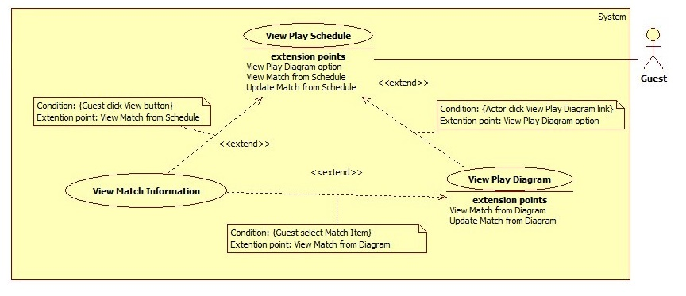

**Figure 14: <Guest, Employee> View Match Information**

**Use Case Specification**

|  |  |  |  |
| --- | --- | --- | --- |
| **USE CASE – MATC0011** | | | |
| **Use Case No.** | MATC0011 | **Use Case Version** | 1.0 |
| **Use Case Name** | View Match Information | | |
| **Author** | Dương Trung Kiên | | |
| **Date** | 25/05/2014 | **Priority** | Normal |
| **Actor:**   * Employee, Guest.   **Summary:**   * This use case allow to employee or guest view match information.   **Goal:**   * View match information.   **Triggers:**   * Click “Xem” button on table of View Schedule page. * Click match item in Play Diagram. * Click match name link in Home page.   **Preconditions:**   * N/A.   **Post Conditions:**   * **Success:** Show pop-up contains match information. * **Fail:** Show error message. Content of the message will be specified in exception section.   **Main Success Scenario:**   |  |  |  | | --- | --- | --- | | Step | Actor Action | System Response | | 1 | Click “Xem” button on table of View Schedule page.  [Alternative 1,2] | Show match information pop-up include:   * Hạng cân: Label. * Giới tính: Label. * Vòng: Label. * Thời gian bắt đầu: Label, format (hh:mm dd-MM-yyyy) * Tên vận động viên 1: Label. * Tên vận động viên 2: Label. * Số báo danh vận động viên 1: label. * Số báo danh vận động viên 1: label. * Người thắng: label. * Điểm từng hiệp: label. * Điểm tổng kết: label. * Lý do thắng: label. * Ghi chú: Textbox, lenght(MAX),   disable  [Exception 1] |   **Alternative Scenario:**   |  |  |  | | --- | --- | --- | | No | Actor Action | System Response | | 1 | Click match item in Play Diagram. | Show match information pop-up include:   * Hạng cân: Label. * Giới tính: Label. * Vòng: Label. * Thời gian bắt đầu: Label, format (hh:mm dd-MM-yyyy) * Tên vận động viên 1: Label. * Tên vận động viên 2: Label. * Số báo danh vận động viên 1: label. * Số báo danh vận động viên 1: label. * Người thắng: label. * Điểm từng hiệp: label. * Điểm tổng kết: label. * Lý do thắng: label. * Ghi chú: Textbox, lenght(MAX),   disable  [Exception 1] | | 2 | Click match name link in Home page. | Show match information pop-up include:   * Hạng cân: Label. * Giới tính: Label. * Vòng: Label. * Thời gian bắt đầu: Label, format (hh:mm dd-MM-yyyy) * Tên vận động viên 1: Label. * Tên vận động viên 2: Label. * Số báo danh vận động viên 1: label. * Số báo danh vận động viên 1: label. * Người thắng: label. * Điểm từng hiệp: label. * Điểm tổng kết: label. * Lý do thắng: label. * Ghi chú: Textbox, lenght(MAX),   disable  [Exception 1] |   **Exceptions:**   |  |  |  | | --- | --- | --- | | No | Actor Action | System Response | | 1 | Connect to database fail. | Show message: “Đã xảy ra lỗi, vui lòng thử lại sau.” |   **Relationships:**   * Extended by View Play Schedule (Select View Match from Schedule). * Extended by View Play Diagram (Select View Match from Diagram). * Extends to Update Match Information (Select Update Match).   **Business Rules:**   * “Hạng cân” will be form (“Từ ” + minWeight + “ đến ” + maxWeight + “ kg”) such as “Từ 40 đến 43 kg” | | | |

##### <Guest> View Athletes in League

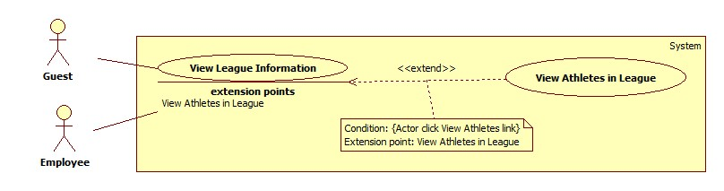

**Figure 15: <Guest, Employee> View Athletes in League**

**Use Case Specification**

|  |  |  |  |
| --- | --- | --- | --- |
| **USE CASE – MATC012** | | | |
| **Use Case No.** | MATC012 | **Use Case Version** | 1.0 |
| **Use Case Name** | View Athletes in League | | |
| **Author** | Nguyễn Duy Nhất | | |
| **Date** | 25/5/2015 | **Priority** | High |
| **Actor:**   * Employee, Guest   **Summary:**   * This use case allows Employee or Guest to view athlete list in a league.   **Goal:**   * Employee or Guest can view athlete list in a league.   **Triggers:**   * Actor clicks “Danh sách VĐV” link on League Information screen.   **Preconditions:** N/A  **Post Conditions:**   * **Success:** Show athlete list in league. * **Fail:** Show error message. Content of the message will be specified in exception section.   **Main Success Scenario:**   |  |  |  | | --- | --- | --- | | Step | Actor Action | System Response | | 1 | Actor clicks “Danh sách VĐV link | Navigate to View Athlete List in League page which contains:  “Thêm Vận động viên”: link  “Tải danh sách”: link  Athlete table which contains:   * “SBD”: label * “Ưu tiên”: label * “Họ tên” : label * “Giới tính”: label * “Ngày sinh”: label * “Cân nặng”: label * “Hạng cân”: label * “Đơn vị”: label * “Cập nhật”: button * “Xóa”: button   [Exception 1] |   **Alternative Scenario:**   |  |  |  | | --- | --- | --- | | No | Actor Action | System Response | | 1 | Athlete list is empty. | Show message “Không có kết quả phù hợp”  [Exception 1] |   **Exceptions:**   |  |  |  | | --- | --- | --- | | No | Actor Action | System Resonse | | 1 | Connect to database fail | Show message “Đã xảy ra lỗi, xin vui lòng thử lại sau” |   **Relationships:** extended by View League Information (View Athletes in League)  **Business Rules:**   * Athlete list is sorted alternately by weight division from male to female, from low weight division to high weight division. In each weight division, athletes are sorted in ascending order of no number. * Table records are paginated with ***N*** records per page. (***N*** is get from configure file which is managed by admin) * Search bar on the top helps user to find athlete faster. Parameters for finding include athlete’s name, athlete’s status, gender and weight division. * If user logins with employee role who manages the league, “Tải danh sách” link will be visible. Otherwise, it will be hidden. * If user logins with employee role who manages the league and the league has not been scheduled, “Thêm Vận động viên” link, “Cập nhật” button and “Xóa” button will be visible. Otherwise, they will be hidden. | | | |

#### <Employee> Overview Use Case

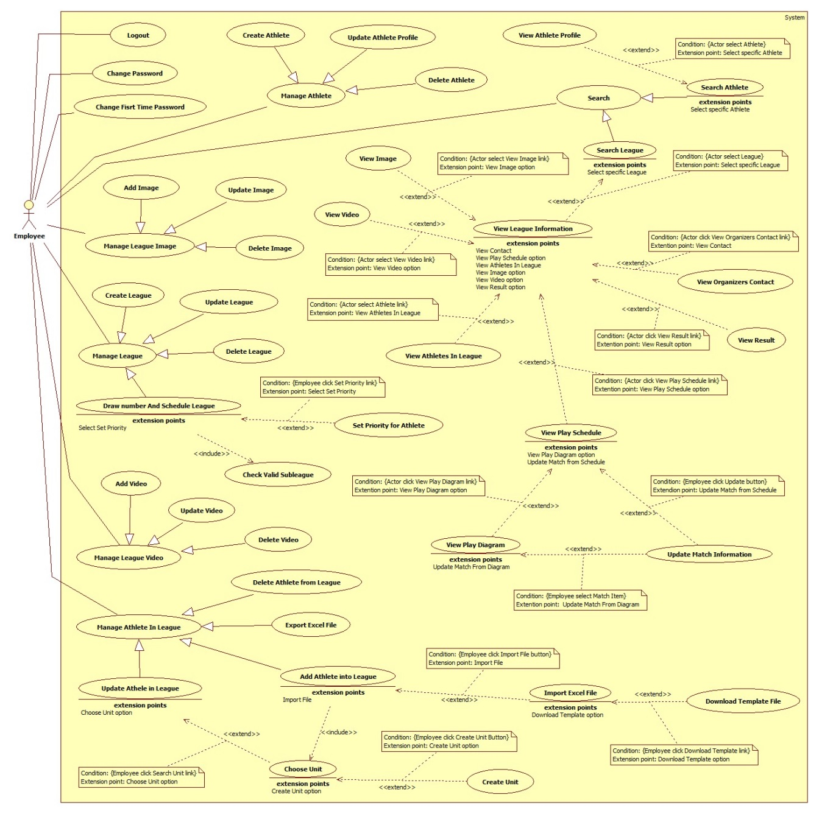

Figure 16: <Employee> Overview Use Case

##### <Employee> Search League

Reference Use Case MATC002

##### <Employee> Search Athlete

Reference Use Case MATC003

##### <Employee> Create Athlete

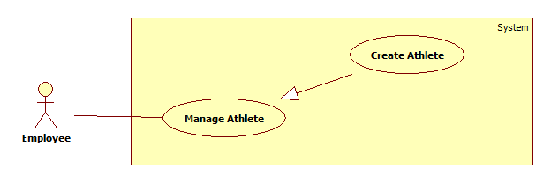

**Figure 17: <Employee> Create Athlete use case diagram**

**Use Case Specification**

|  |  |  |  |
| --- | --- | --- | --- |
| **USE CASE – MATC016** | | | |
| **Use Case No.** | MATC016 | **Use Case Version** | 2.0 |
| **Use Case Name** | Create Athlete | | |
| **Author** | Pham Hoang Truc Vy | | |
| **Date** | 3/6/2015 | **Priority** | Hight |
| **Actor:**   * Employee   **Summary:**   * This use case allows Employee create a new Athlete.   **Goal:**   * Add new athlete.   **Triggers:**   * Employee clicks “Tạo vận động viên mới” link on Menu.   **Preconditions:**   * User login with role Employee and this account must be active.   **Post Conditions:**   * **Success:** Athlete will be added into database. * **Fail:** No athlete will be added. Show error message.   **Main Success Scenario:**   |  |  |  | | --- | --- | --- | | Step | Actor Action | System Response | | 1 | Employee clicks “Tạo vận động viên mới” link on Menu. | Navigate to Create Athlete page which contains:   * “CMND”: text box, length: 9, only integer input, required. * “Họ tên”: text box, min length: 2, max length: 50, required. * “Ngày sinh”: datepicker * “Giới tính”: radio button includes “Nam” and “Nữ”, required. * “Hình dại diện”: “Chọn” button. * “Thêm”: button * “Xóa trắng”: button | | 2 | Employee inputs data and clicks “Thêm” button  [Altenative 1] | * Athlete will be added. * Show message: “Bạn đã tạo thành công 1 vận động viên!”   [Exception 1, 2, 3, 4, 5, 6, 7] |   **Alternative Scenario:**   |  |  |  | | --- | --- | --- | | No | Actor Action | System Response | | 1 | Employee clicks “Xóa trắng” button. | Clear all data input. |   **Exceptions:**   |  |  |  | | --- | --- | --- | | o | Actor Action | System Response | | 1 | ID less than 9 characters. | Show message error: “Không đủ 9 ký tự”. | | 2 | Length of fullname is not in range. | Show message error: “Vui lòng nhập từ 2 đến 50 ký tự, bao gồm khoảng trắng” | | 3 | If athlete’s age is under 18 or over 40 years old. | Show message error: “Không nằm trong độ tuổi quy định. (18 – 40 tuổi)”. | | 4 | Date of birth was not entered | Show error message: “Bạn chưa nhập ngày sinh.” | | 5 | Gender was not choose | Show error message: “Chưa chọn giới tính”. | | 6 | ID is existed. | Show error message: “CMND đã tồn tại!” | | 7 | Cannot add athlete to league | Show error message: “Đã xảy ra lỗi. Vui lòng thử lại sau”. |   **Relationships:** N/A  **Business Rules:**   * Each athlete has a unique ID. * Athlete must over 18 years old and below 40 years. * After employee selects an image, preview image will be showed below. | | | |
|  | | | |

##### <Employee> Update Athlete Profile

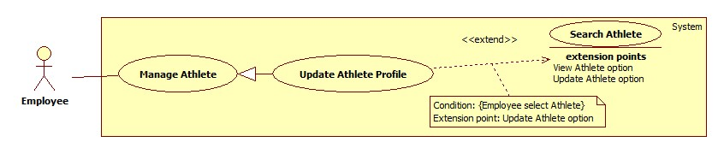

**Figure 18: <Employee> Update Athlete**

**Use Case Specification**

|  |  |  |  |
| --- | --- | --- | --- |
| **USE CASE – MATC016** | | | |
| **Use Case No.** | MATC016 | **Use Case Version** | 1.0 |
| **Use Case Name** | Update Athlete Profile | | |
| **Author** | Dương Trung Kiên | | |
| **Date** | 25/05/2014 | **Priority** | high |
| **Actor:**   * Employee.   **Summary:**   * This usercase allow to employee can update athlete profile.   **Goal:**   * Change athlete’s information.   **Triggers:**   * Employee clicks “Xem thông tin” button.   **Preconditions:**   * User must login with Employee role and account status is active.   **Post Conditions:**   * **Success:** New data is inserted to database. * **Fail:** Nothing is changed in the database and show error message. Content of the message will be specified in exception section.   **Main Success Scenario:**   |  |  |  | | --- | --- | --- | | Step | Actor Action | System Response | | 1 | Employee click on “Xem thông tin” button | Show “Popup” include:   * Ảnh đại diện: image, value: athlete avatar. * Select avatar button. * Họ tên: textbox, min-lengh(2), max-lengh(50), value: athlete name. * Ngày sinh: Datetimepicker, value: athlete date of birth * Giới tính: radio button, readonly,value: athlete gender . * Từng tham gia: table include: joined league name, subleague name, weight devision, result * “Xóa” button: disable. | | 2 | Employee change information and click on “Cập nhật” button  [Alternative 1] | * New athlete information will be added to database and show: “Thông tin đã thay đổi thành công!” * Exception [1, 2, 3, 4]. |   **Alternative Scenario:**   |  |  |  | | --- | --- | --- | | No | Actor Action | System Response | | 1 | Click on “Hủy” button | Change nothing in database, go back to previous status. |   **Exceptions:**   |  |  |  | | --- | --- | --- | | No | Actor Action | System Response | | 1 | Athlete’s name includes number. | Show error message: “Tên không hợp lệ! ” | | 2 | Length of athlete’s name is not in range | Show error message: “Tên vận động viên phải từ 2 đến 50 kí tự!” | | 3 | Year of birth not in require time | Show error message:”Độ tuổi phải từ 18 tới 40!” | | 4 | Connect to database fail | Show message: “Đã xảy ra lỗi, vui lòng thử lại sau.” |   **Relationships:**   * Extended by Search Athlete (Update Athlete option, View Athlete option).   **Business Rules:**   * Gender and joined league cannot be updated. * Age of Athlete validate depend on config file. * If joined league is null, show joined league name, subleague name, weight devision, result are “chưa có” and “Xóa” button will enable. * If athlete avatar is null will show dafault avatar. * Default valid age from 18 to 40. | | | |

##### <Employee> Delete Athlete

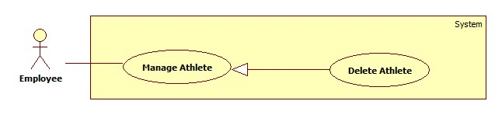

**Figure 19: <Employee> Delete Athlete**

**Use Case Specification**

|  |  |  |  |
| --- | --- | --- | --- |
| **USE CASE – MATC017** | | | |
| **Use Case No.** | MATC017 | **Use Case Version** | 1.0 |
| **Use Case Name** | Delete Athlete | | |
| **Author** | Dương Trung Kiên | | |
| **Date** | 25/5/2015 | **Priority** | Normal |
| **Actor:**   * Employee   **Summary:**   * This use case allows employee can delete athlete.   **Goal:**   * Employee can delete athlete.   **Triggers:** Employee click “Xem thông tin” button and “Xóa” button in Athlete View Profile pop-up has already enabled.  **Preconditions:**   * User must login with Employee role and account status must be active. * Athlete has not joined any league yet.   **Post Conditions:**   * **Success:** Athlete information will be delete from database. * **Fail:** Show error message. Content of the message will be specified in exception section.   **Main Success Scenario:**   |  |  |  | | --- | --- | --- | | Step | Actor Action | System Response | | 1 | Click “Xem thông tin” button. | Show “Popup” include:   * Ảnh đại diện: image, value: athlete avatar. * Select avatar button. * Họ tên: textbox, min-lengh(2), max-lengh(50), value: athlete name. * Ngày sinh: Datetimepicker, value: athlete date of birth * Giới tính: radio button, readonly,value: athlete gender . * Từng tham gia: table include: joined league name, subleague name, weight devision, result * “Xóa” button: enable. | | 2 | Click “Xóa” button.  [Alternative 1] | Show confirm pop-up. | | 3 | Click “Xác nhận” button. | Athlete profile will be delete from database. |   **Alternative Scenario:**   |  |  |  | | --- | --- | --- | | No | Actor Action | System Response | | 1 | Click “Hủy” button | Return Athlete View Profile pop-up and change nothing. |   **Exceptions:**   |  |  |  | | --- | --- | --- | | No | Actor Action | System Response | | 1 | Connect to database fail | Show message “Đã xảy ra lỗi, xin vui lòng thử lại” |   **Relationships:** View Athlete Profile (Delete Athlete Option)  **Business Rules:**   * If Athlete has already presented in some league, “Xóa” button are disable. | | | |

##### <Employee> Create League

Use Case Diagram

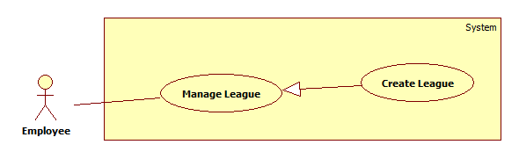

Figure 20: <Employee>Create League use case diagram

Use Case Specification

|  |  |  |  |
| --- | --- | --- | --- |
| **USE CASE – MATC018** | | | |
| **Use Case No.** | MATC018 | **Use Case Version** | 1.0 |
| **Use Case Name** | Create League | | |
| **Author** | Pham Hoang Truc Vy | | |
| **Date** | 2/6/2015 | **Priority** | High |
| **Actor:**   * Employee   **Summary:**   * This use case allows employees to create a new league.   **Goal:**   * Add new league.   **Triggers:**   * Employee clicks “Tạo giải đấu mới” link on Menu.   **Preconditions:**   * User login to system with role employee and that account must be active.   **Post Conditions:**   * **Success:** New league will be inserted. * **Fail:** No league will be inserted, show error message.   **Main Success Scenario:**   |  |  |  | | --- | --- | --- | | Step | Actor Action | System Response | | 1 | Employee clicks “Tạo giải đấu mới” link on Menu | Navigate to Create league page which contains:   * Tab 1: “Thông tin cơ bản” * “Tên giải đấu”: textbox, min-length: 5, max-length: 150, required. * “Nội dung”: text area. * “Môn thi đấu”: drop down list, raw source from database MartialArts table, required. * “Địa điểm thi đấu”: text area, required. * “Khu vực (dành cho giải chỉ trong 1 TP/Tỉnh)”: drop down list, raw source from database City table. * “Hạn chót đăng kí”: Datetimepicker, required. * “Thời gian bắt đầu”: Datetimepicker, required. * Tab 2: “Hạng cân” * Table includes check box for each weight division: raw source from database table WeightDivision, required. * Tab 3: “Thông tin chi tiết” * “Giành giải 3”: radio button “Có” and “Không”. * “Số hiệp/trận”: textbox, only integer input, unit: set per match, min: 1, max: 12, required. * “Thời gian 1 trận”: textbox, only integer input, unit: minute, min: 6m, max: 50m, required. * “Thời gian nghỉ giữa 2 trận”: drop down list, include: 0, 5, 10,…, 60 minute, default: 0, required. * “Thời gian thi đấu trong 1 ngày”: timepicker, required. * “Số ngày nghỉ giữa các vòng”: textbox, only integer input, default: 0 day, max: 5 days, required. * “Số sàn thi đấu”: textbox, type number, default: 1, max: 10 floors each time, required. * Tab4: “Đơn vị tổ chức” * “Tên ban tổ chức”: textbox, max-length: 50, required. * “Email”: textbox, max-length: 50, regurlar expression: /^([\w-]+(?:\.[\w-]+)*)@((?:[\w-]+\.)*\w[\w-]{0,66})\.([a-z]{2,6}(?:\.[a-z]{2})?)$/i, required. * “Điện thoai”: textbox, max-length: 50, required. * “Fax”: textbox, max-length: 50. * “Địa chỉ”: text area. * “Thêm”: button * “Xóa trắng”: button | | 2 | Employee input data fill |  | | 3 | Employee clicks “Thêm” button.  [Alternative ] | * New league will be inserted in database. * Show success message: “Giải đấu mới đã được tạo thành công.”   [Exception 1, 2, 3, 4, 5, 6, 7, 8, 9, 10, 11, 12, 13, 14, 15, 16, 17, 18, 19, 20, 21, 22, 23, 24] |   **Alternative Scenario:**   |  |  |  | | --- | --- | --- | | No | Actor Action | System Resonse | | 1 | Employee clicks “Xóa trắng” button | Clear all input data. |   **Exceptions:**   |  |  |  | | --- | --- | --- | | No | Actor Action | System Response | | 1 | League name is not in range. | Show error message: “Tên giải đấu phải từ 5 đến 150 kí tự!” | | 2 | Place was not entered. | Show error message: “Bạn chưa nhập Địa điểm thi đấu!” | | 3 | Type of martial art was not selected. | Show error message: “Bạn chưa chọn môn võ thi đấu!” | | 4 | Registration deadline was not chose. | Show error message: “Bạn chưa chọn Hạn chót đăng kí!” | | 5 | Registration deadline is before system time plus 2 days | Show error message: “Hạn chót đăng kí phải sau hôm nay ít nhất 2 ngày!” | | 6 | Start date was not chose. | Show error message:” Bạn chưa chọn Thời gian bắt đấu”. | | 7 | Start date is before registration deadline plus 2 days. | Show error message: “Thời gian bắt đấu phải sau Hạn chót đăng kí ít nhất 2 ngày!” | | 8 | Weight Devision was not chose. | Show error message: “Bạn chưa chọn các hạng cân thi đấu!” | | 9 | Number of set was not chose. | Show error message: “Bạn chưa chọn Số hiệp cho 1 trận!” | | 10 | Number of set is not in range. | Show error message: “1 trận phải có từ 1 – 12 hiệp!” | | 11 | Time of one match is not in range | Show error message: “Thời gian 1 trận phải từ 6 – 50 phút”. | | 12 | Time of one match was not entered. | Show error message: “Bạn chưa nhập thời gian 1 trận”. | | 13 | Break time was not entered. | Show error message: “Bạn chưa nhập thời gian nghỉ giữa 2 trận”. | | 14 | Play time on a day was not chose. | Show error message: “Bạn chưa chọn Thời gian bắt đầu!” or “Bạn chưa chọn Thời gian kết thúc!” | | 15 | Finish time is before beginning time plus one match. | Show error message: “Thời gian kết thúc không hợp lí!” | | 16 | Break day between rounds was not entered. | Show error message: “Bạn chưa nhập đủ Số ngày nghỉ giữa các vòng!” | | 17 | Number of floors was not entered. | Show error message: “Bạn chưa nhập Số sàn thi đấu!” | | 18 | Number of floors is not in range | Show error message: “1 lần chỉ có tối đa 10 sàn!” | | 19 | Organizers name was not entered. | Show error message: “Bạn chưa nhập Tên ban tổ chức!” | | 20 | Email was not matched format. | Show error message: “Email phải có định dạng abc@xyz.com!” | | 21 | Email was not entered. | Show error message: “Bạn chưa nhập Email!” | | 22 | Organizer telephone was not entered. | Show error message: “Bạn chưa nhập Số điện thoại của ban tổ chức!” | | 23 | League Name is existed | Show error message: “Giải đấu đã tồn tại. Vui lòng nhập lại”. | | 24 | Cannot insert league to database | Show error message: “Đã xảy ra lỗi. Vui lòng thử lại sau”. |   **Relationships:** N/A  **Business Rules:**   * Each league has unique name. * Each league is held for one martial arts type. If league has many martial arts type, employee have to append name martial art after league name, ex: Đại hội thể dục thể thao toàn quốc (Vovinam). * Registration deadline must be after the system time at least 2 days. * First round must start after registration deadline at least 2 days. * Tab 2 – “Hạng cân” will show weight division list depend on martial art type employee chose in “Môn thi đấu” drop down list. * In “Thời gian thi đấu trong 1 ngày” fields, finish time must be after beginning time at least one match. * Each league can have third place match or not. | | | |

##### <Employee> Update League

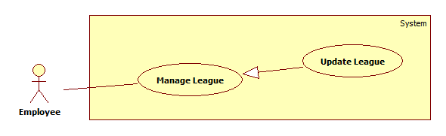

Figure 21: <Employee>Update League use case diagram

Use Case Specification

|  |  |  |  |
| --- | --- | --- | --- |
| **USE CASE – MATC019** | | | |
| **Use Case No.** | MATC019 | **Use Case Version** | 1.0 |
| **Use Case Name** | Update League | | |
| **Author** | Pham Hoang Truc Vy | | |
| **Date** | 2/6/2015 | **Priority** | Normal |
| **Actor:**   * Employee   **Summary:**   * This use case allows employees to update league information.   **Goal:**   * Update league information.   **Triggers:**   * Employee clicks “Sửa” button on Manage League page.   **Preconditions:**   * User login to system with role employee and that account must be active. * League was created by the employee who does this usecase. * League has not finished yet.   **Post Conditions:**   * **Success:** New league information will be updated. * **Fail:** No information will be updated, show error message.   **Main Success Scenario:**   |  |  |  | | --- | --- | --- | | Step | Actor Action | System Response | | 1 | Employee clicks “Sửa” button on Manage League page | Navigate to Update league information page which contains:   * Tab 1: “Thông tin cơ bản” * “Tên giải đấu”: textbox, min-length: 5, max-length: 150, required. * “Nội dung”: text area. * “Môn thi đấu”: drop down list, raw source from database MartialArts table, required. * “Địa điểm thi đấu: text area, required. * “Khu vực (dành cho giải chỉ trong 1 TP/Tỉnh)”: drop down list, raw source from database City table. * “Hạn chót đăng kí”: Datetimepicker, required. * “Thời gian bắt đầu”: Datetimepicker, required. * Tab 2: “Hạng cân” * Table includes check box for each weight division: raw source from database table WeightDivision, required. * Tab 3: “Thông tin chi tiết” * “Giành giải 3”: radio button “Có” and “Không”. * “Số hiệp/trận”: textbox, only integer input, unit: set per match, min: 1, max: 12, required. * “Thời gian 1 trận”: textbox, only integer input, unit: minute, min: 6m, max: 50m, required. * “Thời gian nghỉ giữa 2 trận”: drop down list, include: 0, 5, 10,…, 60 minute, required. * “Thời gian thi đấu trong 1 ngày”: timepicker, required. * “Số ngày nghỉ giữa các vòng”: textbox, type number, max: 5 days, required. * “Số sàn thi đấu”: textbox, type number, max: 10 floors each time, required. * Tab4: “Đơn vị tổ chức” * “Tên ban tổ chức”: textbox, max-length: 50, required. * “Email”: textbox, max-length: 50, regurlar expression: /^([\w-]+(?:\.[\w-]+)*)@((?:[\w-]+\.)*\w[\w-]{0,66})\.([a-z]{2,6}(?:\.[a-z]{2})?)$/i, required. * “Điện thoai”: textbox, max-length: 50, required. * “Fax”: textbox, max-length: 50. * “Địa chỉ”: text area. * “Lưu”: button * “Hủy”: button | | 2 | Employee update data fill |  | | 3 | Employee clicks “Lưu” button.  [Alternative 1] | * League information will be updated in database. * Show success message: “Thông tin giải đấu đã được lưu lại.”   [Exception 1, , 3, 4, 5, 6, 7, 8, 9, 10, 11, 12, 13, 14, 15, 16, 17, 18, 19, 20, 21, 22, 23, 24] |   **Alternative Scenario:**   |  |  |  | | --- | --- | --- | | No | Actor Action | System Response | | 1 | Employee clicks “Hủy” button | Reset all data. |   **Exceptions:**   |  |  |  | | --- | --- | --- | | No | Actor Action | System Response | | 1 | League name is no in range. | Show error message: “Tên giải đấu phải từ 5 đến 150 kí tự!” | | 2 | Place was not entered. | Show error message: “Bạn chưa nhập Địa điểm thi đấu!” | | 3 | Type of martial art was not seleced. | Show error message: “Bạn chưa chọn môn võ thi đấu!” | | 4 | Registraion deadline was not chose. | Show error message: “Bạn chưa chọn Hạn chót đăng kí!” | | 5 | New registration deadline is before old registration deadline and before system time plus 2 days | Show error message: “Nếu hạn chót đăng kí mới trước hạn chót cũ thì phải sau hôm nay ít nhất 2 ngày!” | | 6 | Start date was not chose. | Show error message:” Bạn chưa chọn Thời gian bắt đấu”. | | 7 | Start date is before registration deadline plus 2 days. | Show error message: “Thời gian bắt đấu phải sau Hạn chót đăng kí ít nhất 2 ngày!” | | 8 | Weight Devision was not chose. | Show error message: “Bạn chưa chọn các hạng cân thi đấu!” | | 9 | Number of set was not chose. | Show error message: “Bạn chưa chọn Số hiệp cho 1 trận!” | | 10 | Number of set is not in range. | Show error message: “1 trận phải có từ 1 – 12 hiệp!” | | 11 | Time of one match is not in range | Show error message: “Thời gian 1 trận phải từ 6 – 50 phút”. | | 12 | Time of one match was not entered. | Show error message: “Bạn chưa nhập thời gian 1 trận”. | | 13 | Break time was not entered. | Show error message: “Bạn chưa nhập thời gian ngỉ giữa 2 trận”. | | 14 | Play time on a day was not chose. | Show error message: “Bạn chưa chọn Thời gian bắt đầu!” or “Bạn chưa chọn Thời gian kết thúc!” | | 15 | Finish time is before beginning time plus one match. | Show error message: “Thời gian kết thúc không hợp lí! | | 16 | Break day between rounds was not entered. | Show error message: “Bạn chưa nhập đủ Số ngày nghỉ giữa các vòng!” | | 17 | Number of floors was not entered | Show error message: “Bạn chưa nhập Số sàn thi đấu!” | | 18 | Number of floors is nt in range | Show error message: “1 lần chỉ có tối đa 10 sàn!” | | 19 | Organizers name was not entered. | Show error message: “Bạn chưa nhập Tên ban tổ chức!” | | 20 | Email was not matched format. | Show error message: “Email phải có định dạng abc@example.com!” | | 21 | Emal was not entered. | Show error message: “Bạn chưa nhập Email!” | | 22 | Telephone was not entered | Show error message: “Bạn chưa nhập Số điện thoại của ban tổ chức!” | | 23 | League name is existed. | Show error message: “Giải đấu đã tồn tại. Vui lòng nhập lại”. | | 24 | Canot insert league to database | Show error message: “Đã xảy ra lỗi. Vui lòng thử lại sau”. |   **Relationships:** N/A  **Business Rules:**   * Each league has unique name. * Each league is held for one martial arts type. If league has many martial arts type, employee have to append name martial art after league name, ex: Đại hội thể dục thể thao toàn quốc (Vovinam). * If the system time met the registration deadline, “Hạn chót đăng kí” field, “Tên giải đấu” text field, “Môn thi đấu” drop down list, “Khu vực” text field and tab 2 - “Hạng cân” will disable. * If this league started “Thời gian bắt đầu” field will disable. * If new registration deadline is before old registration deadline, it must be after the system time at least 2 days. * First round must start after registration deadline at least 2 days. * If league has schedule, tab 3 – “Thông tin chi tiết” will disable. | | | |

##### <Employee> Delete League

Use Case Diagram

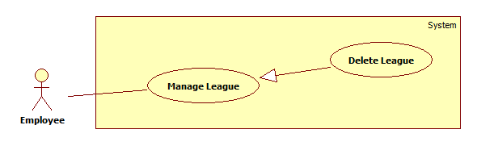

Figure 22: <Employee>Delete League use case diagram

Use Case Specification

|  |  |  |  |
| --- | --- | --- | --- |
| **USE CASE – MATC020** | | | |
| **Use Case No.** | MATC020 | **Use Case Version** | 1.0 |
| **Use Case Name** | Delete League | | |
| **Author** | Pham Hoang Truc Vy | | |
| **Date** | 3/6/2015 | **Priority** | Normal |
| **Actor:**   * Employee   **Summary:**   * This use case allows employees to delete a league.   **Goal:**   * Delete a league.   **Triggers:**   * Employee clicks “Xóa” button on Manage League page.   **Preconditions:**   * User login to system with role employee and that account must be active. * League was created by the employee who does this usecase. * League hasn’t started yet.   **Post Conditions:**   * **Success:** A league will be deleted in database. * **Fail:** No league will be deleted in database, show error message.   **Main Success Scenario:**   |  |  |  | | --- | --- | --- | | Step | Actor Action | System Response | | 1 | Employee clicks “Xóa” button on View Created League List page | * Show confirm message: “Bạn có muốn xóa giải đấu này?” * “Có”: button * “Không”: button | | 2 | Employee clicks “Có” button.  [Alternative 1] | * League will be deleted in database. * Return to View league list page.   [Exception 1] |   **Alternative Scenario:**   |  |  |  | | --- | --- | --- | | No | Actor Action | System Response | | 1 | Employee clicks “Không” button | No league will be deleted. |   **Exceptions:**   |  |  |  | | --- | --- | --- | | No | Actor Action | System Response | | 1 | Cannot delete league information to database | Show error message: “Đã xảy ra lỗi. Vui lòng thử lại sau”. |   **Relationships:** N/A  **Business Rules:**   * Employee cannot delete league after it starts. | | | |

##### <Employee> Draw number and Schedule League

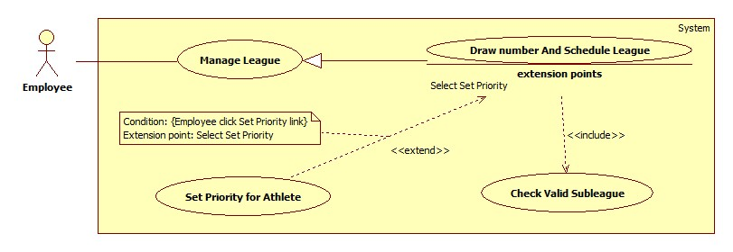

**Figure 23: <Employee> Draw number and Schedule League**

**Use Case Specification**

|  |  |  |  |
| --- | --- | --- | --- |
| **USE CASE – MATC023** | | | |
| **Use Case No.** | MATC023 | **Use Case Version** | 1.0 |
| **Use Case Name** | Draw number and Schedule League | | |
| **Author** | Nguyễn Duy Nhất | | |
| **Date** | 25/5/2015 | **Priority** | High |
| **Actor:**   * Employee   **Summary:**   * This use case allows employee to draw number and schedule a league   **Goal:**   * Employee can draw number and schedule a league   **Triggers:**   * Employee clicks “Xếp lịch” button on a row of the table in “View Created League List” page.   **Preconditions:**   * User must login with Employee role and account status is active. * The league is managed by the employee who does this usecase. * The league has not been scheduled.   **Post Conditions:**   * **Success:** Draw number and schedule league successfully. * **Fail:** Show error message. Content of the message will be specified in exception section.   **Main Success Scenario:**   |  |  |  | | --- | --- | --- | | Step | Actor Action | System Response | | 1 | Employee clicks “Xếp lịch” button | Check Valid Subleague (reference usecase MATC022)  Navigate to Draw number and Schedule league page with information:   * “Giải đấu”: label * “Bộ môn”: label * Subleague list as table with the follow information:   + “STT”: label   + “Hạng cân”: label   + “Giới tính”: label   + “Số lượng VĐV”: label   + “Ưu tiên tối đa”: label   + “Ưu tiên đã chọn”: label   + “Thiết lập ưu tiên”: link * “Bóc thăm và Xếp lịch” button * “Hủy” button   [Exception 1] | | 2 | Employee clicks “Bóc thăm và Xếp lịch” button.  [Alternative 1, 2] | Draw number, schedule league, show message success and navigate to “View Play Schedule” page.  [Exception 1] |   **Alternative Scenario:**   |  |  |  | | --- | --- | --- | | No | Actor Action | System Response | | 1 | Employee clicks “Thiết lập ưu tiên” link on a row | Navigate to Priority page with specific weight division. | | 2 | Employee clicks “Hủy” button | Return “View Created League List” page. |   **Exceptions:**   |  |  |  | | --- | --- | --- | | No | Actor Action | System Response | | 1 | Connect to database fail | Show message “Đã xảy ra lỗi, xin vui lòng thử lại sau” |   **Relationships:** extends to Set Priority for Athlete (Select Set Priority), includes Check Valid Subleague  **Business Rules:**   * The tournament for each weight division is called by “subleague”. * Subleague list are sorted by gender from female to male. In each gender, weight divisions are sorted in ascending order of weight. * If the number of athletes of a subleague is one of the following values {4, 8, 16, 32} that there is no athlete of this subleague who is exempt from the first round, “Thiết lập” link for this subleague will be hidden. * If the subleague has N athletes who are exempt from the first round, then after draw number, the athlete list will be shown as: The first N positions are N athletes who are exempt from the first round. The remaining positions will be arranged at random. * A match contains 2 athletes and play mode is knockout. The winner will participate in the match which belongs to next round and the loser will be eliminated. If league has the third place match, the losers of semi-finals matches will participate in the third place match. * League is just drawed number and scheduled by the employee who manages the league. * Employee can draw number and schedule a league before the league is scheduled. * After scheduled, “hasScheduled” status of the league is changed to “TRUE” in database. * Table records are paginated with ***N*** records per page. (***N*** is get from configure file which is managed by admin) | | | |

##### <Employee> Check Valid Subleague

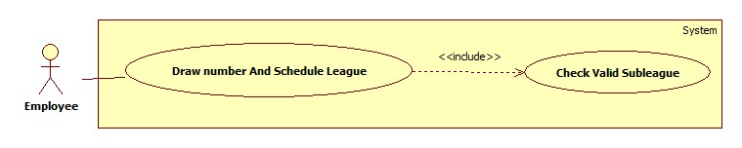

**Figure 24: <Employee> Check Valid Subleague**

**Use Case Specification**

|  |  |  |  |
| --- | --- | --- | --- |
| **USE CASE – MATC022** | | | |
| **Use Case No.** | MATC022 | **Use Case Version** | 1.0 |
| **Use Case Name** | Check Valid Subleague | | |
| **Author** | Nguyễn Duy Nhất | | |
| **Date** | 25/5/2015 | **Priority** | High |
| **Actor:**   * Employee   **Summary:**   * This use case allows employee to check valid subleague before scheduled.   **Goal:**   * Employee can check valid subleague before scheduled.   **Triggers:**   * Employee clicks “Xếp lịch” button on a row of the table in “View Created League List” page.   **Preconditions:**   * User must login with Employee role and account status is active. * The league is managed by the employee who does this usecase. * The league has not been scheduled.   **Post Conditions:**   * **Success:** All subleagues are checked before scheduled. * **Fail:** Show error message. Content of the message will be specified in exception section.   **Main Success Scenario:**   |  |  |  | | --- | --- | --- | | Step | Actor Action | System Response | | 1 | Employee clicks “Xếp lịch” button | Show popup which contain:   * “Số lượng hạng cân dưới 4 VĐV tham gia sẽ bị xóa sau khi tiếp tục”: label * Invalid subleague Table which contain:   + “STT”: label   + “Giới tính”: label   + “Hạng cân”: label   + “Số lượng VĐV”: label * “Tiếp tục” button * “Hủy” button   [Alternative 1, 2]  [Exception 1] | | 2 | Employee clicks “Tiếp tục” button  [Alternative 3] | Delete invalid subleagues from database, and navigate to “Draw number and Schedule League” page.  [Exception 1] |   **Alternative Scenario:**   |  |  |  | | --- | --- | --- | | No | Actor Ation | System Response | | 1 | All subleague is valid | Show popup with contents: “Mọi hạng cân đều hợp lệ!”   * “Tiếp tục” button * “Hủy” button   [Exception 1] | | 2 | There is no valid subleague. | Show popup with contents: “Không tồn tại hạng cân có từ 4 Vận động viên tham gia trở lên. Vui lòng kiểm tra lại!”   * “Hủy” button   [Exception 1] | | 3 | Employee clicks “Hủy” button | Change nothing and close popup. |   **Exceptions:**   |  |  |  | | --- | --- | --- | | No | Actor Action | System Response | | 1 | Connect to database fail | Show message “Đã xảy ra lỗi, xin vui lòng thử lại sau” |   **Relationships:** included from Draw number and Schedule League  **Business Rules:**   * The tournament for each weight division is called by “subleague”. * The valid subleague is the subleague which has participating athlete number is from 4 to 32. * The valid league is the league which has at least 1 valid subleague. * All invalid subleagues are deleted before the league is scheduled. * League is just checked by the employee who manages the league. * Employee can check a league before the league is scheduled. * After checked, “hasChecked” status of the league is changed to “TRUE” in database. | | | |

##### <Employee> Set Priority for Athlete

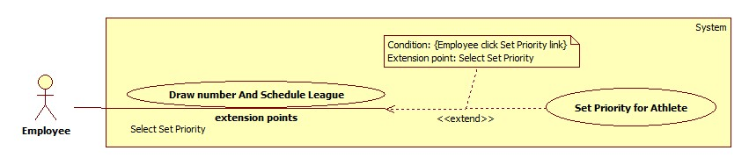

**Figure 25: <Employee> Set Priority for Athlete**

**Use Case Specification**

|  |  |  |  |
| --- | --- | --- | --- |
| **USE CASE – MATC025** | | | |
| **Use Case No.** | MATC025 | **Use Case Version** | 1.0 |
| **Use Case Name** | Set Priority for Athlete | | |
| **Author** | Nguyễn Duy Nhất | | |
| **Date** | 25/5/2015 | **Priority** | High |
| **Actor:**   * Employee   **Summary:**   * This use case allows employee to set priority for athlete of the league with specific weight division   **Goal:**   * Employee can set priority for athlete of the league with specific weight division.   **Triggers:**   * Employee clicks “Thiết lập” link on a row of the table in “Draw number and schedule league” page.   **Preconditions:**   * User must login with Employee role and account status is active. * The league is managed by the employee who does this usecase. * The league has not been scheduled.   **Post Conditions:**   * **Success:** Update new priority information in database. * **Fail:** Show error message. Content of the message will be specified in exception section.   **Main Success Scenario:**   |  |  |  | | --- | --- | --- | | Step | Actor Action | System Response | | 1 | Employee clicks “Thiết lập” link | Navigate to Priority page with information:   * “Giải đấu”: label * “Bộ môn”: label * “Hạng cân”: label * “Giới tính”: label * “Số VĐV tham gia”: label * “Số VĐV tối đa được ưu tiên miễn vòng đầu”: label * List of Athlete who belong the weigh division as table with the follow information:   + “STT”: label   + “CMND”: label   + “Họ tên”: label   + “Ngày sinh”: label   + “Cân nặng”: label   + “Đơn vị”: label   + “Chọn”: checkbox * “Xác nhận” button * “Hủy” button   [Exception 1] | | 2 | Employee ticks checkbox and clicks “Xác nhận” button  [Alternative 1] | Update new priority information in database and return Draw number page.  [Exception 1] |   **Alternative Scenario:**   |  |  |  | | --- | --- | --- | | No | Actor Action | System Response | | 1 | Employee clicks “Hủy” button | Return Draw number and Schedule league page without update priority information. |   **Exceptions:**   |  |  |  | | --- | --- | --- | | No | Actor Action | System Response | | 1 | Connect to database fail | Show message “Đã xảy ra lỗi, xin vui lòng thử lại sau” |   **Relationships:** extended by Draw number and Schedule (Select Set Priority)  **Business Rules:**   * Athlete is just set priority by the employee who manages the league which the athlete participate in. * Employee can set priority for the athlete before the league is scheduled. * Athlete list is sorted by name follow alphabet order. * The athletes who have priority will be exempted from the first round. * The number of checkbox can be ticked is not more than the maximum number of athletes have priority. * The maximum number of athletes have priority depends on the number of athletes who participate in the weight division of the league. * After set priority, status “isPriority” of athlete who has priority will change to “TRUE” in database. * Table records are paginated with ***N*** records per page. (***N*** is get from configure file which is managed by admin) | | | |

##### <Employee> View League Information

Reference Use Case MATC005

##### <Employee> View Play Schedule

Reference Use Case MATC010

##### <Employee> View Play Diagram

Reference Use Case MATC011

##### <Employee> Update Match Information

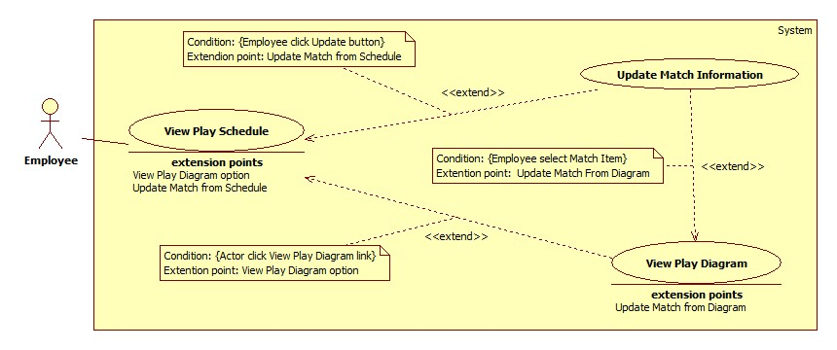

**Figure 26: <Employee> Update Match Information**

**Use Case Specification**

|  |  |  |  |
| --- | --- | --- | --- |
| **USE CASE – MATC027** | | | |
| **Use Case No.** | MATC027 | **Use Case Version** | 1.0 |
| **Use Case Name** | Update Match Information | | |
| **Author** | Nguyễn Duy Nhất | | |
| **Date** | 25/5/2015 | **Priority** | High |
| **Actor:**   * Employee   **Summary:**   * This use case allows Employee to update information of specific match.   **Goal:**   * Employee can update information of specific match.   **Triggers:**   * Employee clicks “Cập nhật” button on Match item in View Schedule page. * Employee clicks on Match item in View Diagram page.   **Preconditions:**   * User must login to system with Employee role and account status is active. * The match belongs to the league which is managed by the employee who does this usecase. * The match has started.   **Post Conditions:**   * **Success:** The match will be updated with new information. * **Fail:** Show error message. Content of the message will be specified in exception section.   **Main Success Scenario:**   |  |  |  | | --- | --- | --- | | Step | Actor Action | System Response | | 1 | Click “Cập nhật” button on Match item in View Schedule page  [Alternative 1] | Show pop-up and get match information in database include the following information:   * “Vòng đấu”: label * “Thời gian diễn ra”: label, format: “hh:mm tt dd/MM/yyyy” * “Vận động viên 1”: label * “SBD VĐV 1”: label * “Hình VĐV 1”: image * “Vận động viên 2”: label * “SBD VĐV 2”: label * “Hình VĐV 2”: image * “Điểm số các hiệp”: textbox * “VĐV thắng”: dropdownlist, required * “Hình thức thắng”: dropdownlist, required, default is “Chưa biết” * “Hình thức khác”: textbox * “Diễn biến, Ghi chú”: textbox, length (MAX), default value: “” * “Xác nhận”: button * “Hủy”: button   [Exception 9] | | 2 | Input information and click “Xác nhận” button.  [Alternative 2] | Update new information into database.  [Exception 1, 2, 3, 4, 5, 6, 7, 8, 9] |   **Alternative Scenario:**   |  |  |  |  | | --- | --- | --- | --- | | No | Step | Actor Action | System Response | | 1 | 1 | Employee clicks on Match item in View Diagram page. | Show pop-up and get match information in database include the following information:   * “Vòng đấu”: label * “Thời gian diễn ra”: label, format: “hh:mm tt dd/MM/yyyy” * “Vận động viên 1”: label * “SBD VĐV 1”: label * “Hình VĐV 1”: image * “Vận động viên 2”: label * “SBD VĐV 2”: label * “Hình VĐV 2”: image * “Điểm số các hiệp”: textbox * “VĐV thắng”: dropdownlist, required * “Hình thức thắng”: dropdownlist, required, default is “Chưa biết” * “Hình thức khác”: textbox * “Diễn biến, Ghi chú”: textbox, length (MAX), default value: “” * “Xác nhận”: button * “Hủy”: button   [Exception 9] | | 2 | Input information and click “Xác nhận” button.  [Alternative 2] | Update new information into database.  [Exception 1, 2, 3, 4, 5, 6, 7, 8, 9] | | 2 | 1 | Click “Hủy” button | Close pop-up and change nothing |   **Exceptions:**   |  |  |  | | --- | --- | --- | | No | Actor Action | System Response | | 1 | Employee enters score of matches discontinuously. | Show message “Tỉ số các hiệp không được ngắt quãng!” | | 2 | Employee enters score of a match incompletely. | Show message “Tỉ số trong một hiệp không đầy đủ!” | | 3 | Employee chooses “Thắng điểm” winning reason and enters score of matches incompletely. | Show message “Với hình thức thắng 'Thắng điểm', tỉ số các hiệp không được để trống!” | | 4 | Employee chooses “Thắng điểm” winning reason and result points of 2 athletes are equal. | Show message “Kết quả chung cuộc không phù hợp với Hình thức thắng này!” | | 5 | Employee chooses “Bằng điểm, trọng tài quyết định” winning reason and enters score of matches incompletely. | Show message “Với hình thức thắng 'Bằng điểm, trọng tài quyết định”, tỉ số các hiệp không được để trống!” | | 6 | Employee chooses “Bằng điểm, trọng tài quyết định” winning reason and result points of 2 athletes are not equal. | Show message “Kết quả chung cuộc không phù hợp với Hình thức thắng này!” | | 7 | Employee chooses winning reason which is not default reason, and doesn’t choose winner. | Show message “Khi đã chọn Hình thức thắng, Vận động viên thắng không được để trống!” | | 8 | Employee chooses winning reason which is “Hình thức thắng khác”, and lefts “Hình thức khác” textbox blank. | Show message “Vui lòng nhập dữ liệu vào trường 'Hình thức khác'!” | | 9 | Connect to database fail | Show message “Đã xảy ra lỗi, xin vui lòng thử lại” |   **Relationships:** extended by View Play Schedule (Update match from Schedule), extended by View Play Schedule (Update match from Diagram)  **Business Rules:**   * Match is just updated by the employee who manages league containing the match. * Employee can update match result after the match has stared. * To update a match which is not belong to the first round of league, employee must update fully result of reference matches that are belong before round. For example, to update Final match, employee must update fully result of two Semi-finals matches. * After the match is updated, “isUpdated” status of the match is changed to TRUE and employee cannot update 2 reference matches which belong to the before round. * The winner will participate in the match which belongs to next round. If league has the third place match, the losers of semi-finals matches will participate in the third place match. * If athletes cheating, they will be eliminated, the competitor will win, the matches of previous rounds, which did not discover, result will not change. | | | |

##### <Employee> View Organizers Contact

Reference Use Case MATC006

##### <Employee> View Result

Reference Use Case MATC007

##### <Employee> View Athlete List in League

Reference Use Case MATC013

##### <Employee> Add Athlete into League

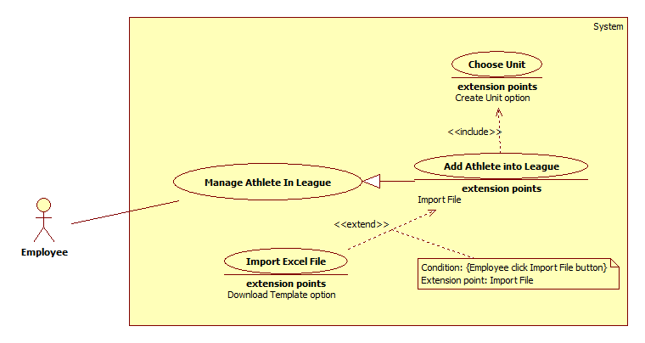

**Figure 27: <Employee> Add Athlete into League use case diagram**

**Use Case Specification**

|  |  |  |  |
| --- | --- | --- | --- |
| **USE CASE – MATC031** | | | |
| **Use Case No.** | MATC031 | **Use Case Version** | 2.0 |
| **Use Case Name** | Add Athlete into League | | |
| **Author** | Pham Hoang Truc Vy | | |
| **Date** | 3/6/2015 | **Priority** | Hight |
| **Actor:**   * Employee   **Summary:**   * This use case allows Employee add an Athlete into league.   **Goal:**   * Add new athlete into the league.   **Triggers:**   * Employee clicks “Thêm vận động viên” link on View Athlete in League page.   **Preconditions:**   * User login with role Employee and this account must be active. * League was created by the employee who does this usecase. * The league has not been scheduled.   **Post Conditions:**   * **Success:** Athlete will be added into league. * **Fail:** No new athlete will be added. Show error message.   **Main Success Scenario:**   |  |  |  | | --- | --- | --- | | Step | Actor Action | System Response | | 1 | Employee clicks “Thêm vận động viên” link on View Athlete in League page. | Navigate to Add Athlete into League page which contains:   1. “Nhập thông thường” tab  * “CMND”: text box, length: 9, only integer input, required. * “Họ tên”: text box, min length: 2, max length: 50, required. * “Ngày sinh”: datepicker * “Giới tinh”: radio button includes “Nam” and “Nữ”, required. * “Đơn vị”: text box, read only, required. * “Tra cứu”: link * “Cân nặng”: text box, only number input, unit: kg, min: min weight of the lightest weight division plus 0.3, max: max weight of the heaviest weight division plus 0.3, required. * “Hình dại diện”: “Chọn” button. * “Thêm”: button * “Xóa trắng”: button  1. “Thêm bằng file excel” tab 2. “Quản lý vđv” link | | 2 | Employee inputs data and clicks “Thêm” button  [Alternative 1] | * Athlete will be added to league. * Show message: “Bạn đã thêm vận động viên thành công!”   [Exception 1, 2, 3, 4, 5, 6, 7, 8, 9, 10, 11, 12] |   **Alternative Scenario:**   |  |  |  | | --- | --- | --- | | No | Actor Action | System Response | | 1 | Employee clicks “Xóa trắng” button. | Clear all data input. |   **Exceptions:**   |  |  |  | | --- | --- | --- | | No | Actor Action | System Response | | 1 | Employee was not choose unit | Show message error: “Bạn chưa chọn đơn vị cho vận động viên”. | | 2 | ID less than 9 characters. | Show message error: “Không đủ 9 ký tự”. | | 3 | Length of fullname is not in range. | Show message error: “Vui lòng nhập từ 2 đến 50 ký tự, bao gồm khoảng trắng” | | 4 | If athlete’s age is under 18 or over 40 years old. | Show message error: “Không nằm trong độ tuổi quy định. (18 - 40 tuổi)”. | | 5 | Date of birth was not entered | Show error message: “Bạn chưa nhập ngày sinh.” | | 6 | Gender was not choose | Show error message: “Chưa chọn giới tính”. | | 7 | Weight was not entered | Show error message: “Bạn chưa nhập cân nặng của vận động viên.” | | 8 | Weight is not in range | Show error message: “Cân nặng đăng kí chỉ được từ [min weight] đến dưới [max weight].” | | 9 | Weight is not in weight division list | Show error message: “Cân nặng không nằm trong hạng cân đăng kí.” | | 10 | Unit was entered has 2 athletes in that weight division. | Show error message: “Mỗi đơn vị chỉ được có tối đa 2 vđv trong 1 hạng cân.” | | 11 | That weight division has 32 athletes. | Show error message: “Hạng cân đã đủ 32 vđv.” | | 12 | Cannot add athlte to league | Show error message: “Đã xảy ra lỗi. Vui lòng thử lại sau”. |   **Relationships:**   * Extends to Import File Excel (Employee click Import File button). * Includes Choose Unit.   **Business Rules:**   * If Athlete has already existed, fullname, date of birth, gender and avatar will be show and disable. Else, system will create new athlete and add to League. * Avatar image will be saved with image name is athlete ID. * Each weight division in league must contain at least 4 Athletes and max is 32 Athletes. * In each weight division, each unit has maximum 2 athletes participate. * Each weight division has at least 2 Units participate. * Athlete must over 18 years old and below 40 years old. * Athlete will be added to suitable weight division in league with min weight of weight division plus 0.3 and max weight of weight division plus 0.3.   Example: With weight division 45 – 48 kg, athlete has weight 48 kg will be arranged to this weight division. But athlete has weight 48.3 kg will be arranged to next weight division 48 – 51 kg.   * New athlete in league will have rank is 0. | | | |
|  | | | |

##### <Employee> Update Athlete in League

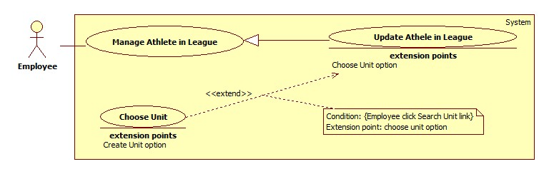

**Figure 28: <Employee> Update Athlete in League**

**Use Case Specification**

|  |  |  |  |
| --- | --- | --- | --- |
| **USE CASE – MATC032** | | | |
| **Use Case No.** | MATC032 | **Use Case Version** | 1.0 |
| **Use Case Name** | Update Athlete in League | | |
| **Author** | Nguyễn Duy Nhất | | |
| **Date** | 25/05/2015 | **Priority** | Hight |
| **Actor:**   * Employee   **Summary:**   * This use case allows Employee update Athlete’s profile in League.   **Goal:**   * Employee can update Athlete’s profile in league.   **Triggers:**   * Employee clicks “Cập Nhật” button on row of athlete table in “View Athlete List in League” page.   **Preconditions:**   * User must login to system with Employee role and account status is active. * The league is managed by the employee who does this usecase. * The league has not been scheduled.   **Post Conditions:**   * **Success:** Athlete’s information is updated. * **Fail:** Nothing changes. Show message error with specified content in exception section.   **Main Success Scenario:**   |  |  |  | | --- | --- | --- | | Step | Actor Action | System Response | | 1 | Employee clicks “Cập Nhật” button. | Navigate to Update Athlete in League page which contains:   * “CMND”: label * “Họ Tên”: label * “Ngày Sinh”: label * “Giới tính”: label * “Hình ảnh”: image * “Đơn vị”: text box, read only, required. * “Tra cứu”: link * “Cân nặng”: text box, only number input, unit: kg, min: min weight of the lightest weight division plus 0.3, max: max weight of the heaviest weight division plus 0.3, required. * “Cập Nhật”: button. * “Huỷ”: button.   [Exception 6] | | 2 | Input information and click “Xác nhận” button. [Alternative 1] | Update in database, show successful message: “Cập nhật thành công” and return View Athlete in League page.  [Exception 1, 2, 3, 4, 5, 6] |   **Alternative Scenario:**   |  |  |  | | --- | --- | --- | | No | Actor Action | System Response | | 1 | Employee clicks “Huỷ” button. | Change nothing and return View Athlete in League page. |   **Exceptions:**   |  |  |  | | --- | --- | --- | | No | Actor Action | System Response | | 1 | Weight was not entered | Show error message: “Bạn chưa nhập cân nặng của vận động viên.” | | 2 | Weight is not in range | Show error message: “Cân nặng đăng kí chỉ được từ [min weight] đến dưới [max weight].” | | 3 | Weight is not in weight division list | Show error message: “Cân nặng không nằm trong hạng cân đăng kí.” | | 4 | Unit was entered has 2 athletes in that weight division. | Show error message: “Mỗi đơn vị chỉ được có tối đa 2 vđv trong 1 hạng cân.” | | 5 | That weight division has 32 athletes. | Show error message: “Hạng cân đã đủ 32 vđv.” | | 6 | Connect to server is failed. | Show error message:” Đã xảy ra lỗi, vui lòng thử lại sau”. |   **Relationships:** Extends to Choose Unit (choose unit option)  **Business Rules:**   * Athlete just has been updated by the employee who manages league which the athlete participates in. * Employee has just been able to update weight and unit of the athlete only. * Employee can update the athlete information before the league is scheduled. * Each weight division in league must contain at least 4 Athletes and max is 32 Athletes. * In each weight division, each unit has maximum 2 athletes participate. * Each weight division has at least 2 Units participate. * Athlete will be added to suitable weight division in league with min weight of weight division plus 0.3 and max weight of weight division plus 0.3.   Example: With weight division 45 – 48 kg, athlete has weight 48 kg will be arranged to this weight division. But athlete has weight 48.3 kg will be arranged to next weight division 48 – 51 kg.   * If weight and unit are valid, “Cập nhật” button is visible. Otherwise, it is hidden. | | | |

##### <Employee> Delete Athlete from League

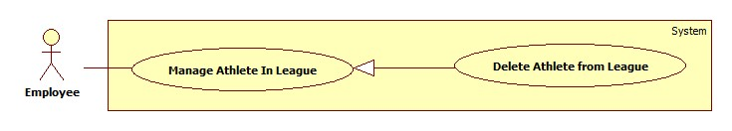

**Figure 29: <Employee> Delete Athlete from League**

**Use Case Specification**

|  |  |  |  |
| --- | --- | --- | --- |
| **USE CASE – MATC033** | | | |
| **Use Case No.** | MATC033 | **Use Case Version** | 1.0 |
| **Use Case Name** | Delete Athlete From League | | |
| **Author** | Nguyễn Duy Nhất | | |
| **Date** | 25/05/2015 | **Priority** | Hight |
| **Actor:**   * Employee   **Summary:**   * This use case allows employee to delete Athlete from league.   **Goal:**   * Employee can delete athlete from the league.   **Triggers:**   * Employee clicks “Xóa” button on row of athlete table in “View Athlete List in League” page.   **Preconditions:**   * User must login to system with Employee role and account status is active. * The league is managed by the employee who does this usecase. * The league has not been scheduled.   **Post Conditions:**   * **Success:** Athlete is removed from league. * **Fail:** Nothing changes. Show message error with specified content in exception section.   **Main Success Scenario:**   |  |  |  | | --- | --- | --- | | Step | Actor Action | System Response | | 1 | Employee clicks “Xóa” button | Show confirm message box with content: “Bạn chắn chắn muốn xóa Vận động viên này?” | | 2 | Employee clicks “Có” button  [Alternative 1] | Delete athlete from league and return “View Athlete List in League” page.  [Exception 1] |   **Alternative Scenario:**   |  |  |  | | --- | --- | --- | | No | Actor Action | System Response | | 1 | Employee clicks “Không” button. | Change nothing, message box is closed. |   **Exceptions:** N/A   |  |  |  | | --- | --- | --- | | No | Actor Action | System Response | | 1 | Connect to database fail | Show message “Đã xảy ra lỗi, xin vui lòng thử lại sau” |   **Relationships:** N/A  **Business Rules:**   * Athlete is just deleted by the employee who manages league which the athlete participates in. * Employee can delete the athlete from league before the league is scheduled. | | | |

##### <Employee> Export Excel File

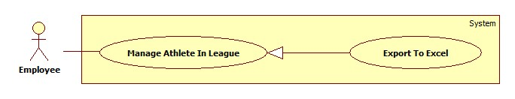

**Figure 30: <Employee> Export Excel File**

**Use Case Specification**

|  |  |  |  |
| --- | --- | --- | --- |
| **USE CASE – MATC034** | | | |
| **Use Case No.** | MATC034 | **Use Case Version** | 1.0 |
| **Use Case Name** | Export Excel File | | |
| **Author** | Nguyễn Duy Nhất | | |
| **Date** | 25/05/2015 | **Priority** | Normal |
| **Actor:**   * Employee   **Summary:**   * This use case allows employee to export athlete list in league to excel file (.xls) and download to computer.   **Goal:**   * Employee can export athlete list in league to excel file (.xls) and download to computer.   **Triggers:**   * Employee clicks “Tải danh sách” link on “View Athelte in League” page.   **Preconditions:**   * User must login to system with Employee role and account status is active. * The league is managed by the employee who does this usecase.   **Post Conditions:**   * **Success:** Athletes file is downloaded to computer. * **Fail:** No file is downloaded. Show message error with specified content in exception section.   **Main Success Scenario:**   |  |  |  | | --- | --- | --- | | Step | Actor Action | System Response | | 1 | Employee clicks “Tải danh sách” link. | Browser show file is on download progress. [Exception 1] |   **Alternative Scenario:** N/A  **Exceptions:**   |  |  |  | | --- | --- | --- | | No | Actor Action | System Response | | 1 | Connect to server is failed. | Brower shows error: “Đã xảy ra lỗi, xin vui lòng thử lại sau”. |   **Relationships:** N/A  **Business Rules:**   * The excel file has extension is .xls (Microsoft Office 2003). * Format of file name is: “Danh sách VĐV ” + league name + “.xls”. * Each weight division will be placed as a sheet in excel file. * Weight divisions are sorted alternately from male to female, from low weight division to high weight division. In each weight division, athletes are sorted in ascending order of no number. * Structure of excel file: | | | |
|  | | | |

##### <Employee> Import Excel File

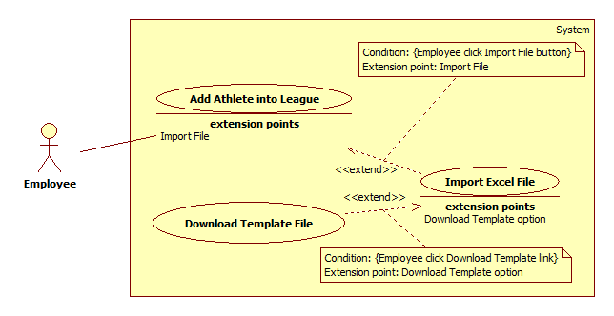

**Figure 31: <Employee> Import Excel File use case diagram**

**Use Case Specification**

|  |  |  |  |
| --- | --- | --- | --- |
| **USE CASE – MATC037** | | | |
| **Use Case No.** | MATC037 | **Use Case Version** | 2.0 |
| **Use Case Name** | Import Excel File | | |
| **Author** | Pham Hoang Truc Vy | | |
| **Date** | 3/6/2015 | **Priority** | Hight |
| **Actor:**   * Employee   **Summary:**   * This use case allows Employee to upload athlete information by excel file.   **Goal:**   * Add one or many athletes by excel into a league.   **Triggers:**   * Employee clicks “Thêm bằng file excel” tab on Menu of Add Athlete into League page.   **Preconditions:**   * User login with role Employee and account must be active. * League was created by the employee who does this usecase. * The league has not been scheduled.   **Post Conditions:**   * **Success:** New athletes will be added to league. * **Fail:** No athlete will be added. Show error message.   **Main Success Scenario:**   |  |  |  | | --- | --- | --- | | Step | Actor Action | System Response | | 1 | Employee clicks “Thêm bằng file excel” tab on Menu of Add Athlete into League page. | Show tab “Thêm bằng file excel” which contains:   * “Tải file mẫu”: link * “Tìm file”: button * File name: text box, readonly * “Lưu”: button | | 2 | Employee clicks “Tìm file” button and select a file. | Show file name in file name text field. | | 3 | Employee clicks “Lưu” button. | * Add athletes into league * Show message: “Bạn đã thêm vận động viên thành công!”   [Exception 1, 2, 3, 4, 5, 6, 7, 8, 9, 10, 11, 12, 13, 14, 15, 16, 17, 18, 19, 20, 21, 22, 23, 24, 25] |   **Alternative Scenario:** N/A  **Exceptions:**   |  |  |  | | --- | --- | --- | | No | Actor Action | System Response | | 1 | File extension is different from .xls and .xlsx | Show error message: “File vừa upload không đúng định dạng. (Chỉ upload file .xls hoặc .xlsx)”. | | 2 | ID was not entered. | Show error message: “Hàng […]: Chưa nhập CMND”. | | 3 | ID length is less than or more than 9. | Show error message: “Hàng […]: Số CMND […] không đúng. (CMND gồm 9 chữ số!)”. | | 4 | ID is not number | Show error message: “Hàng […]: Số CMND […] không đúng. (CMND gồm 9 chữ số!)”. | | 5 | Full name was not entered | Show error message: “Hàng […]: Chưa nhập tên VĐV”. | | 6 | Full name length is less than 2 or more than 50 | Show error message: “Hàng […]: Họ tên […] không hợp lệ. (Họ tên gồm 2 - 50 kí tự!)”. | | 7 | Gender was not entered | Show error message: “Hàng […]: Chưa nhập giới tính”. | | 8 | Gender is not “Nam” or “Nữ” | Show error message: “Hàng […]: Giới tính […] không hợp lệ. (Giới tính gồm Nam hoặc Nữ!)”. | | 9 | Date of birth was not entered | Show error message: “Hàng […]: Chưa nhập ngày sinh.” | | 10 | Athlete age is less than 18 years old or more than 40 years old. | Show error message: “Hàng […]: VĐV không nằm trong độ tuổi quy định. (18 - 40 tuổi).” | | 11 | Date of birth is not match date format (dd/MM/yyyy) | Show error message: “Hàng […]: Ngày sinh […] không đúng” | | 12 | Weight was not entered | Show error message: “Hàng […]: Chưa nhập cân nặng.” | | 13 | Weight is less than min weight of the lightest weight division plus 0.3 or more than the heaviest weight division plus 0.3 | Show error message: “Hàng […]: Cân nặng […] không nằm trong hạng cân đăng kí.” | | 14 | Weight is not sui table with any weight division in league | Show error message: “Hàng […]: Cân nặng […] không nằm trong hạng cân đăng kí.” | | 15 | Suitable weight division of weight was entered has 32 athletes | Show error message: “Hàng […]: Hạng cân đã đủ 32 vđv.” | | 16 | Weight is not number | Show error message: “Hàng […]: Cân nặng […] không đúng.” | | 17 | Unit was not entered | Show error message: “Hàng […]: Chưa nhập tên đơn vị.” | | 18 | City of unit was not entered | Show error message: “Hàng […]: Chưa nhập đơn vị thuộc Tỉnh/TP nào.” | | 19 | City is not in Viet Nam city list | Show error message: “Hàng […]: Tỉnh/TP […] không đúng.” | | 20 | If league is held for only one city and district was not entered | Show error message: “Hàng […]: Chưa nhập đơn vị thuộc Quận/Huyện nào.” | | 21 | District is not in district list of city | Show error message: “Hàng […]: Quận/Huyện […] không thuộc [city name].” | | 22 | Unit does not exist in city and district | Show error message: “Hàng […]: Đơn vị […] chưa tồn tại. Vui lòng thêm đơn vị trước khi upload file.” | | 23 | Unit has 2 athletes in this athlete suitable weight division | Show error message: “Hàng […]: Mỗi đơn vị chỉ được có tối đa 2 vđv trong 1 hạng cân.” | | 24 | File was not chosen | Show error message: “Bạn chưa chọn file.” | | 25 | Cannot add athletes to league | Show error message: “Đã xảy ra lỗi. Vui lòng thử lại sau”. |   **Relationships:**   * Extended by Add Athlete into League (Employee click Import File button). * Extends to Download Template File (Employee click Download Template link).   **Business Rules:**   * The system only accepts excel file. * All of the errors in the excel file will be showed for employee correcting file. * If Athlete does not exist, system will create new athlete and add to League. * If athlete registed, system will update athlete weight and unit. * Each weight division in league must contain at least 4 Athletes and max is 32 Athletes. * In each weight division, each unit has maximum 2 athletes participate. * Each weight division has at least 2 Units participate. * Athlete must over 18 years old and below 40 years old. * If unit does not exist in city and district was entered, employee have to add new unit before upload file. * Athlete will be added to suitable weight division in league with min weight of weight division plus 0.3 and max weight of weight division plus 0.3.   Example: With weight division 45 – 48 kg, athlete has weight 48 kg will be arranged to this weight division. But athlete has weight 48.3 kg will be arranged to next weight division 48 – 51 kg. | | | |
|  | | | |

##### <Employee> Choose Unit



**Figure 32: <Employee> Choose unit use case diagram**

**Use Case Specification**

|  |  |  |  |
| --- | --- | --- | --- |
| **USE CASE – MATC036** | | | |
| **Use Case No.** | MATC036 | **Use Case Version** | 2.0 |
| **Use Case Name** | Choose unit | | |
| **Author** | Pham Hoang Truc Vy | | |
| **Date** | 3/6/2015 | **Priority** | Hight |
| **Actor:**   * Employee   **Summary:**   * This use case allows Employee choose a unit for an Athlete when add athlete to league.   **Goal:**   * Choose unit for employee.   **Triggers:**   * Employee clicks “Tra cứu” link on Add Athlete into League page.   **Preconditions:**   * User login with role Employee and this account must be active. * League was created by the employee who does this usecase. * The league has not been scheduled.   **Post Conditions:**   * **Success:** Unit name will be showed on unit name field of Add athlete to league page. * **Fail:** No unit will be showed. Show error message.   **Main Success Scenario:**   |  |  |  | | --- | --- | --- | | Step | Actor Action | System Response | | 1 | Employee clicks “Tra cứu” link on Add Athlete into League page. | Show “Tra cứu đơn vị” popup which contains:   * “Tỉnh/Thành phố”: drop down list, raw source from City table in database. * “Quận/Huyện”: drop down list, raw source from District table in database. * Unit table includes check box for each unit name. * “Thêm đơn vị”: button * “Chọn”: button * “Đóng”: button | | 2 | Employee select city and district  [Alternative 1] | Show list of unit on unit table.  [Exception 1] | | 3 | Employee selects a unit and click “Chọn” button | Show unit name on “Đơn vị” text field of Add athlete into league page. |   **Alternative Scenario:**   |  |  |  | | --- | --- | --- | | No | Actor Action | System Response | | 1 | There aren’t any units in city and district employee chose | Show message: “Chưa có đơn vị”. |   **Exceptions:**   |  |  |  | | --- | --- | --- | | No | Actor Action | System Response | | 1 | Cannot show list of unit | Show error message: “Đã xảy ra lỗi. Vui lòng thử lại sau”. |   **Relationships:** Extends to Create Unit (Employee click Create Unit Button)  **Business Rules:**   * If league is held for only one city, “Tỉnh/Thành phố” drop down list will change to read only text box with city name of league. * “Quận/Huyện” drop down list depends on city. | | | |
|  | | | |

##### <Employee> Create Unit

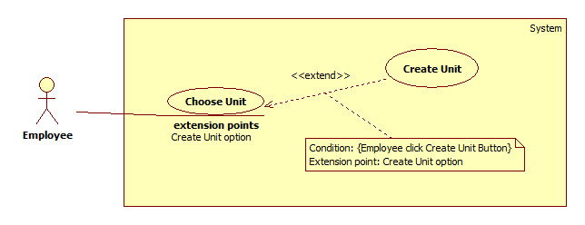

**Figure 33: <Employee> Create Unit use case diagram**

**Use Case Specification**

|  |  |  |  |
| --- | --- | --- | --- |
| **USE CASE – MATC037** | | | |
| **Use Case No.** | MATC037 | **Use Case Version** | 2.0 |
| **Use Case Name** | Create Unit | | |
| **Author** | Pham Hoang Truc Vy | | |
| **Date** | 3/6/2015 | **Priority** | Hight |
| **Actor:**   * Employee   **Summary:**   * Employee creates new Unit if it doesn’t exist in city and district was chosen for adding athlete into league.   **Goal:**   * Create new Unit.   **Triggers:**   * Employee clicks “Thêm đơn vị” button on “Tra cứu đơn vị” pop up of Add athlete into league page.   **Preconditions:**   * User login with role Employee and account must be active.   **Post Conditions:**   * **Success:** New Unit will be added to database. * **Fail:** No Unit will be added. Show error message.   **Main Success Scenario:**   |  |  |  | | --- | --- | --- | | Step | Actor Action | System Response | | 1 | Employee clicks “Thêm đơn vị” button on “Tra cứu đơn vị” pop up of Add athlete into league page. | Show “Thêm đơn vị” pop up which contains:   * “Tỉnh/Thành phố”: text box, read only * “Quận/ Huyện”: text box, read only. * “Tên đơn vị”: text box, min length: 5, max length: 50, required. * “Thêm”: button * “Đóng”: button | |  | Employee fills the form and clicks “Thêm” button.  [Alternative 1] | Insert new Unit to database and show result in unit table of “Tra cứu đơn vị” pop up.  [Exception 1, 2, 3] |   **Alternative Scenario:**   |  |  |  | | --- | --- | --- | | No | Actor Action | System Response | | 1 | Employee clicks “Đóng” button. | Close “Thêm đơn vị” pop up |   **Exceptions:**   |  |  |  | | --- | --- | --- | | No | Actor Action | System Response | | 1 | Length of “Tên Đơn Vị” is not in range. | Show message error: “Vui lòng nhập từ 5-50 ký tự bao gồm khoảng trắng”. | | 2 | Name of unit has been existed in the district and city. | Show message error: “Tên đơn vị đã tồn tại ở khu vực này. Vui lòng kiểm tra lại” | | 3 | Cannot add new unit | Show error message: “Đã xảy ra lỗi. Vui lòng thử lại sau”. |   **Relationships:**   * Extended by Choose Unit (Employee click Create Unit Button).   **Business Rules:**   * Each unit in a disctrict has unique name. * Values of “Tỉnh/Thành phố” text field and “Quận/Huyện” text field are gotten from city and district employee chose on “Tra cứu đơn vị” pop up. * Unit can belong to a district or a city. | | | |
|  | | | |

##### <Employee> Download Template File

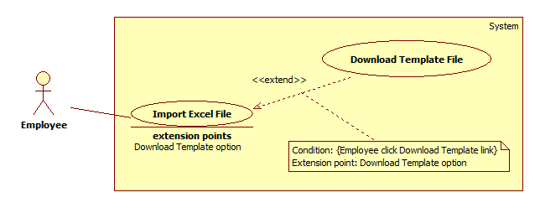

**Figure 34: <Employee> Download Template File use case diagram**

**Use Case Specification**

|  |  |  |  |
| --- | --- | --- | --- |
| **USE CASE – MATC038** | | | |
| **Use Case No.** | MATC038 | **Use Case Version** | 2.0 |
| **Use Case Name** | Download Template File | | |
| **Author** | Pham Hoang Truc Vy | | |
| **Date** | 3/6/2015 | **Priority** | Hight |
| **Actor:**   * Employee   **Summary:**   * This use case allows Employee download template file for importing excel file.   **Goal:**   * Employee download template file.   **Triggers:**   * Employee clicks “Tải file mẫu” link on “Thêm bằng file excel” tab of Add Athlete into League page.   **Preconditions:**   * User login with role Employee and account must be active.   **Post Conditions:**   * **Success:** File template will be downloaded. * **Fail:** No file will be downloaded. Show error message.   **Main Success Scenario:**   |  |  |  | | --- | --- | --- | | Step | Actor Action | System Response | | 1 | Employee clicks “Tải file mẫu” link on “Thêm bằng file excel” tab of Add Athlete into League page. | File excel template will be downloaded.  [Exception 1] |   **Alternative Scenario:** N/A  **Exceptions:**   |  |  |  | | --- | --- | --- | | No | Actor Action | System Response | | 1 | Cannot download file template | Show error message: “Đã xảy ra lỗi. Vui lòng thử lại sau”. |   **Relationships:**   * Extended by Import Excel File (Employee click Download Template link).   **Business Rules:**   * Template has following columns: * “CMND”: format: text * “Họ tên” * “Giới tính”: value includes: “Nam” and “Nữ” * “Ngày sinh”: format: dd/MM/yyyy * “Cân nặng (kg)”: format: number * “Đơn vị” * “Đơn vị thuộc Tỉnh/TP” * “Đơn vị thuộc Quận/Huyện (nếu có)” | | | |
|  | | | |

##### <Employee> Add Image

Use Case Diagram

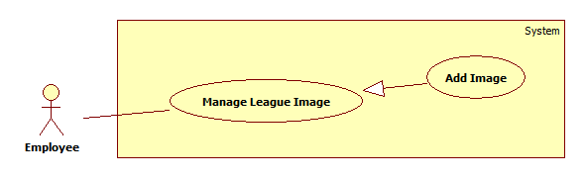

Figure 35: <Employee> Add Image use case diagram

Use Case Specification

|  |  |  |  |
| --- | --- | --- | --- |
| **USE CASE – MATC039** | | | |
| **Use Case No.** | MATC039 | **Use Case Version** | 1.0 |
| **Use Case Name** | Add Image | | |
| **Author** | Pham Hoang Truc Vy | | |
| **Date** | 3/6/2015 | **Priority** | Normal |
| **Actor:**   * Employee   **Summary:**   * This use case allows employees to add image.   **Goal:**   * Insert new images.   **Triggers:**   * Employee clicks “Thêm hình ảnh” button on Manage Image page.   **Preconditions:**   * User login to system with role employee and that account must be active. * League was created by the employee who does this usecase. * League started.   **Post Conditions:**   * **Success:** New images will be inserted to database. * **Fail:** No image will be inserted to database, show error message.   **Main Success Scenario:**   |  |  |  | | --- | --- | --- | | Step | Actor Action | System Response | | 1 | Employee clicks “Thêm hình ảnh” button on Manage Image page | Show popup which contains:   * Browse: button * “Lưu”: button * “Hủy”: button | | 2 | Employee clicks “Browse” button and select one or many images | * Show preview images. * Delete: button for each image. * Remove: button | | 3 | Employee clicks “Lưu” button  [Alternative 1, 2, 3] | Inserted new images to database  [Exception 1] |   **Alternative Scenario:**   |  |  |  | | --- | --- | --- | | No | Actor Action | System Response | | 1 | Employee clicks “Hủy” button | No image will be inserted, popup will be closed | | 2 | Employee clicks “Remov” button | Remove all images was selected. | | 3 | Employee clicks delete button | Delete one image. |   **Exceptions:**   |  |  |  | | --- | --- | --- | | No | Actor Action | System Response | | 1 | Cannot insert image to database | Show error message: “Đã xảy ra lỗi. Vui lòng thử lại sau”. |   **Relationships:** N/A  **Business Rules:**   * Image will be saved in folder has name is league ID. * If image name is existed, image name will be appended “(*count*)”, with *count* begin from 1. | | | |

##### <Employee> Update Image

Use Case Diagram

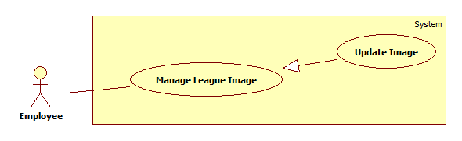

Figure 36: <Employee> Update Image use case diagram

Use Case Specification

|  |  |  |  |
| --- | --- | --- | --- |
| **USE CASE – MATC040** | | | |
| **Use Case No.** | MATC040 | **Use Case Version** | 1.0 |
| **Use Case Name** | Update Image | | |
| **Author** | Pham Hoang Truc Vy | | |
| **Date** | 3/6/2015 | **Priority** | Normal |
| **Actor:**   * Employee   **Summary:**   * This use case allows employees to edit image description.   **Goal:**   * Edit image description.   **Triggers:**   * Employee clicks on image on Manage Image page.   **Preconditions:**   * User login to system with role employee and that account must be active. * League was created by the employee who does this usecase. * League started.   **Post Conditions:**   * **Success:** Image description will be updated. * **Fail:** Nothing will be updated, show error message.   **Main Success Scenario:**   |  |  |  | | --- | --- | --- | | Step | Actor Action | System Response | | 1 | Employee clicks on image on Manage Image page | Show popup which contains:   * That image * “Chú thích”: text area * “Lưu”: button * “Hủy”: button | | 2 | Employee enters decription and clicks “Lưu” button.  [Alternative 1] | New description will be updated to database.  [Exception 1] |   **Alternative Scenario:**   |  |  |  | | --- | --- | --- | | No | Ator Action | System Response | | 1 | Employee clicks “Hủy” button | Nothing will be updated, popup will be closed |   **Exceptions:**   |  |  |  | | --- | --- | --- | | No | Actor Action | System Response | | 1 | Cannot update image description to database | Show error message: “Đã xảy ra lỗi. Vui lòng thử lại sau”. |   **Relationships:** N/A  **Business Rules:** N/A | | | |

##### <Employee> View Image

Reference Use Case MATC008

##### <Employee> Add Video

Use Case Diagram

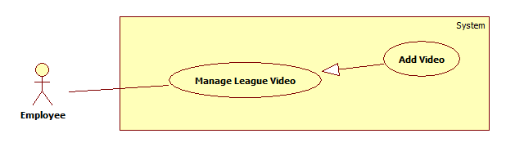

Figure 37: <Employee> Add Video use case diagram

Use Case Specification

|  |  |  |  |
| --- | --- | --- | --- |
| **USE CASE – MATC042** | | | |
| **Use Case No.** | MATC042 | **Use Case Version** | 1.0 |
| **Use Case Name** | Add Video | | |
| **Author** | Pham Hoang Truc Vy | | |
| **Date** | 3/6/2015 | **Priority** | Normal |
| **Actor:**   * Employee   **Summary:**   * This use case allows employees to add video.   **Goal:**   * Insert new video.   **Triggers:**   * Employee clicks “Thêm video” button on Manage Video page.   **Preconditions:**   * User login to system with role employee and that account must be active. * League was created by the employee who does this usecase. * League started.   **Post Conditions:**   * **Success:** New video will be inserted to database. * **Fail:** No video will be inserted to database, show error message.   **Main Success Scenario:**   |  |  |  | | --- | --- | --- | | Step | Actor Action | System Response | | 1 | Employee clicks “Thêm video” button on Manage Video page | Show popup which contains:   * “Link”: text area * “Chú thích”: text area * “Lưu”: button * “Hủy”: button | | 2 | Employee input data and clicks “Lưu” button  [Alternative 1] | Insert new video to database  [Exception 1] |   **Alternative Scenario:**   |  |  |  | | --- | --- | --- | | No | Actor Action | System Response | | 1 | Employee clicks “Hủy” button | No video will be inserted, popup will be closed |   **Exceptions:**   |  |  |  | | --- | --- | --- | | No | Actor Action | System Response | | 1 | Cannot insert video to database | Show error message: “Đã xảy ra lỗi. Vui lòng thử lại sau”. |   **Relationships:** N/A  **Business Rules:**   * If “Link” field was not entered, “Lưu” button will disable. * Link of video have to get from youtube. | | | |

##### <Employee> Update Video

Use Case Diagram

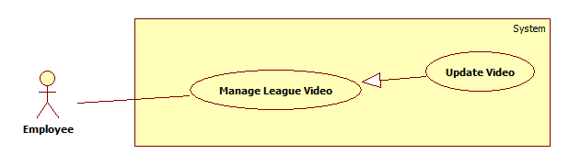

Figure 38: <Employee> Update Video use case diagram

Use Case Specification

|  |  |  |  |
| --- | --- | --- | --- |
| **USE CASE – MATC043** | | | |
| **Use Case No.** | MATC043 | **Use Case Version** | 1.0 |
| **Use Case Name** | Update Video | | |
| **Author** | Pham Hoang Truc Vy | | |
| **Date** | 3/6/2015 | **Priority** | Normal |
| **Actor:**   * Employee   **Summary:**   * This use case allows employees to edit video description.   **Goal:**   * Edit video description.   **Triggers:**   * Employee clicks “Chỉnh sửa” button on Manage Video page.   **Preconditions:**   * User login to system with role employee and that account must be active. * League was created by the employee who does this usecase. * League started.   **Post Conditions:**   * **Success:** Video description will be updated. * **Fail:** Nothing will be updated, show error message.   **Main Success Scenario:**   |  |  |  | | --- | --- | --- | | Step | Actor Action | System Response | | 1 | Employee clicks on “Chỉnh sửa” button on Manage Video page | * Description field will change to text box. * “Chỉnh sửa” button will change to “Lưu” button. | | 2 | Employee enters decription and clicks “Lưu” button. | New description will be updated to database.  [Exception 1] |   **Alternative Scenario:** N/A  **Exceptions:**   |  |  |  | | --- | --- | --- | | No | Actor Action | System Response | | 1 | Cannot update video description to database | Show error message: “Đã xảy ra lỗi. Vui lòng thử lại au”. |   **Relationships:** N/A  **Business Rules:** N/A | | | |

##### <Employee> View Video

Reference Use Case MATC009

#### <Admin> Overview Use Case

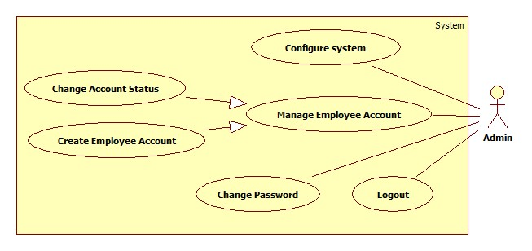

Figure 39: <Guest> Overview Use Case

##### <Admin> Change Account Status



**Figure 40: <Admin> Change Account Status**

**Use Case Specification**

|  |  |  |  |
| --- | --- | --- | --- |
| **USE CASE – MATC045** | | | |
| **Use Case No.** | MATC045 | **Use Case Version** | 1.0 |
| **Use Case Name** | Change Account Status | | |
| **Author** | Dương Trung Kiên | | |
| **Date** | 24/5/2015 | **Priority** | Normal |
| **Actor:**   * Admin   **Summary:**   * This use case allows admin to change an employee account status.   **Goal:**   * Update an employee account status.   **Triggers:**   * Admin selects “Quản lý tài khoản” on account menu.   **Preconditions:**   * User login to system with admin role.   **Post Conditions:**   * **Success:** Employee account status will be changed. Active account will become inactive and inactive account will become active. * **Fail:** No account status will be changed, show error message.   **Main Success Scenario:**   |  |  |  | | --- | --- | --- | | Step | Actor Action | System Response | | 1 | Admin selects “Quản lý tài khoản” on menu bar. | Show account table with the follow information:   * “Tài khoản” : label * “Email”: label * “Khóa/ Mở khóa”: button | | 2 | Admin clicks “Khóa/Mở khóa” button on a row | Shows confirm message “Bạn muốn khóa/mở khóa tài khoản này?”, “Xác nhận” and “Hủy” button. | | 3 | Admin clicks “Xác nhận” button.  [Alternative 1] | Active account will become inactive, inactive account will become active and save in database.  [Exception 1] |   **Alternative Scenario:**   |  |  |  | | --- | --- | --- | | No | Actor Action | System Response | | 1 | Admin clicks “Hủy” button. | Employee accoun status will not change. |   **Exceptions:**   |  |  |  | | --- | --- | --- | | No | Actor Action | System Response | | 1 | Cannot change employee account status | Show error message: “Đã xảy ra lỗi, vui lòng thử lại sau.” |   **Relationships:** N/A  **Business Rules:**   * Account table just contains employee’s account. * The deactivate account cannot login to the system. | | | |

##### <Admin> Create Employee Account

Use Case Diagram



Figure 41: <Admin> Create Employee Account use case diagram

Use Case Specification

|  |  |  |  |
| --- | --- | --- | --- |
| **USE CASE – MATC046** | | | |
| **Use Case No.** | MATC046 | **Use Case Version** | 1.0 |
| **Use Case Name** | Create Employee Account | | |
| **Author** | Pham Hoang Truc Vy | | |
| **Date** | 24/5/2015 | **Priority** | Normal |
| **Actor:**   * Admin   **Summary:**   * This use case allows admin to create an employee account.   **Goal:**   * Add an employee account.   **Triggers:**   * Admin clicks “Tạo tài khoản” link.   **Preconditions:**   * User login to system with role admin.   **Post Conditions:**   * **Success:** A new employee account will be added. * **Fail:** No account will be added, show error message.   **Main Success Scenario:**   |  |  |  | | --- | --- | --- | | Step | Actor Action | System Response | | 1 | Admin clicks “Tạo tài khoản” link | Navigate to add account page which contains:   * “Tên đăng nhập”: textbox, min-length: 5, max-length: 30, required. * “Email”: textbox, max-length: 50, regular expression: /^([\w-]+(?:\.[\w-]+)*)@((?:[\w-]+\.)*\w[\w-]{0,66})\.([a-z]{2,6}(?:\.[a-z]{2})?)$/I, required. * “Thêm”: button * “Xóa trắng”: button | | 2 | Admin fills data on the form |  | | 3 | Admin clicks “Thêm” button.  [Alternative 1] | * Insert new employee account into database. * Send an email to employee email which contains: account username and password. * Show success message: “Bạn đã tạo thành công 1 tài khoản. Tên đăng nhập và mật khẩu đã được gửi tới email đăng kí.”   [Exception 1, 2, 3, 4, 5, 6] |   **Alternative Scenario:**   |  |  |  | | --- | --- | --- | | No | Actor Action | System Response | | 1 | Admin clicks “Xóa trắng” button. | Clear all input data. |   **Exceptions:**   |  |  |  | | --- | --- | --- | | No | Actor Action | System Response | | 1 | Username length is not in range. | Show error message: “Tên đăng nhập phải chứa 5-30 kí tự”. | | 2 | Email does not match regular expression. | Show error message: “Email phải có dạng [abc@xyz.com](mailto:abc@xyz.com)”. | | 3 | Email length was not entered. | Show error message: “Bạn chưa nhập Email”. | | 4 | Username is existed. | Show error message: “Tên đăng nhập đã tồn tại”. | | 5 | Email is existed. | Show error message: “Email đã có tài khoản”. | |  | Cannot insert account to database | Show error message: “Đã xảy ra lỗi. Vui lòng thử lại sau”. |   **Relationships:** N/A  **Business Rules:**   * Each email has only one account. * New created account will be active and “hasChangePass” is false. * Password will be generated by system that contains 8 characters which is number type. * Username and password is sent to user email automatically. * Employees must change their passwords when they login to system first time. | | | |

##### <Admin> Configure System

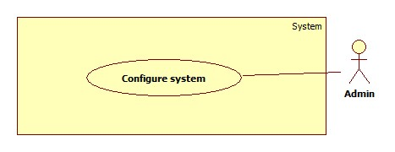

Figure 42: <Admin> Config System

Use Case Specification

|  |  |  |  |
| --- | --- | --- | --- |
| **USE CASE – MATC047** | | | |
| **Use Case No.** | MATC047 | **Use Case Version** | 1.0 |
| **Use Case Name** | Configure System | | |
| **Author** | Dương Trung Kiên | | |
| **Date** | 25/05/2014 | **Priority** | Normal |
| **Actor:**   * Admin.   **Summary:**   * Configure system.   **Goal:**   * Change system’s configuration.   **Triggers:**   * Admin clicks “Thay đổi cấu hình” link in Home menu.   **Preconditions:**   * User must login with Admin role.   **Post Conditions:**   * **Success:** New data is inserted to database and web.config file. * **Fail:** Nothing is changed in the database.   **Main Success Scenario:**   |  |  |  | | --- | --- | --- | | Step | Actor Action | System Response | | 1 | Admin click on “Thay đổi cấu hình” button. | Show Change Configure System page include:   * Độ tuổi tham gia: * Nhỏ nhất: selectbox, min(16),max(20), value get from current configure file. * Lớn nhất: selectbox, min(35), max(40), value get from current configure file. * Thay đổi avatar môn võ: * Môn võ: selectbox, value from MartialArt table. * “Chọn” button: button. * Số lượng phân trang: selectbox, min(5), max(10), value get from current configure file. | | 2 | Admin change information. And click on “Cập nhật” button.  [Alternative 1] | * New athlete information will be added to database, web.config file and show: “Thông tin đã thay đổi thành công!”   [Exception 1] |   **Alternative Scenario:**   |  |  |  | | --- | --- | --- | | No | Actor Action | System Response | | 1 | Click on “Hủy” button | Change nothing. |   **Exceptions:**   |  |  |  | | --- | --- | --- | | No | Actor Action | System Response | | 1 | Connect to database fail | Show message: “Đã xảy ra lỗi, vui lòng thử lại sau.” |   **Relationships:** N/A  **Business Rules:**   * Default number of record is 8, min-age is 18, max-age is 40. * Value of number of record, min-age, max-age are saved in configure file, avatar of martial art are saved in MartialArt table. * If martial was not selected, select image button will be disable. * Review change image of martial will be show after chose image. | | | |

## Software System Attribute

### Usability

##### Graphic User Interface

* + - Texts which are name of button, messages, labels are written by Vietnamese.

##### Usability

* + - Admin, employee should need about 3 days for training to use system.
    - Guest can use the system easily without training.

##### Installation

* + - The system must be easy to deploy.
    - The customer can deploy successfully and learn to configure, maintain the system within one day of training.
    - The attached manual guide must be clear. User can read and do themselves without developer’s help.

### Reliability

* Last update date of website can be viewed by user.

### Availability

* + - Support view league by play diagram.
    - Recovery from system failure.
    - Restarting after system failure.

### Security

* Privacy: Each role of user has a specific permission to interact with system.
* System always checks authorization and authentication before doing anything.
* Only admin can grant permission to employee.

### Maintainability

* The system is divided into separated modules.
* The code is easy to maintain and upgrade.

### Portability

* This system can be deployed into many type of servers those have IIS server.

### Performance

* Search should be within 4 seconds.
* Load Play Schedule, Play Diagram page should be within 5 seconds.

## Conceptual Diagram

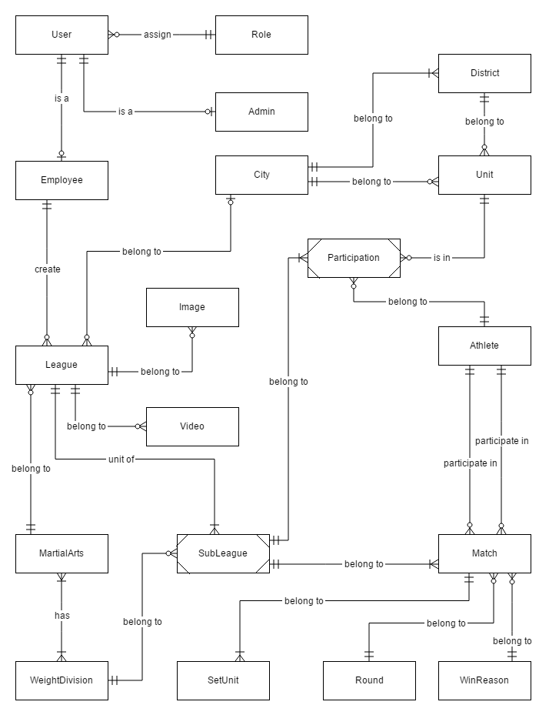

Figure 43: Conceptual Diagram

**Data Dictionary**

|  |  |
| --- | --- |
| **Entity Data dictionary: describe content of all entities** | |
| Entity Name | Description |
| Role | Describe all roles in the system. |
| User | Describe all users in the system. Each user has only one account |
| Admin | Describe all users with role admin in the system. |
| Employee | Describe all users with role employee in the system. |
| League | Describe all leagues in the system. |
| MartialArts | Describe all martial arts in the system. |
| WeightDivision | Describe all weight division in the system. |
| SubLeague | Describe all sub leagues in the system. Each sub league belongs to one weight division in one league. |
| Unit | Describe all units in the system. |
| District | Describe all districts in the system. |
| City | Describe all cities in the system. |
| Athlete | Describe all athletes in the system. |
| Match | Describe all matches in the system. |
| Round | Describe all rounds in the system. |
| SetUnit | Describe all sets in the system. |
| Image | Describe all images in the system. |
| Video | Describe all videos in the system. |
| WinReason | Describe all win reasons in the system. |
| Participation | Describe all participation in the system. |

# Report No. 4 Software Design Description

## Design Overview

* This document describes the technical and user interface design of MATC System. It includes the architectural design, the detailed design of common functions and business functions and the design of database model.
* The architectural design describes the overall architecture of the system and the architecture of each main component and subsystem.
* The detailed design describes static and dynamic structure for each component and functions. It includes class diagrams, class explanations and sequence diagrams for each use cases.
* The database design describes the relationships between entities and details of each entity.
* Document overview:
* Section 2: gives an overall description of the system architecture design.
* Section 3: gives component diagrams that describe the connection and integration of the system.
* Section 4: gives the detail design description which includes class diagram, class explanation, and sequence diagram to details the application functions.
* Section 5: describe screens design.
* Section 6: describe database design by logical data model.
* Section 7: describe algorithms which are used to implement the system’s function.

## System Architectural Design

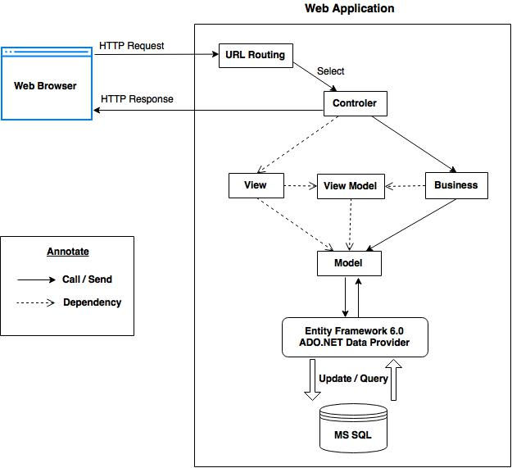

Figure 44: System Architectural Design

### Web application architecture description

* The system is developed from MVC architecture style and customized with passive model to adapt to MVC5, Web API 2.2 and Entity Framework 6 technologies.
* **Model** is the parts of the application that acts like a data transfer object between the system and database. Model is generated by mapping the database table by Entity Framework 6.
* **View** is the parts of the application that handles the display of the data. Most often the views are created from the model data. The creation of View is under control of Controller
* **Controller** is the parts of the application that acts like event handler to handles user interaction. Typically controller read data from a request and calls appropriate Business’s method then selects view to generate.
* **Business** is the parts of the application that do business processing to solve domain problems.
* **View Model** is the parts of the application that acts like value object (VO). Typically view model contains model instances and is passed to view by controller.

## Component Diagram

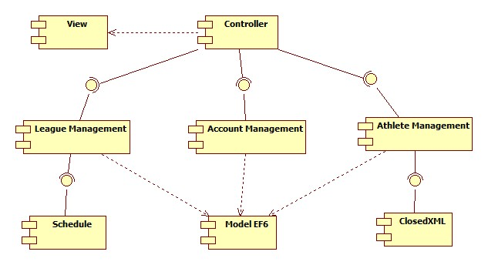

Figure 45: Component Diagram

|  |  |
| --- | --- |
| **Component dictionary: describe component** | |
| Component Name | Description |
| View | Content all views of the system. |
| Controller | Content all controllers of the system. |
| Account Management | Business logic processing for Users. |
| Athlete Management | Business logic processing for Athlete. |
| League Management | Business logic processing for League. |
| Schedule | Business logic processing for scheduling and planing time for a league. |
| ClosedXML | Support to export excel file. |
| Model EF6 | Entity Framework 6 mapping models. |

## Detailed Description

### Class Diagram

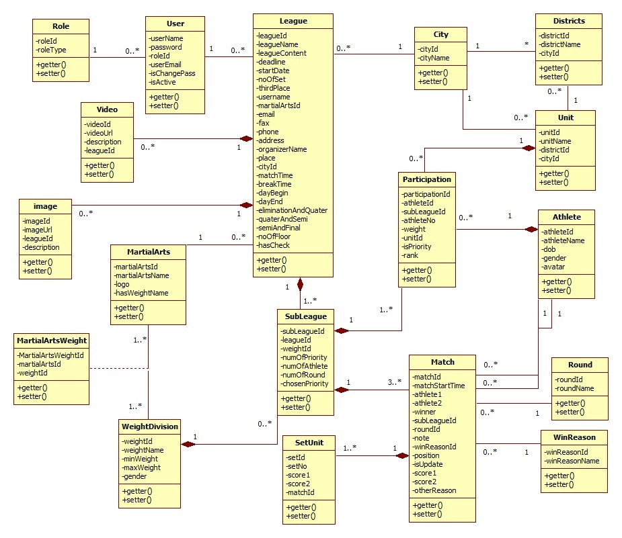

Figure 46: Class Diagram

### Class Diagram Explanation

#### Role

Attribute

|  |  |  |  |
| --- | --- | --- | --- |
| **Attribute** | **Type** | **Visibility** | **Description** |
| roleId | int | Private | Unique identifier of a role |
| roleType | string | Private | Role name |

Method

|  |  |  |  |
| --- | --- | --- | --- |
| **Method** | **Return type** | **Visibility** | **Description** |
| GetRoleId | Attribute type | Public | Get roleId value |
| GetType | Attribute type | Public | Get roleType value |

#### User

Attribute

|  |  |  |  |
| --- | --- | --- | --- |
| **Attribute** | **Type** | **Visibility** | **Description** |
| username | string | Private | Unique identifier of an account |
| password | string | Private | Password of an account |
| roleId | int | Private | ID of account’s role |
| userEmail | string | Private | Email address |
| status | Char | Private | State of an account |

Method

|  |  |  |  |
| --- | --- | --- | --- |
| **Method** | **Return type** | **Visibility** | **Description** |
| Getter | Attribute type | Public | Get attribute value |
| Setter | Void | Public | Set value of attribute |

#### League

Attribute

|  |  |  |  |
| --- | --- | --- | --- |
| **Attribute** | **Type** | **Visibility** | **Description** |
| leagueId | int | private | Unique identifier of a league |
| leagueName | string | private | Name of league |
| leagueContent | string | private | Content of league |
| deadline | Datetime | private | Registration deadline |
| startDate | Datetime | private | First round start date |
| noOfSet | int | private | Number of set of each match |
| thirdPlace | bool | private | League has third place match or not |
| hasSchedule | bool | private | League has schedule or not |
| username | string | private | Username of employee who created that league |
| martialArtsId | int | private | ID of martial arts which that league was held for. |
| email | string | private | Email address of organizers. |
| fax | string | private | Fax of organizers. |
| phone | string | private | Telephone number of organizers. |
| address | string | private | Address of organizers. |
| organizerName | string | private | Name of organizer. |
| place | string | private | Place where league was held |
| cityId | int | private | ID of city where that league belong to |
| matchTime | int | private | How long does each match take? |
| breakTime | int | private | How long does each break time (between 2 matches) take? |
| dayBegin | string | private | Point of time competition begins each day. |
| dayEnd | string | private | Point of time competition ends each day. |
| eliminationAndQuater | int | private | Number of day between elimination round and quarter-final round |
| quarterAndSemi | int | private | Number of day between quarter-final round and semi-final round |
| semiAndFinal | int | private | Number of day between semi-final round and final round |
| noOfFloor | int | private | Number of floor each point of time can hold competition |
| hasCheck | bool | private | League checked number of athlete in each weight division and counted number of priority athletes or not. |

Method

|  |  |  |  |
| --- | --- | --- | --- |
| **Method** | **Return type** | **Visibility** | **Description** |
| Getter | Attribute type | public | Get attribute value |
| setter | void | public | Set value of attribute |

#### SubLeague

Attribute

|  |  |  |  |
| --- | --- | --- | --- |
| **Attribute** | **Type** | **Visibility** | **Description** |
| subLeagueId | int | private | Unique identifier of a sub league |
| leagueId | int | private | ID of league which sub league belongs to |
| weightId | int | private | ID of weight division which sub league belongs to |
| numOfPriority | int | private | Number of priority athletes employee must choose |
| numOfAthlete | int | private | Number of athletes in each sub league |
| numOfRound | int | private | Number of rounds sub league has |
| chosenPriority | int | private | Number of priority athletes was chose |

Method

|  |  |  |  |
| --- | --- | --- | --- |
| **Method** | **Return type** | **Visibility** | **Description** |
| getter | Attribute type | public | Get attribute value |
| setter | void | public | Set value of attribute |

#### Participation

Attribute

|  |  |  |  |
| --- | --- | --- | --- |
| **Attribute** | **Type** | **Visibility** | **Description** |
| particiationId | int | private | Unique identifier of participation |
| athleteId | int | private | ID of athlete participates in that league |
| subleagueId | int | private | ID of sub league which participation belongs to |
| athleteNo | int | private | Candidate number of athlete when participate in that league |
| weight | float | private | Athlete’s weight when participate in that league |
| unitId | int | private | ID of unit which athlete belongs to when participate that league |
| isPriority | bool | private | Athlete is priority or not |
| rank | Int | private | Rank of athlete in subleague |

Method

|  |  |  |  |
| --- | --- | --- | --- |
| **Method** | **Return type** | **Visibility** | **Description** |
| getter | Attribute type | public | Get attribute value |
| setter | void | public | Set value of attribute |

#### MartialArts

Attribute

|  |  |  |  |
| --- | --- | --- | --- |
| **Attribute** | **Type** | **Visibility** | **Description** |
| martialArtsId | int | private | Unique identifier of martial arts |
| martialArtsName | string | private | Name of martial arts |
| logo | string | private | Logo image link of each martial arts |
| hasWeightName | bool | private | Martial art has weight name or not |

Method

|  |  |  |  |
| --- | --- | --- | --- |
| **Method** | **Return type** | **Visibility** | **Description** |
| getter | Attribute type | public | Get attribute value |
| setter | void | public | Set value of attribute |

#### MartialArtsWeight

Attribute

|  |  |  |  |
| --- | --- | --- | --- |
| **Attribute** | **Type** | **Visibility** | **Description** |
| martialArtsWeightId | int | Private | Unique identifier of MartialArtsWeightId |
| martialArtsId | int | Private | Id of Martial Arts |
| weightId | int | Private | Id of Weight Division |

Method

|  |  |  |  |
| --- | --- | --- | --- |
| **Method** | **Return type** | **Visibility** | **Description** |
| getter | Attribute type | Public | Get attribute value |
| setter | Void | Public | Set value of attribute |

#### WeightDivision

Attribute

|  |  |  |  |
| --- | --- | --- | --- |
| **Attribute** | **Type** | **Visibility** | **Description** |
| weightId | int | Private | Unique identifier of weight division |
| weightName | string | Private | Name of weight division |
| minWeight | int | Private | Min weight of weight division |
| maxWeight | int | Private | Max weight of weight division |
| gender | string | Private | Gender of Athlete |

Method

|  |  |  |  |
| --- | --- | --- | --- |
| **Method** | **Return type** | **Visibility** | **Description** |
| Getter | Attribute type | Public | Get attribute value |
| Setter | Void | Public | Set value of attribute |

#### Set

Attribute

|  |  |  |  |
| --- | --- | --- | --- |
| **Attribute** | **Type** | **Visibility** | **Description** |
| setId | int | Private | Unique identifier of Set |
| setNo | int | Private | Number of Set |
| score1 | int | Private | Score for Athlete 1 |
| score2 | int | Private | Score for Athlete 2 |
| matchId | int | Private | Id of Match contain Set |

Method

|  |  |  |  |
| --- | --- | --- | --- |
| **Method** | **Return type** | **Visibility** | **Description** |
| Getter | Attribute type | Public | Get attribute value |
| Setter | Void | Public | Set value of attribute |

#### Match

|  |  |  |  |
| --- | --- | --- | --- |
| **Attribute** | **Type** | **Visibility** | **Description** |
| matchId | int | Private | Unique identifier of Match |
| matchStartTime | datetime | Private | Time start Match |
| athlete1 | int | Private | Id of Athlete 1 |
| athlete2 | int | Private | Id of Athlete 2 |
| winner | int | Private | Winner of match. 1 for athlete 1 and 2 for athlete 2. |
| subLeagueId | int | Private | Id of SubLeague contain Match |
| roundId | int | Private | Id of Round contain Match |
| match1 | int | Private | Id of reference match |
| match2 | int | Private | Id of reference match |
| note | string | Private | Note of Match |

Method

|  |  |  |  |
| --- | --- | --- | --- |
| **Method** | **Return type** | **Visibility** | **Description** |
| Getter | Attribute type | Public | Get attribute value |
| Setter | Void | Public | Set value of attribute |

#### Athlete

Attribute

|  |  |  |  |
| --- | --- | --- | --- |
| **Attribute** | **Type** | **Visibility** | **Description** |
| athleteId | int | private | Unique identifier of an Athlete |
| athleteName | string | private | Athlete name |
| dob | DateTime | private | Athlete’s date of birth |
| gender | string | private | Athlete’s gender |
| avatar | string | private | Athlete’s avatar url |

Method

|  |  |  |  |
| --- | --- | --- | --- |
| **Method** | **Return type** | **Visibility** | **Description** |
| Getter | Attribute type | Public | Get attribute value |
| Setter | Void | Public | Set value of attribute |

#### Round

Attribute

|  |  |  |  |
| --- | --- | --- | --- |
| **Attribute** | **Type** | **Visibility** | **Description** |
| roundId | int | Private | Unique identifier of a round |
| roudName | string | Private | Round name |

Method

|  |  |  |  |
| --- | --- | --- | --- |
| **Method** | **Return type** | **Visibility** | **Description** |
| Getter | Attribute type | Public | Get attribute value |
| Setter | Void | Public | Set value of attribute |

#### Unit

Attribute

|  |  |  |  |
| --- | --- | --- | --- |
| **Attribute** | **Type** | **Visibility** | **Description** |
| unitId | int | private | Unique identifier of a unit |
| unitName | string | private | Unit name |
| districtId | int | private | Unit in District |
| cityId | int | private | City ID unit belongs to |

Method

|  |  |  |  |
| --- | --- | --- | --- |
| **Method** | **Return type** | **Visibility** | **Description** |
| Getter | Attribute type | Public | Get attribute value |
| Setter | Void | Public | Set value of attribute |

#### District

Attribute

|  |  |  |  |
| --- | --- | --- | --- |
| **Attribute** | **Type** | **Visibility** | **Description** |
| districtId | int | Private | Unique identifier of a District |
| districtName | string | Private | District name |
| cityId | int | Private | District in City |

Method

|  |  |  |  |
| --- | --- | --- | --- |
| **Method** | **Return type** | **Visibility** | **Description** |
| Getter | Attribute type | Public | Get attribute value |
| Setter | Void | Public | Set value of attribute |

#### City

Attribute

|  |  |  |  |
| --- | --- | --- | --- |
| **Attribute** | **Type** | **Visibility** | **Description** |
| cityId | int | Private | Unique identifier of a City |
| cityName | string | Private | City name |

Method

|  |  |  |  |
| --- | --- | --- | --- |
| **Method** | **Return type** | **Visibility** | **Description** |
| Getter | Attribute type | Public | Get attribute value |
| Setter | Void | Public | Set value of attribute |

#### Image

Attribute

|  |  |  |  |
| --- | --- | --- | --- |
| **Attribute** | **Type** | **Visibility** | **Description** |
| imageId | int | private | Unique identifier of an image |
| imageUrl | string | private | Link of an image |
| leagueId | int | private | ID of league image belongs to |
| description | string | private | Description of image |

Method

|  |  |  |  |
| --- | --- | --- | --- |
| **Method** | **Return type** | **Visibility** | **Description** |
| Getter | Attribute type | Public | Get attribute value |
| Setter | Void | Public | Set value of attribute |

#### Video

Attribute

|  |  |  |  |
| --- | --- | --- | --- |
| **Attribute** | **Type** | **Visibility** | **Description** |
| videoId | int | private | Unique identifier of a video |
| videoUrl | string | private | Link of video |
| leagueId | int | private | ID of league video belongs to |
| description | string | private | Description of video |

Method

|  |  |  |  |
| --- | --- | --- | --- |
| **Method** | **Return type** | **Visibility** | **Description** |
| Getter | Attribute type | Public | Get attribute value |
| Setter | Void | Public | Set value of attribute |

#### WinReason

Attribute

|  |  |  |  |
| --- | --- | --- | --- |
| **Attribute** | **Type** | **Visibility** | **Description** |
| winReasonId | int | private | Unique identifier of a win reason |
| winReasonName | string | private | Name of win reason |

Method

|  |  |  |  |
| --- | --- | --- | --- |
| **Method** | **Return type** | **Visibility** | **Description** |
| Getter | Attribute type | Public | Get attribute value |
| Setter | Void | Public | Set value of attribute |

### Interaction Diagram

#### <Guest> View Play Schedule

**Summary:** This diagram shows how a guest or an employee views play schedule.

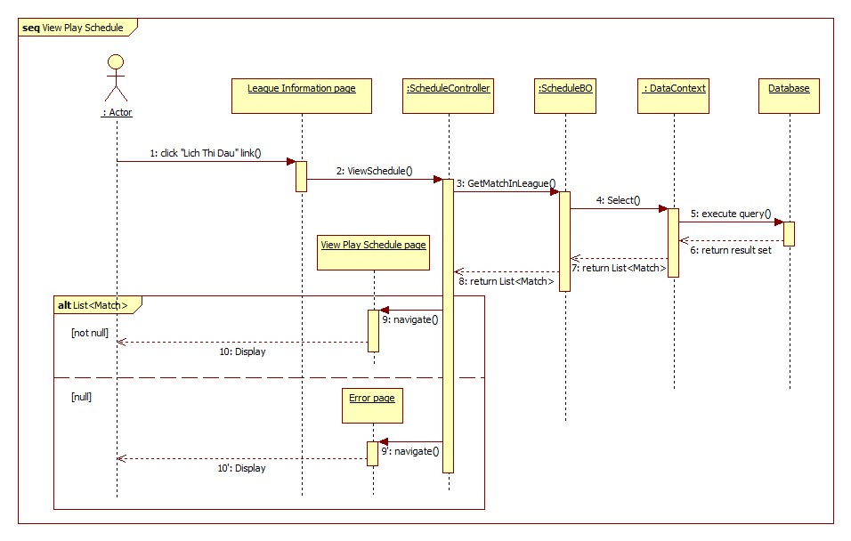

Figure 47: < Guest, Employee > View Play Schedule sequence diagram

#### <Guest> View Athletes in League

**Summary:** This diagram shows how a guest or an employee views athletes in a league

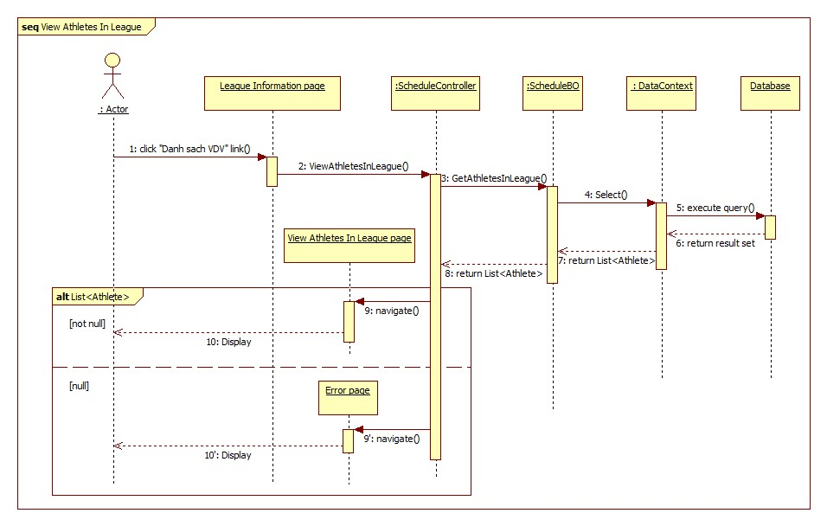

Figure 48: < Guest, Employee > View Athletes in League sequence diagram

#### <Guest> View League Information

**Summary:** This diagram shows how a guest or an employee views league information.

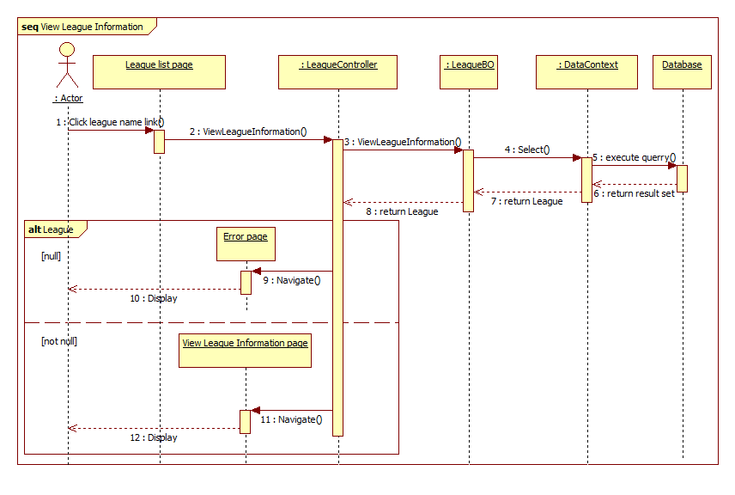

Figure 49: < Guest > View League Information sequence diagram

#### <Guest> Search Athlete

**Summary:** This diagram shows how guest and employee can serach athlete.

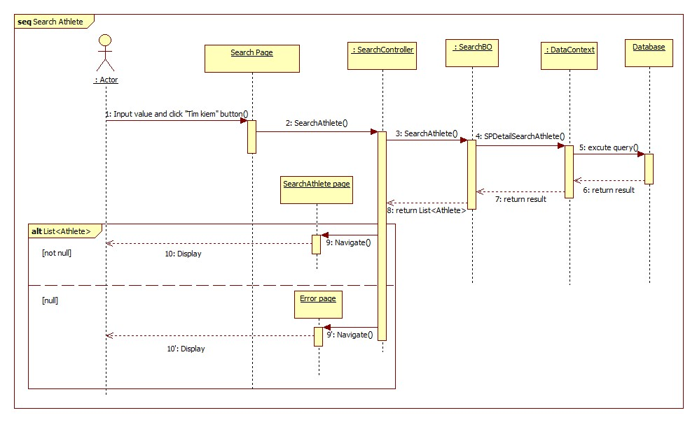

Figure 50: < Guest > Search Athlete sequence diagram

#### <Guest> Search League

**Summary:** This diagram shows how guest and employee can serach league.

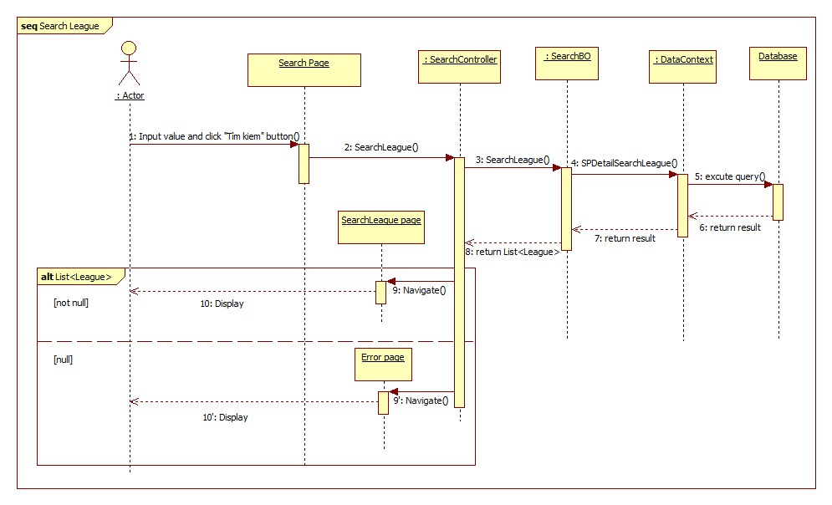

Figure 51: < Guest > Search League sequence diagram

#### <Guest> View Athlete Profile

**Summary:** This diagram shows how guest and employee can view Athlete profile.

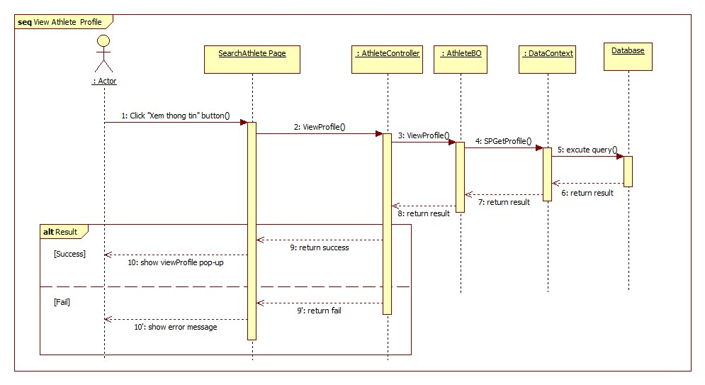

Figure 52: < Guest > View Athlete Profile sequence diagram

#### <Guest> View Match

**Summary:** This diagram shows how guest and employee can view Match information.

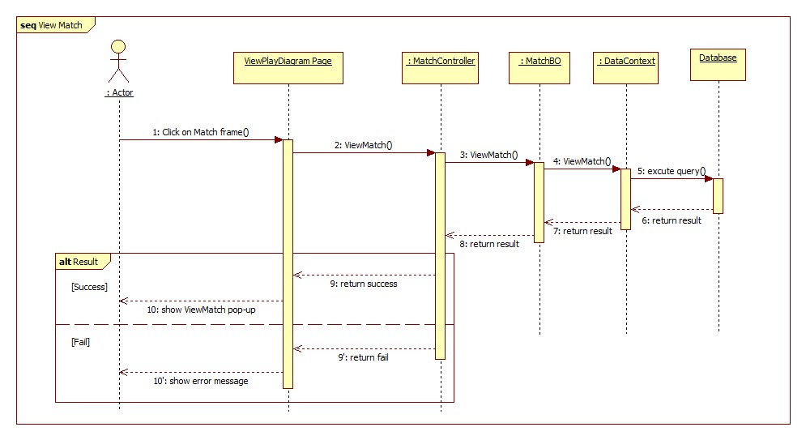

Figure 53: < Guest > View Match sequence diagram

#### <Guest> View Play Diagram

**Summary:** This diagram shows how guest and employee can view Play Diagram.

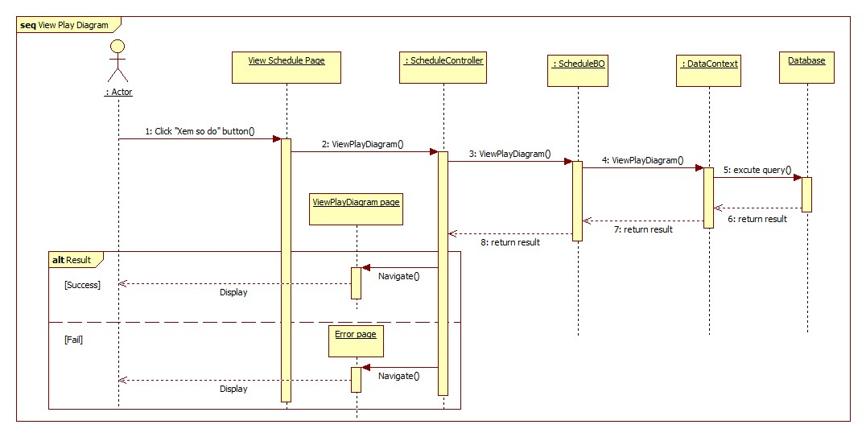

Figure 54: < Guest > View Play Diagram sequence diagram

#### <Employee> Create Athlete

**Summary:** This diagram shows how an employee creates an athlete.

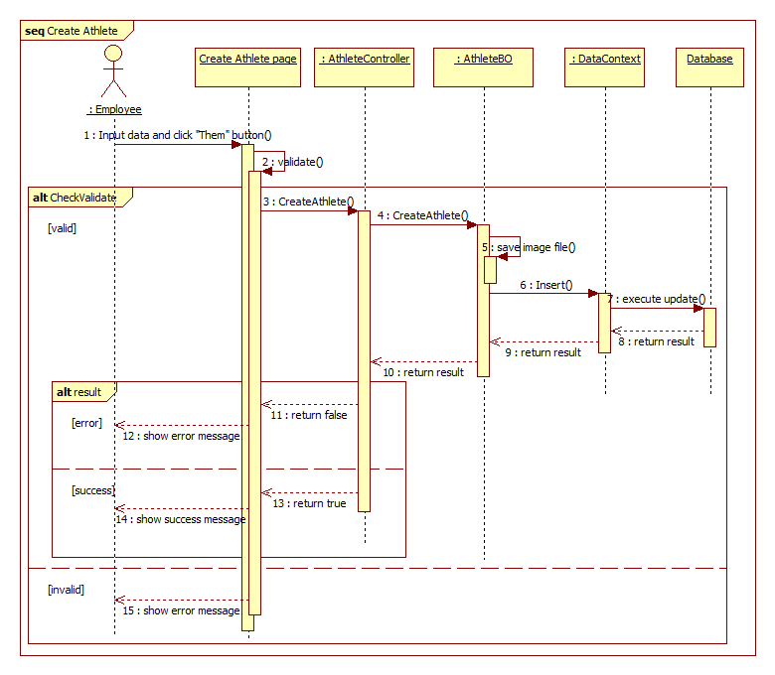

Figure 55: < Employee > Create Athlete sequence diagram

#### <Employee> Create League

**Summary:** This diagram shows how an employee creates a league.

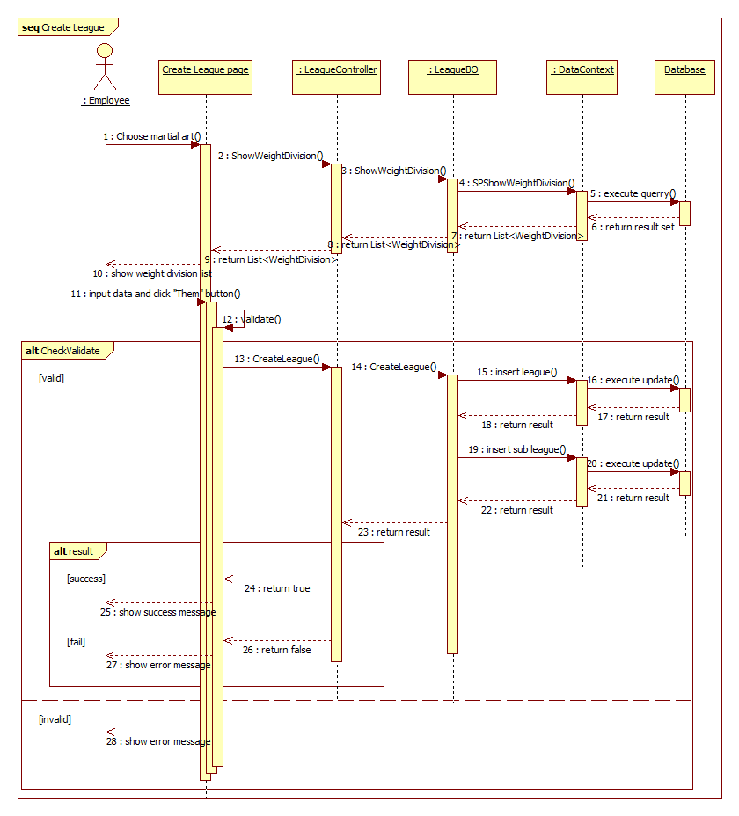

Figure 56: < Employee > Create League sequence diagram

#### <Employee> Update League Information

**Summary:** This diagram shows how an employee updates league information.

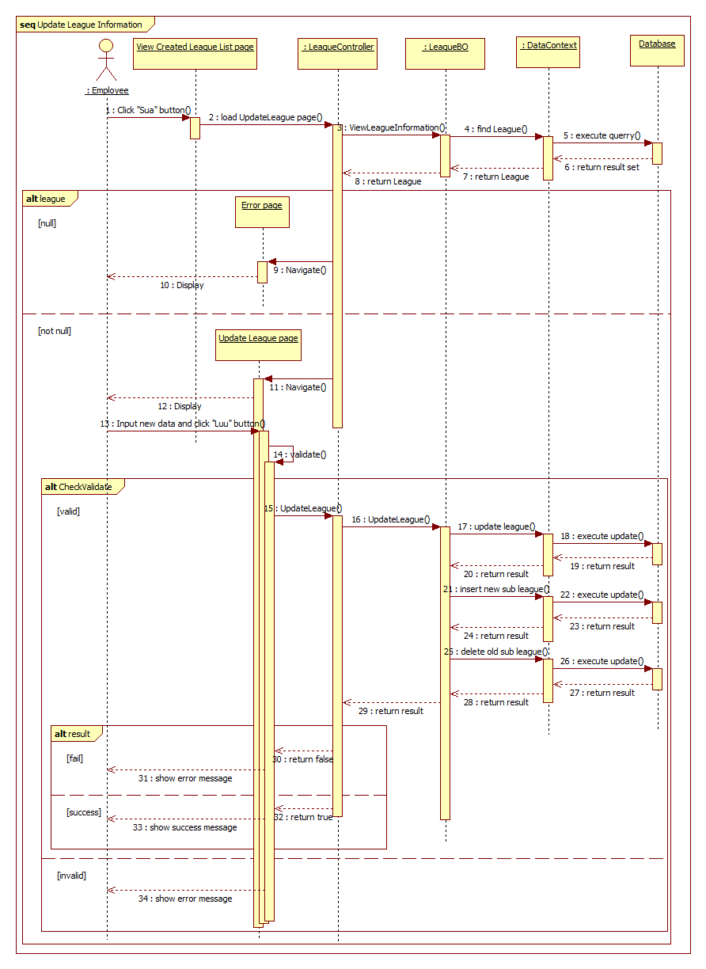

Figure 57: < Employee > Update League Information sequence diagram

#### <Employee> Delete League

**Summary:** This diagram shows how an employee deletes a league.

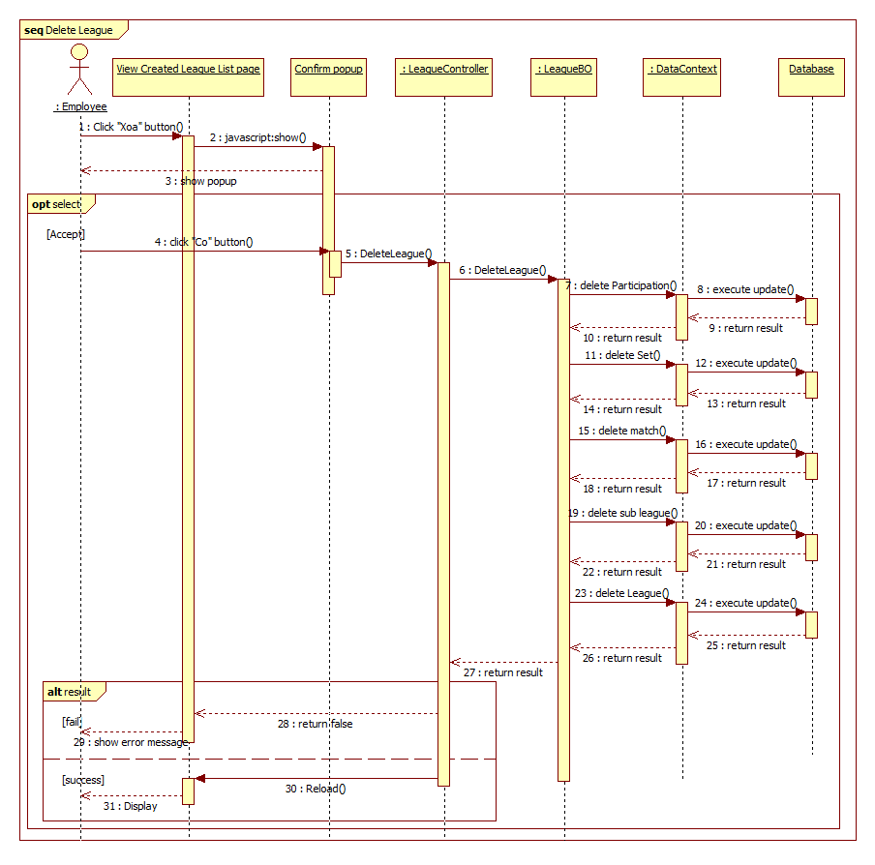

Figure 58: < Employee > Delete League sequence diagram

#### <Employee> Check Valid Subleague

**Summary:** This diagram shows how an employee check valid subleague before schedule league.

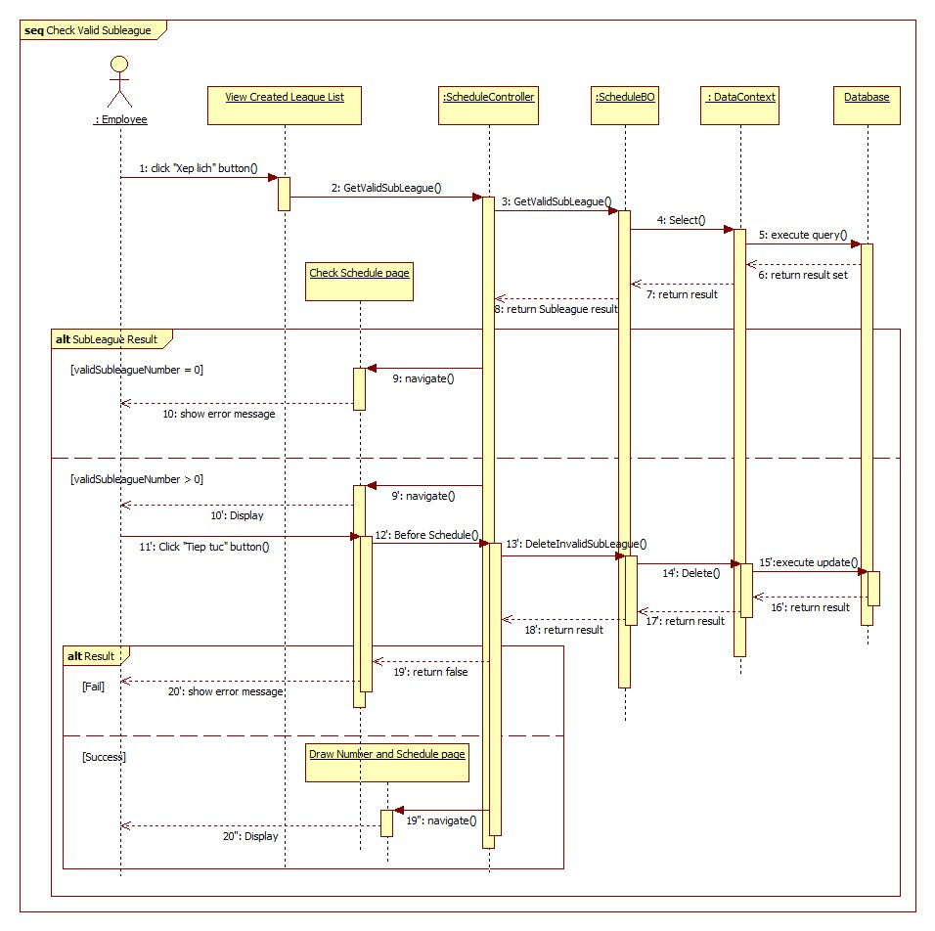

Figure 59: < Employee > Check Valid Subleague sequence diagram

#### <Employee> Draw number and Schedule league

**Summary:** This diagram shows how an employee draw number for athletes in league and schedule that league.

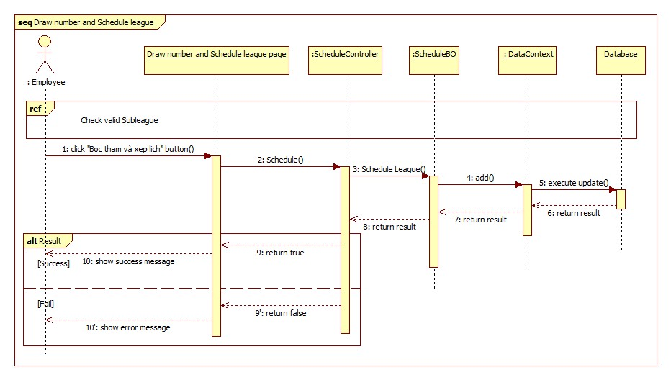

Figure 60: < Employee > Draw number and Schedule league sequence diagram

#### <Employee> Set Priority

**Summary:** This diagram shows how an employee set priority for athletes in league.

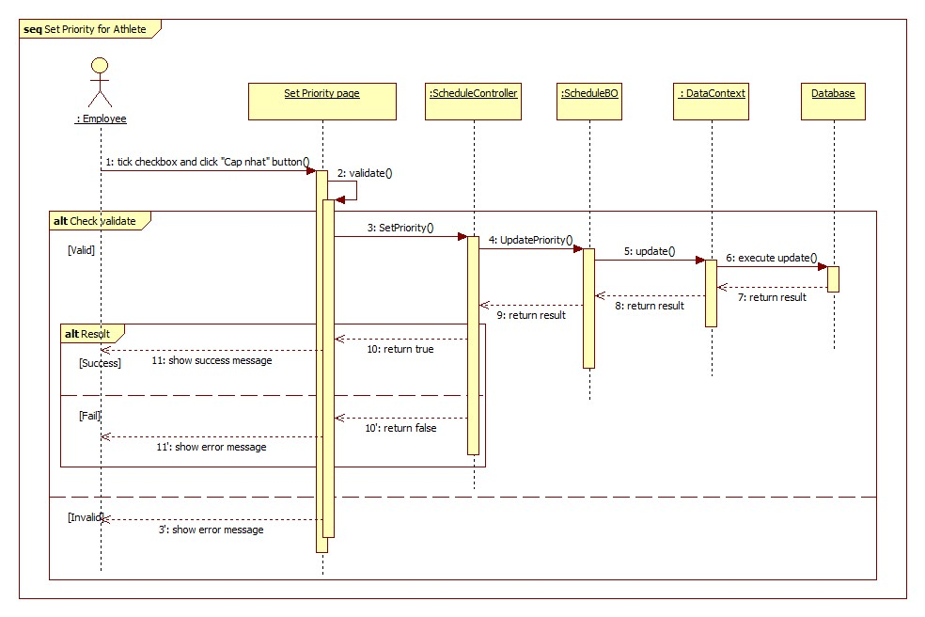

Figure 61: < Employee > Set Priority sequence diagram

#### <Employee> Update Match

**Summary:** This diagram shows how an employee updates a match result.

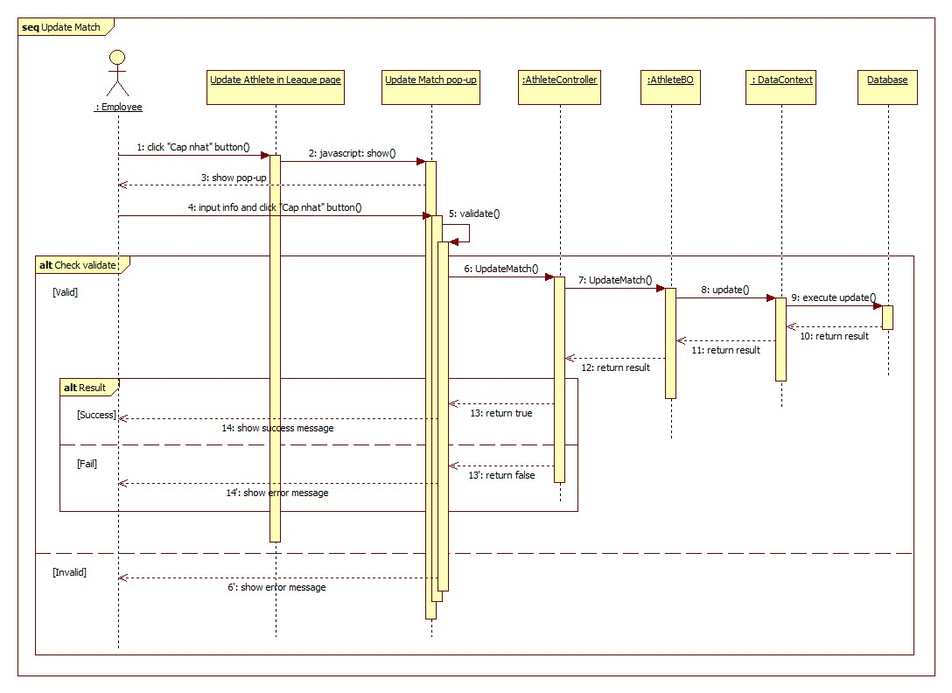

Figure 62: < Employee > Update Match sequence diagram

#### <Employee> Add Athlete into League

**Summary:** This diagram shows how an employee adds an athlete into league.

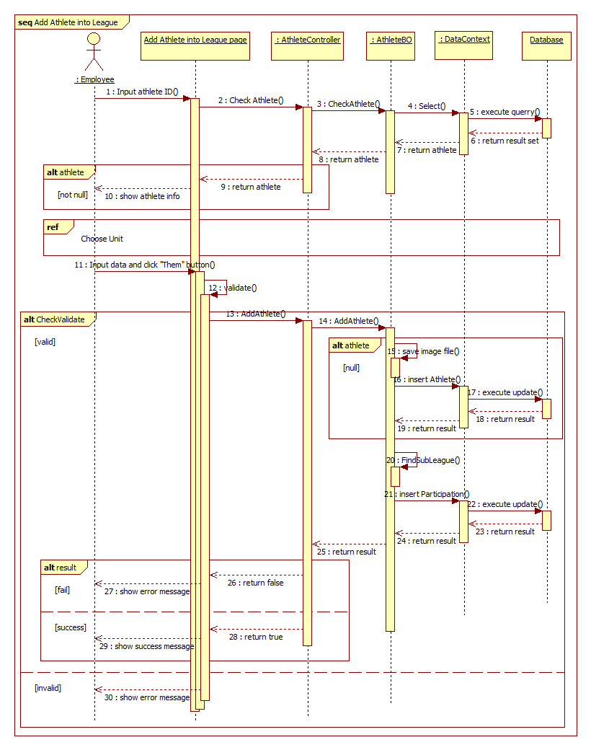

Figure 63: < Employee > Add Athlete into League sequence diagram

#### <Employee> Update Athlete in League

**Summary:** This diagram shows how an employee updates an athlete information in league.

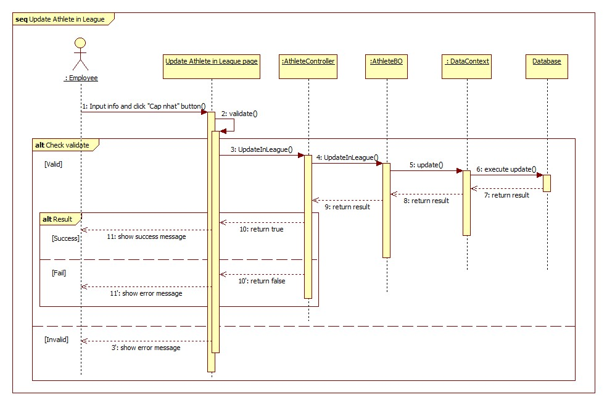

Figure 64: < Employee > Update Athlete in League sequence diagram

#### <Employee> Delete Athlete from League

**Summary:** This diagram shows how an employee deletes an athlete from league.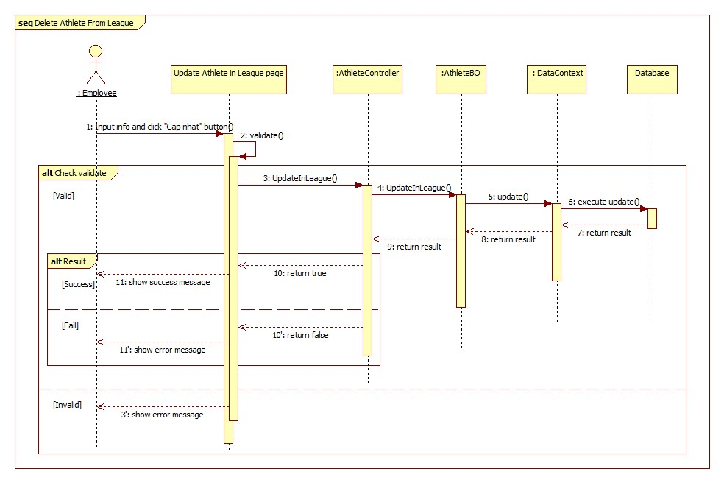

Figure 65: < Employee > Delete Athlete from League sequence diagram

#### <Employee> Import Excel File

**Summary:** This diagram shows how an employee adds list of athlete by excel file.

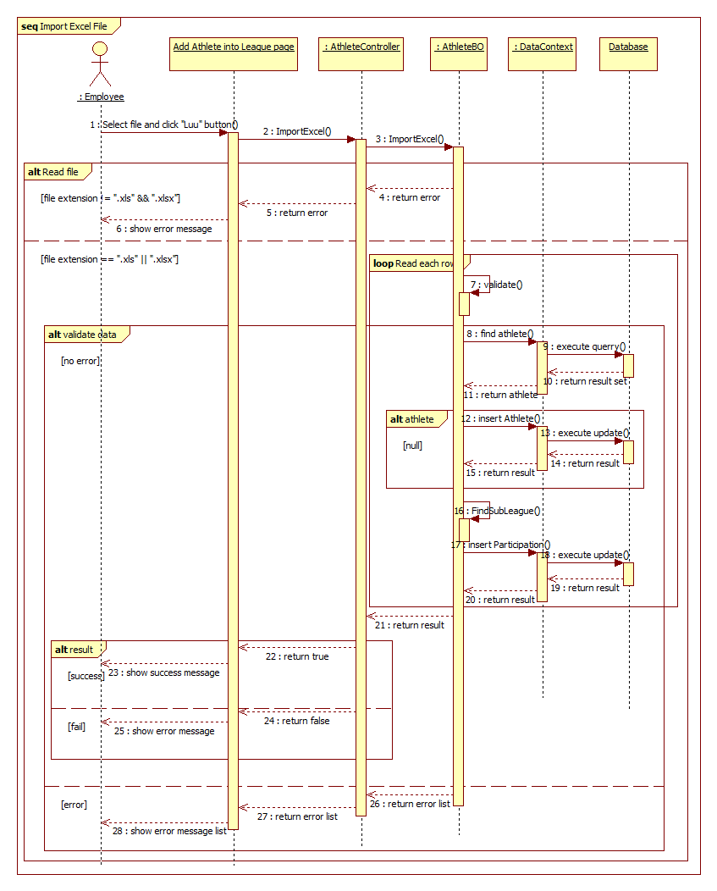

Figure 66: < Employee > Import Excel File sequence diagram

#### <Employee> Choose Unit

**Summary:** This diagram shows how an employee chooses a unit for athlete when add into league.

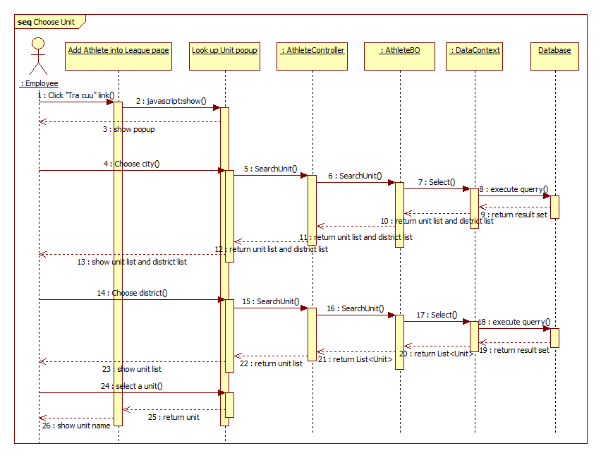

Figure 67: < Employee > Choose unit sequence diagram

#### <Employee> Create Unit

**Summary:** This diagram shows how an employee creates a new unit.

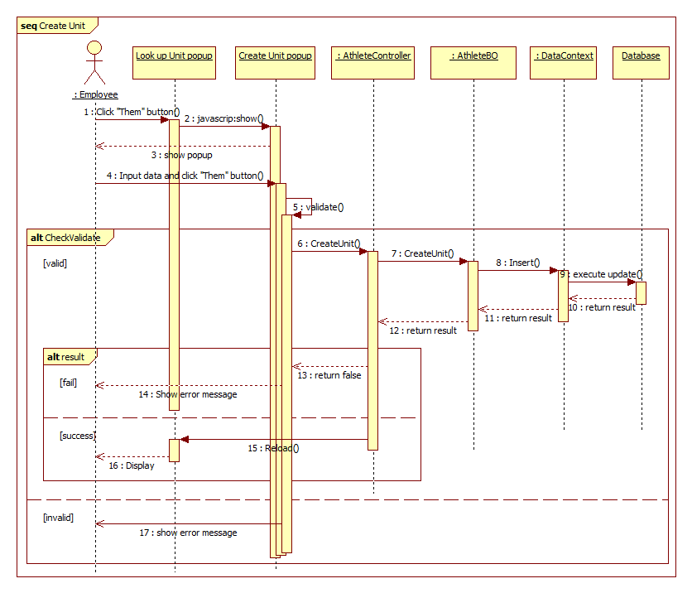

Figure 68: < Employee > Create Unit sequence diagram

#### <Employee> Delete Athlete

**Summary:** This diagram shows how an Employee delete an Athlete

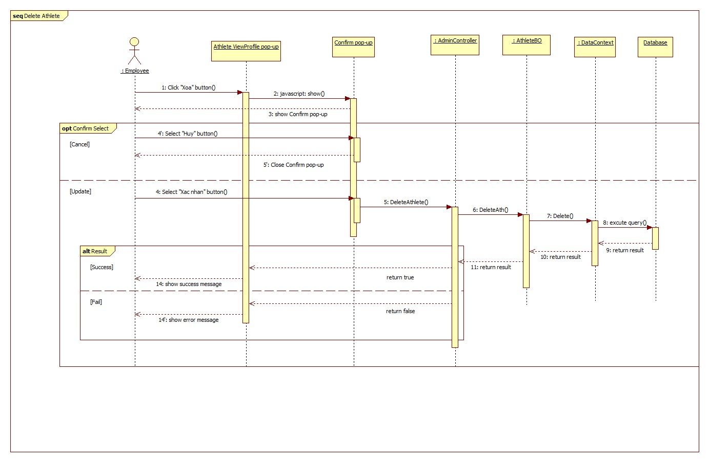

Figure 69: < Employee > Delete Athlete sequence diagram

#### <Employee> Update Athlete

**Summary:** This diagram shows how an Employee updates Athlete infomation.

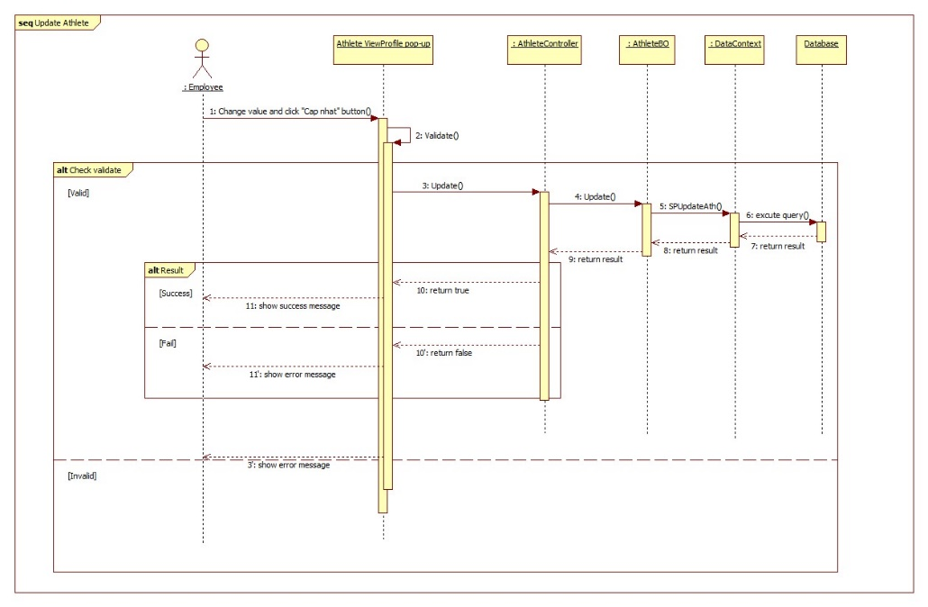

Figure 70: < Employee > Update Athlete sequence diagram

## User Interface Design

### Guest Interface Design

#### Search League

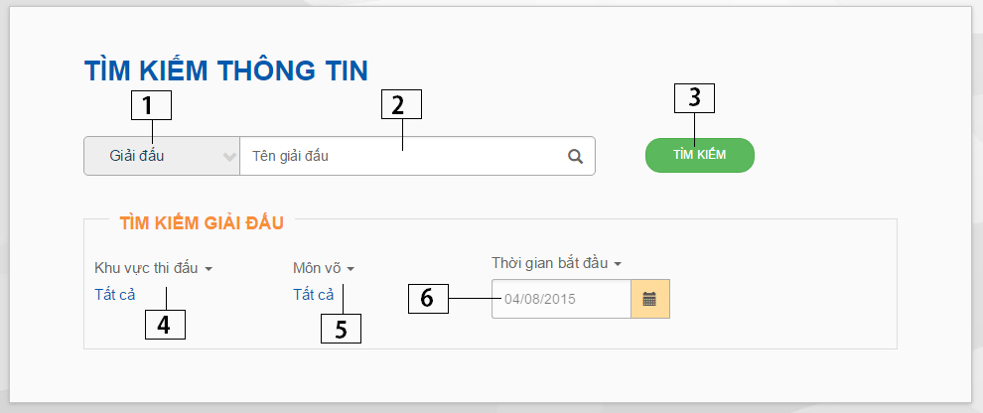

Figure 71: Search League page

**Fields**

|  |  |  |  |  |  |  |  |
| --- | --- | --- | --- | --- | --- | --- | --- |
| **No** | **Field Name** | **Description** | **Read only** | **Mandatory** | **Control Type** | **Data Type** | **Length** |
| 1 | Result type | Select League or Athlete | No | Yes | Selectbox | String | N/A |
| 2 | League Name | Fill league name | No | No | Textbox | String | N/A |
| 4 | Playing place | Select place where league playing | No | No | Selectbox | String | N/A |
| 5 | Martial Arts | Select martial art of league | No | No | Selectbox | String | N/A |
| 6 | Playing Date | Fill playing date | Yes | No | Textbox | String | N/A |

**Buttons/Hyperlinks**

|  |  |  |  |  |
| --- | --- | --- | --- | --- |
| **No** | **Function** | **Description** | **Validation** | **Outcome** |
| 3 | Search | Search league | N/A | Transfer to Search league page |

#### Search Athlete

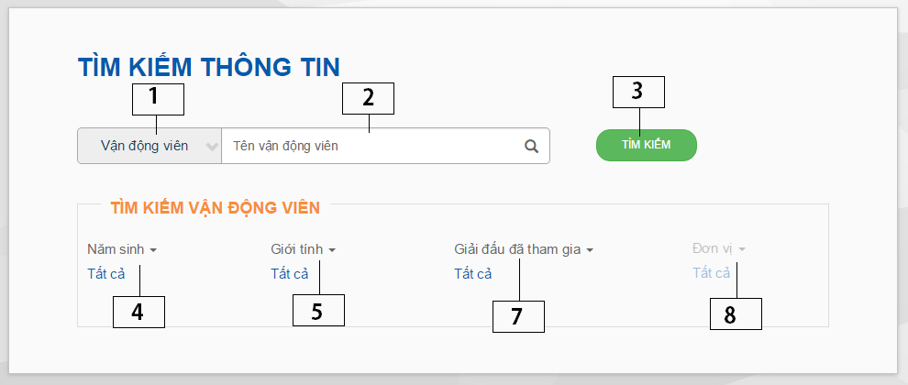

Figure 72: Search Athlete page

**Fields**

|  |  |  |  |  |  |  |  |
| --- | --- | --- | --- | --- | --- | --- | --- |
| **No** | **Field Name** | **Description** | **Read only** | **Mandatory** | **Control Type** | **Data Type** | **Length** |
| 1 | Result type | Select League or Athlete | No | Yes | Selectbox | String | N/A |
| 2 | Athlete Name | Fill athlete name | No | No | Textbox | String | N/A |
| 4 | Joinned league | Select athlete joinned league | No | No | Selectbox | String | N/A |
| 5 | Unit in league | Select athlete unit in league | No | No | Selectbox | String | N/A |

**Buttons/Hyperlinks**

|  |  |  |  |  |
| --- | --- | --- | --- | --- |
| **No** | **Function** | **Description** | **Validation** | **Outcome** |
| 3 | Search | Search athlete | N/A | Transfer to Search athlete page |

#### View Athlete Profile

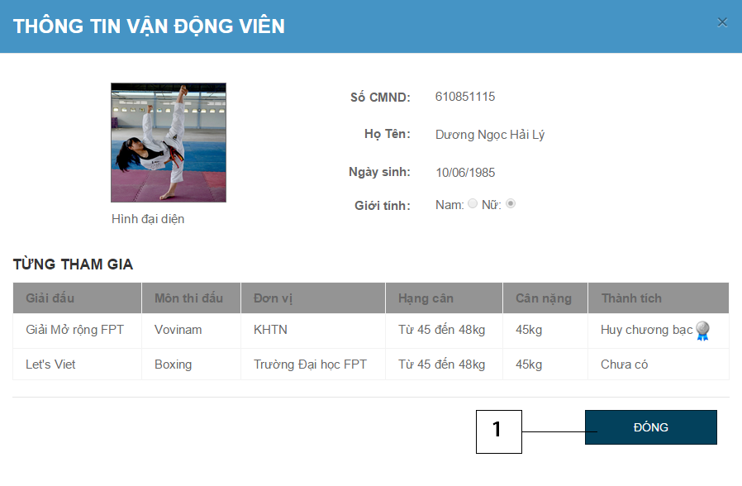

Figure 73: View Athlete Profile popup

**Buttons/Hyperlinks**

|  |  |  |  |  |
| --- | --- | --- | --- | --- |
| **No** | **Function** | **Description** | **Validation** | **Outcome** |
| 1 | Close | Close view athlete profile pop-up | N/A | Back to previous page |

#### View League Information

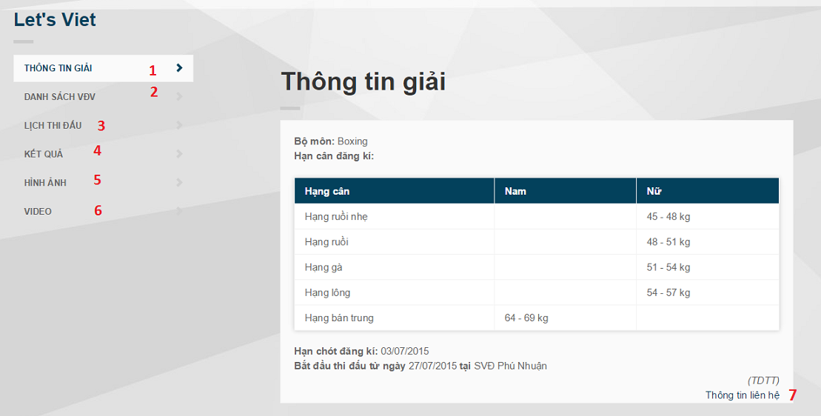

Figure 74: View league information page

**Buttons/Hyperlinks**

|  |  |  |  |  |
| --- | --- | --- | --- | --- |
| **No** | **Function** | **Description** | **Validation** | **Outcome** |
| 1 | View League Information | View league information | N/A | Transfer to view league information page |
| 2 | View Athletes in league | View athlete list in league | N/A | Transfer to view athletes in league page |
| 3 | View schedule | View play schedule of league | N/A | Transfer to view schedule page |
| 4 | View result | View result of league | N/A | Transfer to view result page |
| 5 | View image | View images of league | N/A | Transfer to view image page |
| 6 | View video | View videos of league | N/A | Transfer to view video page |
| 7 | View organizer contact | View league organizer contact | N/A | Show organizer contact pop up |

#### View Organizers Contact

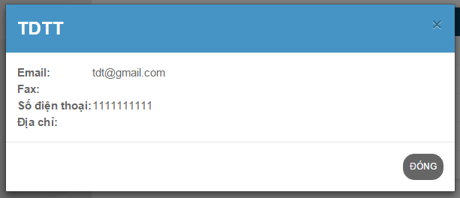

Figure 75: View organizer contact popup

#### View Play Diagram

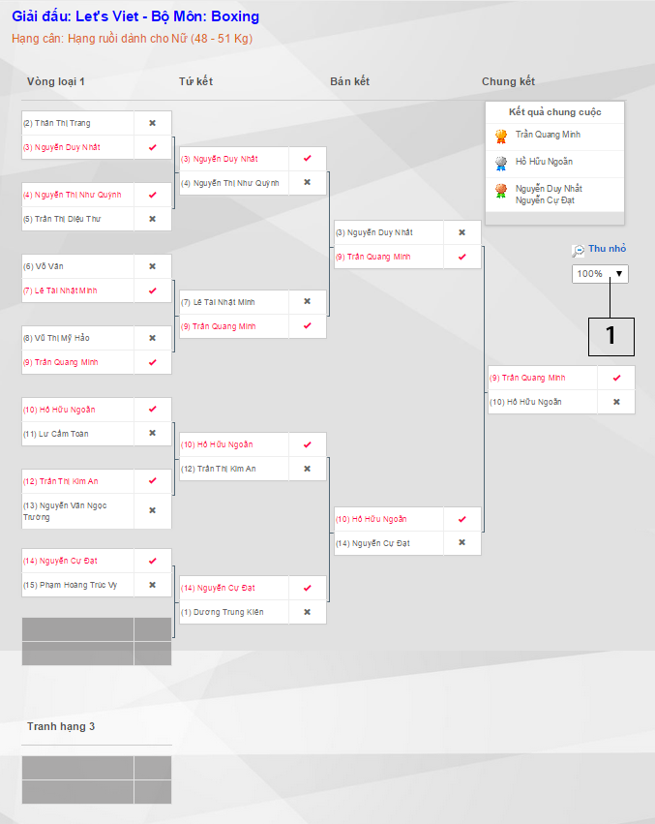

Figure 76: View Play Diagram page

**Buttons/Hyperlinks**

|  |  |  |  |  |
| --- | --- | --- | --- | --- |
| **No** | **Function** | **Description** | **Validation** | **Outcome** |
| 1 | Zoom | Zoom in or zoom out diagram | N/A | N/A |

#### View Result

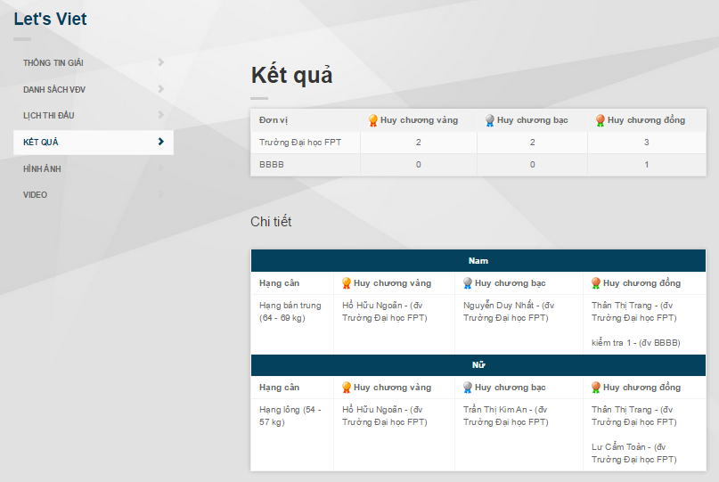

Figure 77: View result page

### Employee Interface Design

#### Create Athlete

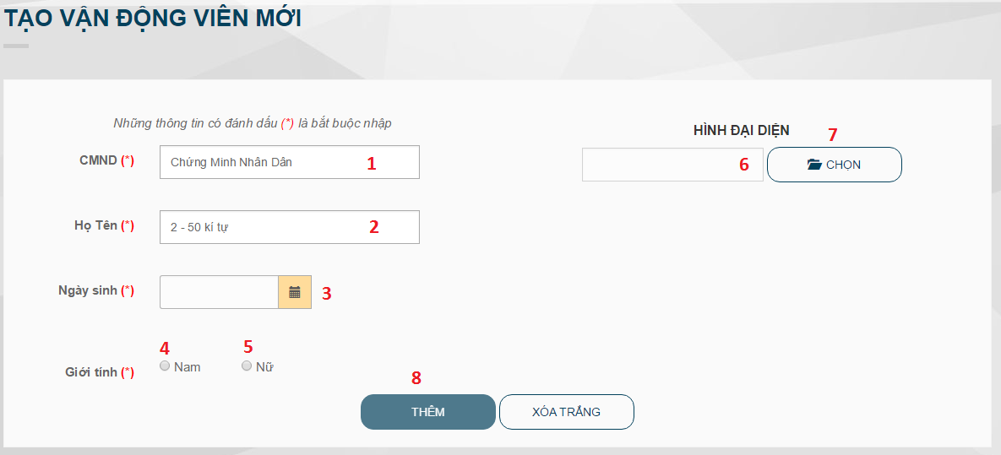

Figure 78: Create athlete page

**Fields**

|  |  |  |  |  |  |  |  |
| --- | --- | --- | --- | --- | --- | --- | --- |
| **No** | **Field Name** | **Description** | **Read only** | **Mandatory** | **Control Type** | **Data Type** | **Length** |
| 1 | Identity number | Fill athlete’s identity number | No | Yes | Textbox | int | 9 |
| 2 | Full name | Fill athlete’s full name | No | Yes | Textbox | String | 50 |
| 3 | Date of birth | Fill athlete’s date of birth | Yes | Yes | Datepicker | Datetime | N/A |
| 4 | Male | Athlete is a man | No | Yes | Radio button | String | N/A |
| 5 | Female | Athlete is a woman | No | Yes | Radio button | String | N/A |
| 6 | Image file name | Image file name | Yes | No | Textbox | String | N/A |

**Buttons/Hyperlinks**

|  |  |  |  |  |
| --- | --- | --- | --- | --- |
| **No** | **Function** | **Description** | **Validation** | **Outcome** |
| 7 | Browse image file | Browse image file | N/A | Show preview image, image name |
| 8 | Create athlete | Create a new athlete | N/A | Back to create athlete page with message |

#### Manage Athlete

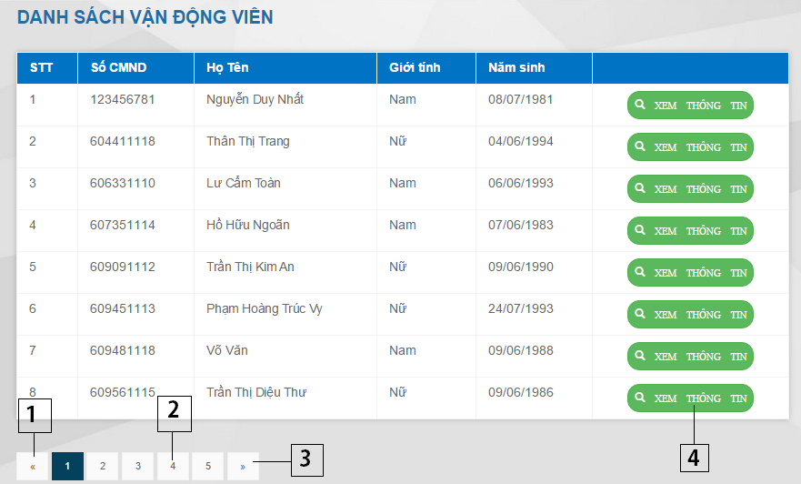

Figure 79: Manage Athlete page

**Buttons/Hyperlinks**

|  |  |  |  |  |
| --- | --- | --- | --- | --- |
| **No** | **Function** | **Description** | **Validation** | **Outcome** |
| 1 | Previous page | Go to previous page | N/A | Transfer to previous page |
| 2 | Next page | Go to next page | N/A | Transfer to next page |
| 3 | Specific page | Go to specific page | N/A | Tranfers to specific page |
| 4 | View Athlete Profile | Show profile of athlete | N/A | Show athlete profile pop-up |

#### Update Athlete Profile

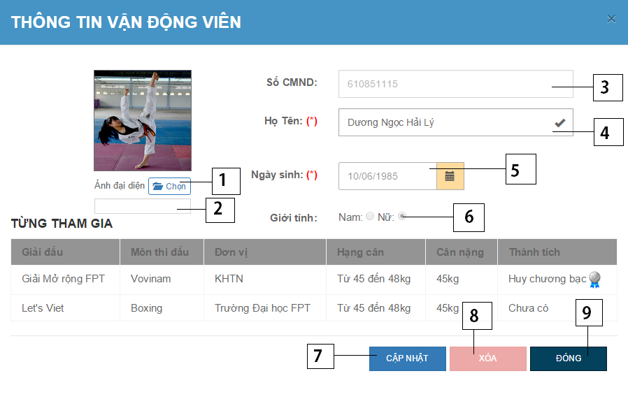

Figure 80: Update Athlete Profile popup

|  |  |  |  |  |  |  |  |
| --- | --- | --- | --- | --- | --- | --- | --- |
| **No** | **Field Name** | **Description** | **Read only** | **Mandatory** | **Control Type** | **Data Type** | **Length** |
| 2 | Image name | Show new image update name | Yes | No | Textbox | String | N/A |
| 3 | Athlete Name | Athlete’s name | No | Yes | Textbox | String | N/A |
| 4 | Identify number | Athlete’s number | Yes | No | Textbox | String | 9 |
| 5 | Date of birth | Fill athlete’s date of birth | Yes | Yes | Datepicker | Datetime | N/A |
| 6 | Gender | Athlete’gender | Yes | No | Radio button | String | N/A |

**Buttons/Hyperlinks**

|  |  |  |  |  |
| --- | --- | --- | --- | --- |
| **No** | **Function** | **Description** | **Validation** | **Outcome** |
| 1 | Browse image file | Browse image file | N/A | Show preview image, image name |
| 7 | Update athlete | Update new information of athlete | N/A | Back to previous page |
| 8 | Delete | Confirm delete athlete | N/A | Show delete pop-up |
| 9 | Close | Close current pop-up | N/A | Back to previous page |

#### View Play Schedule

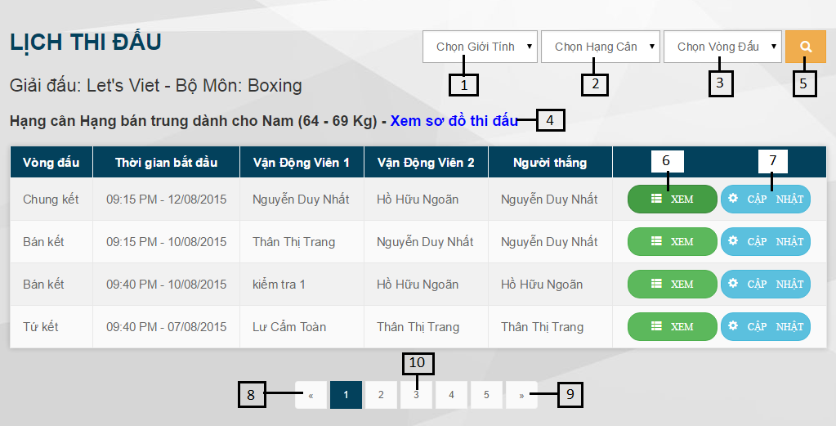

Figure 81: View Play Schedule page

**Fields**

|  |  |  |  |  |  |  |  |
| --- | --- | --- | --- | --- | --- | --- | --- |
| **No** | **Field Name** | **Description** | **Read only** | **Manda-tory** | **Control Type** | **Data Type** | **Length** |
| 1 | Gender | Gender of athlete | No | N/A | Dropdown list | String | N/A |
| 2 | Weight division | Weight division which the athlete participates in | No | N/A | Dropdown list | String | N/A |
| 3 | Round | Round which the match belongs to | No | N/A | Dropdown list | String | N/A |

**Buttons/Hyperlinks**

|  |  |  |  |  |
| --- | --- | --- | --- | --- |
| **No** | **Function** | **Description** | **Validation** | **Outcome** |
| 4 | View Play Diagram | View play diagram of weight division | N/A | Navigate to view play diagram page |
| 5 | Search | Search match | N/A | Search match |
| 6 | View Match | View a match | N/A | Show popup to view match |
| 7 | Update Match | Update a match | N/A | Show popup to update match |
| 8 | Previous page | Go to previous page | N/A | Transfer to previous page |
| 9 | Next page | Go to next page | N/A | Transfer to next page |
| 10 | Specific page | Go to specific page | N/A | Tranfers to specific page |

#### Update Match Information

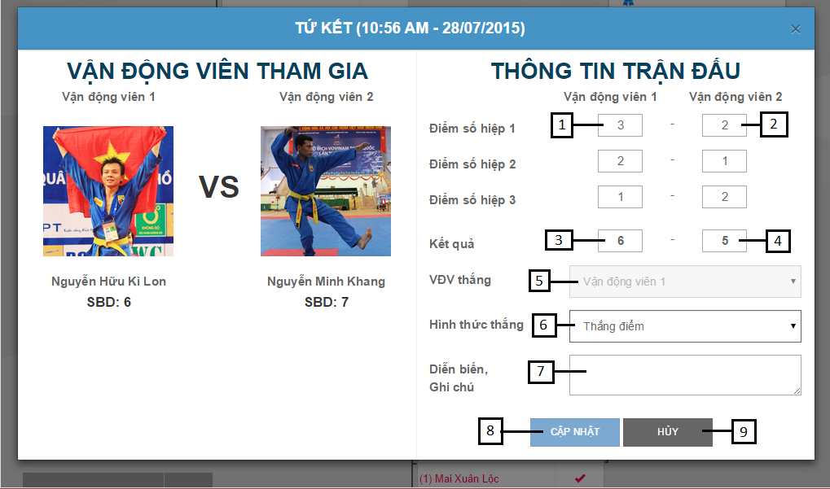

Figure 82: Update match information popup

**Fields**

|  |  |  |  |  |  |  |  |
| --- | --- | --- | --- | --- | --- | --- | --- |
| **No** | **Field Name** | **Description** | **Read only** | **Manda-tory** | **Control Type** | **Data Type** | **Length** |
| 1 | Set Score of Athlete 1 | Score of athlete 1 in a set. | No | N/A | Textbox | String | N/A |
| 2 | Set Score of Athlete 2 | Score of athlete 2 in a set. | No | N/A | Textbox | String | N/A |
| 3 | Result of athlete 1 | Result of athlete 1 | Yes | N/A | Textbox | String | N/A |
| 4 | Result of athlete 2 | Result of athlete 2 | Yes | N/A | Textbox | String | N/A |
| 5 | Winner | Winner of the match | N/A | N/A | Dropdown list | String | N/A |
| 6 | Win reason | Win reason of the match | No | Yes | Dropdown list | String | N/A |
| 7 | Note | Note of the match | No | No | Text area | String | N/A |

**Buttons/Hyperlinks**

|  |  |  |  |  |
| --- | --- | --- | --- | --- |
| **No** | **Function** | **Description** | **Validation** | **Outcome** |
| 8 | Update | Update new match information | N/A | Pop-up closed |
| 9 | Cancel | Cancel update | N/A | Pop-up closed |

#### Create League

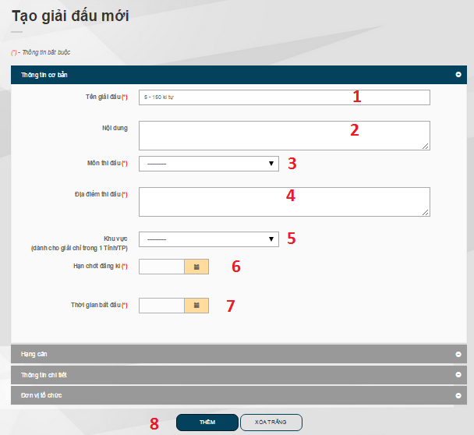

Figure 83: Create league_tab 1

**Fields**

|  |  |  |  |  |  |  |  |
| --- | --- | --- | --- | --- | --- | --- | --- |
| **No** | **Field Name** | **Description** | **Read only** | **Mandatory** | **Control Type** | **Data Type** | **Length** |
| 1 | League name | Fill league name | No | Yes | Textbox | String | 150 |
| 2 | League content | Fill league content | No | No | Text area | String | N/A |
| 3 | Martial art | Select martial art | No | Yes | Drop down list | Int | N/A |
| 4 | Participate place | Fill participate place | No | Yes | Text area | String | N/A |
| 5 | City | Select city league is held in | No | No | Drop down list | Int | N/A |
| 6 | Registration deadline | Select registration deadline | Yes | Yes | Datepicker | Datetime | N/A |
| 7 | Start date | Select league start date | Yes | Yes | Datepicker | Datetime | N/A |

**Buttons/Hyperlinks**

|  |  |  |  |  |
| --- | --- | --- | --- | --- |
| **No** | **Function** | **Description** | **Validation** | **Outcome** |
| 8 | Create league | Create a new league | N/A | Back to Create league page with message |

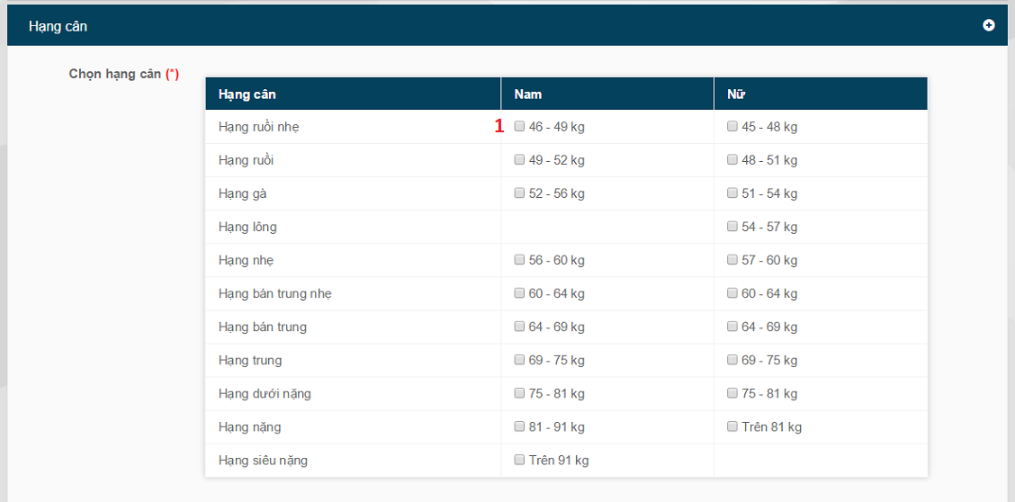

Figure 84: Create league_tab 2

**Fields**

|  |  |  |  |  |  |  |  |
| --- | --- | --- | --- | --- | --- | --- | --- |
| **No** | **Field Name** | **Description** | **Read only** | **Mandatory** | **Control Type** | **Data Type** | **Length** |
| 1 | Weight division range | Select weight division range | No | Yes | Check box | Int | N/A |

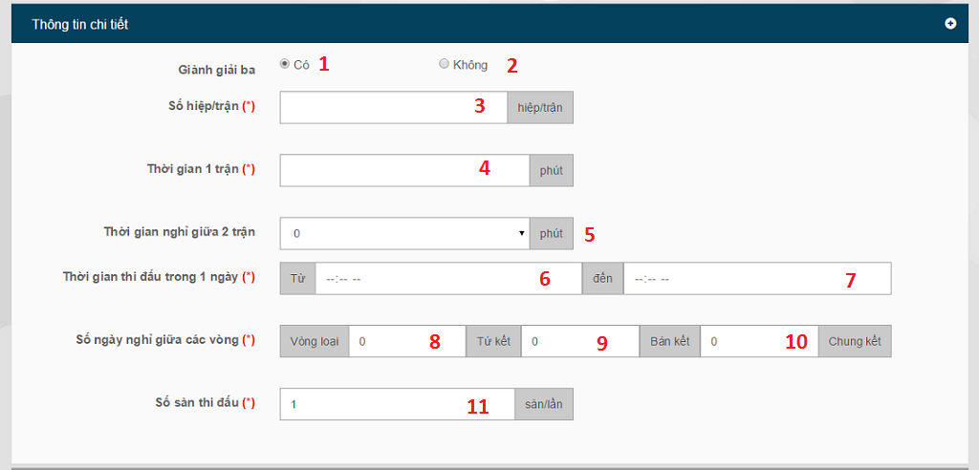

Figure 85: Create league_tab 3

**Fields**

|  |  |  |  |  |  |  |  |
| --- | --- | --- | --- | --- | --- | --- | --- |
| **No** | **Field Name** | **Description** | **Read only** | **Mandatory** | **Control Type** | **Data Type** | **Length** |
| 1 | Has third place match | League has third place match | No | Yes | Radio button | string | N/A |
| 2 | Has no third place match | League does not have third place match | No | Yes | Radio button | string | N/A |
| 3 | Number of sets per match | Fill number of sets per match | No | Yes | Textbox | Int | N/A |
| 4 | Time of each match | Fill time for each match | No | Yes | Textbox | Int | N/A |
| 5 | Break time between 2 matches | Select break time between 2 matches | No | Yes | Drop down list | Int | N/A |
| 6 | Begin time in a participate day | Fill begin time in a participate day | No | Yes | Time | String | N/A |
| 7 | End time in a participate day | Fill end time in a participate day | No | Yes | Time | String | N/A |
| 8 | Number of day off between elimination round and quarter-final round | Fill number of day off between elimination round and quarterfinal round | No | Yes | Textbox | Int | N/A |
| 9 | Number of day off between quarter-final round and semi-final round | Fill number of day off between quarter-final round and semi-final round | No | Yes | Textbox | Int | N/A |
| 10 | Number of day off between semi-final round and final round | Fill number of day off between semi-final round and final round | No | Yes | Textbox | Int | N/A |
| 11 | Number of floors | Fill number of floors | No | Yes | Textbox | Int | N/A |

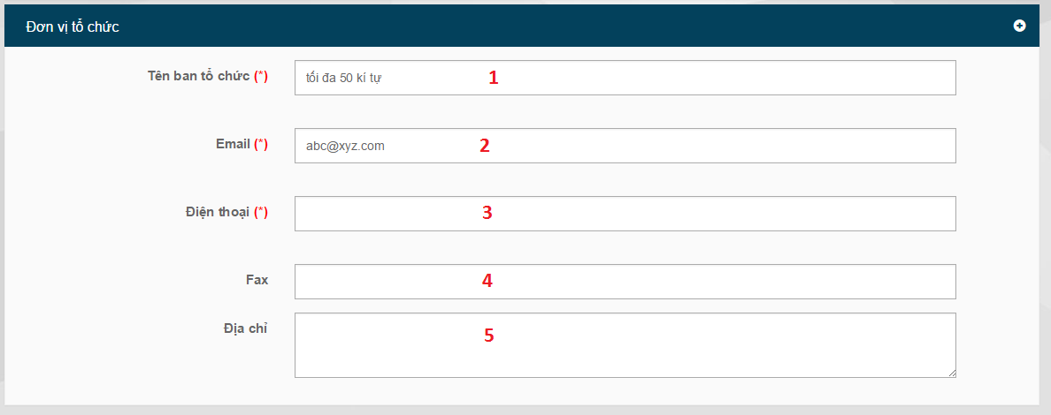

Figure 86: Create league_tab 4

**Fields**

|  |  |  |  |  |  |  |  |
| --- | --- | --- | --- | --- | --- | --- | --- |
| **No** | **Field Name** | **Description** | **Read only** | **Mandatory** | **Control Type** | **Data Type** | **Length** |
| 1 | Organizer name | Fill organizer name | No | Yes | Textbox | String | N/A |
| 2 | Email | Fill organizer email | No | Yes | Textbox | String | N/A |
| 3 | Telephone number | Fill organizer telephone number | No | Yes | Textbox | String | N/A |
| 4 | Fax | Fill organizer fax number | No | Yes | Textbox | String | N/A |
| 5 | Address | Fill organizer address | No | Yes | Textbox | String | N/A |

#### Manage League

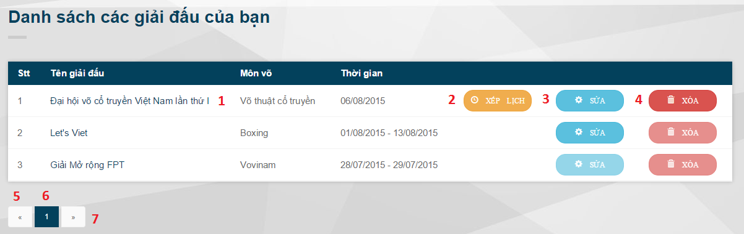

Figure 87: Manage league page

**Buttons/Hyperlinks**

|  |  |  |  |  |
| --- | --- | --- | --- | --- |
| **No** | **Function** | **Description** | **Validation** | **Outcome** |
| 1 | View league information | View league full information for employee | N/A | Transfer to View league full information page |
| 2 | Arrange schedule | Arrange play schedule of league | N/A | Check valid sub league |
| 3 | Update league | Update league information | N/A | Transfer to Update league page |
| 4 | Delete league | Delete league | N/A | Reload Manage league page |
| 5 | Previous page | Go to previous page | N/A | Transfer to previous page |
| 6 | Specific page | Go to 1st page | N/A | Tranfers to specific page |
| 7 | Next page | Go to next page | N/A | Transfer to next page |

#### Manage Athlete in League

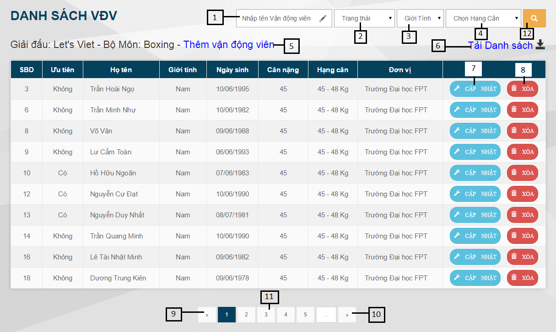

Figure 88: Manage Athlete in League page

**Fields**

|  |  |  |  |  |  |  |  |
| --- | --- | --- | --- | --- | --- | --- | --- |
| **No** | **Field Name** | **Description** | **Read only** | **Manda-tory** | **Control Type** | **Data Type** | **Length** |
| 1 | Athlete name | Name of athlete | No | N/A | Textbox | String | N/A |
| 2 | Athlete status | Athlete has been priority or not | No | N/A | Dropdown list | String | N/A |
| 3 | Gender | Gender of athlete | No | N/A | Dropdown list | String | N/A |
| 4 | Weight division | Weight division which the athlete participates in | No | N/A | Dropdown list | String | N/A |

**Buttons/Hyperlinks**

|  |  |  |  |  |
| --- | --- | --- | --- | --- |
| **No** | **Function** | **Description** | **Validation** | **Outcome** |
| 5 | Add Athlete | Add new athlete into the league | N/A | Navigate to Add Athlete page |
| 6 | Export To Excel | Export athlete list to excel file and download to computer | N/A |  |
| 7 | Update Athlete | Update a athlete | N/A | Show popup to update athlete |
| 8 | Delete Athlete | Delete a athlete from the league | N/A | Show confirm popup |
| 9 | Previous page | Go to previous page | N/A | Transfer to previous page |
| 10 | Next page | Go to next page | N/A | Transfer to next page |
| 11 | Specific page | Go to specific page | N/A | Tranfers to specific page |
| 12 | Search | Search athlete | N/A | Search athlete |

#### Add Athlete into League

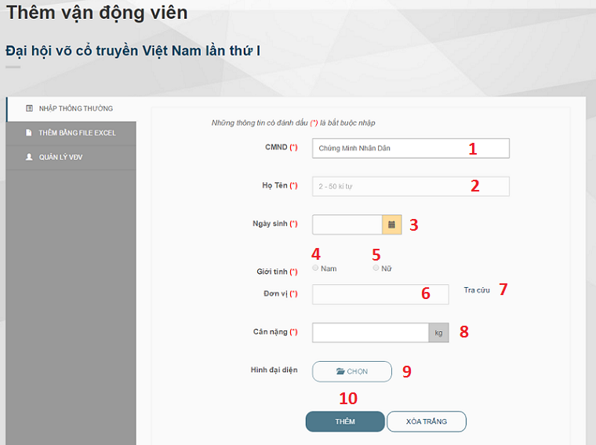

Figure 89: Add athlete to league page

**Fields**

|  |  |  |  |  |  |  |  |
| --- | --- | --- | --- | --- | --- | --- | --- |
| **No** | **Field Name** | **Description** | **Read only** | **Mandatory** | **Control Type** | **Data Type** | **Length** |
| 1 | Identity number | Fill athlete’s identity number | No | Yes | Textbox | int | 9 |
| 2 | Full name | Fill athlete’s full name | No (yes when athlete existed) | Yes | Textbox | String | 50 |
| 3 | Date of birth | Fill athlete’s date of birth | Yes | Yes | Datepicker | Datetime | N/A |
| 4 | Male | Athlete is a man | No (yes when athlete existed) | Yes | Radio button | String | N/A |
| 5 | Female | Athlete is a woman | No (yes when athlete existed) | Yes | Radio button | String | N/A |
| 6 | Unit | Show unit name | Yes | Yes | Textbox | String | N/A |
| 8 | Weight | Fill athlete’s weight | No | Yes | Textbox | Double | N/A |

**Buttons/Hyperlinks**

|  |  |  |  |  |
| --- | --- | --- | --- | --- |
| **No** | **Function** | **Description** | **Validation** | **Outcome** |
| 7 | Look up unit | Look up athlete’s unit | N/A | Show look up unit pop up |
| 9 | Browse image file | Browse image file | N/A | Show preview image employee chose |
| 10 | Add athlete | Add an athlete to league | N/A | Back to add athlete in to league page with message |

#### Update Athlete in League

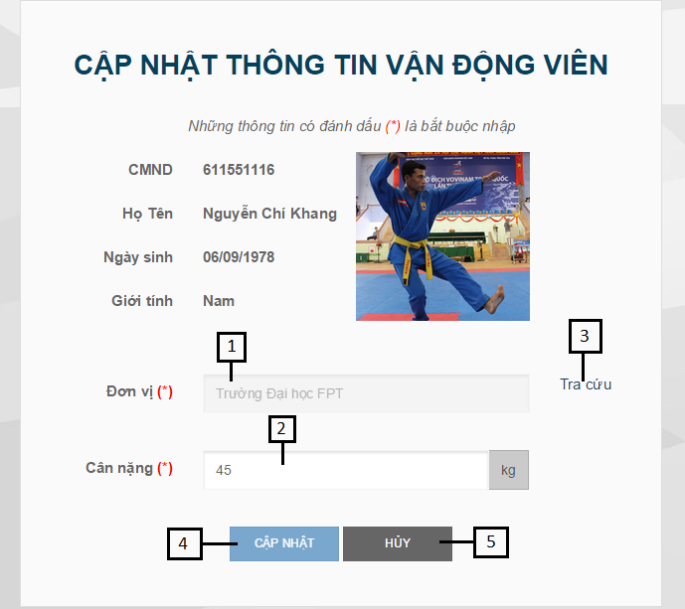

Figure 90: Update athlete in league page

**Fields**

|  |  |  |  |  |  |  |  |
| --- | --- | --- | --- | --- | --- | --- | --- |
| **No** | **Field Name** | **Description** | **Read only** | **Manda-tory** | **Control Type** | **Data Type** | **Length** |
| 1 | Unit Name | Name of unit | Yes | Yes | Textbox | String | N/A |
| 2 | Athlete weight | Weight of athlete | No | Yes | Textbox | String | N/A |

**Buttons/Hyperlinks**

|  |  |  |  |  |
| --- | --- | --- | --- | --- |
| **No** | **Function** | **Description** | **Validation** | **Outcome** |
| 3 | Search Unit | Search to choose unit | N/A | Show pop-up to choose unit |
| 4 | Update | Update new athlete information | N/A | Navigate to View Athletes In League page |
| 5 | Cancel | Cancel update | N/A | Navigate to View Athletes In League page |

#### Import Excel File

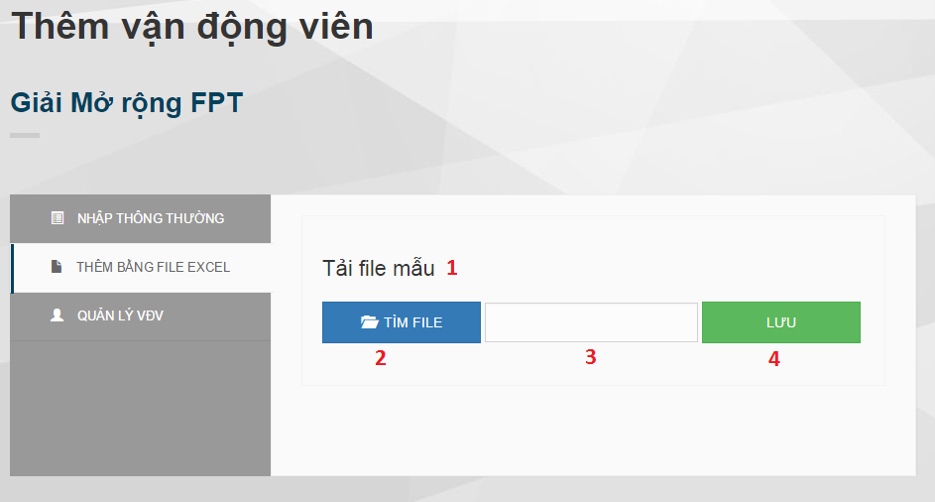

Figure 91: Import Excel tab

**Fields**

|  |  |  |  |  |  |  |  |
| --- | --- | --- | --- | --- | --- | --- | --- |
| **No** | **Field Name** | **Description** | **Read only** | **Mandatory** | **Control Type** | **Data Type** | **Length** |
| 3 | File name | Excel file name | Yes | Yes | Textbox | String | N/A |

**Buttons/Hyperlinks**

|  |  |  |  |  |
| --- | --- | --- | --- | --- |
| **No** | **Function** | **Description** | **Validation** | **Outcome** |
| 1 | Download template | Download template file | N/A | Template file will be downloaded |
| 2 | Browse file | Browse file | N/A | Show file name |
| 4 | Import excel | Import excel file | N/A | Back to add athlete into league page with message |

#### Choose Unit

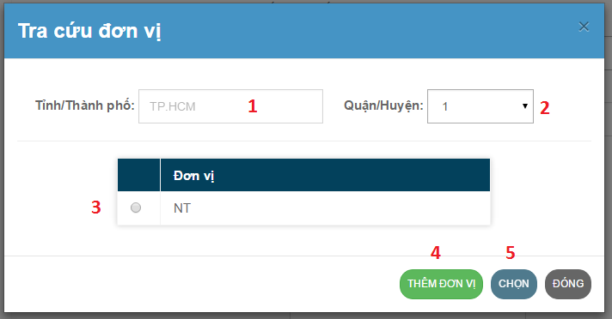

Figure 92: Choose unit pop up

**Fields**

|  |  |  |  |  |  |  |  |
| --- | --- | --- | --- | --- | --- | --- | --- |
| **No** | **Field Name** | **Description** | **Read only** | **Mandatory** | **Control Type** | **Data Type** | **Length** |
| 1 | City | City name | Yes, when league is held for only one city | Yes | Drop down list (text box when league is held for only one city) | String | N/A |
| 2 | District | District name | No | Yes | Drop down list | String | N/A |
| 3 | Unit | Choose unit | No | Yes | Check box | String | N/A |

**Buttons/Hyperlinks**

|  |  |  |  |  |
| --- | --- | --- | --- | --- |
| **No** | **Function** | **Description** | **Validation** | **Outcome** |
| 4 | Create unit | Show create unit pop up | N/A | Show create unit pop up |
| 5 | Select unit | Select an unit | N/A | Close look up unit pop up and show unit name on unit name text field of add athlete into league page |

#### Create Unit

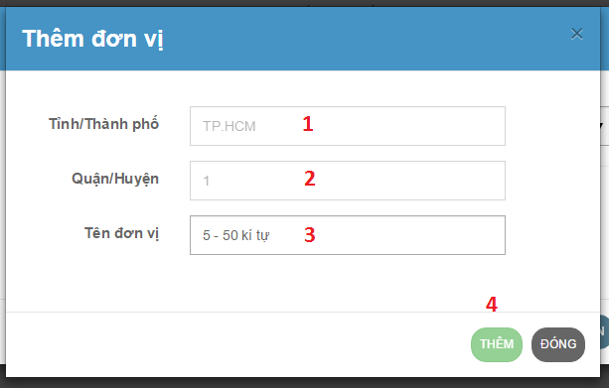

Figure 93: Create unit popup

**Fields**

|  |  |  |  |  |  |  |  |
| --- | --- | --- | --- | --- | --- | --- | --- |
| **No** | **Field Name** | **Description** | **Read only** | **Mandatory** | **Control Type** | **Data Type** | **Length** |
| 1 | City | Show city name | Yes | Yes | Textbox | String | N/A |
| 2 | District | Show district name | Yes | Yes | Textbox | String | N/A |
| 3 | Unit | Fill unit name | No | Yes | Textbox | String | 50 |

**Buttons/Hyperlinks**

|  |  |  |  |  |
| --- | --- | --- | --- | --- |
| **No** | **Function** | **Description** | **Validation** | **Outcome** |
| 4 | Create unit | Create a new unit | N/A | Back to Look up unit pop up and show new unit |

#### Draw number and Schedule League

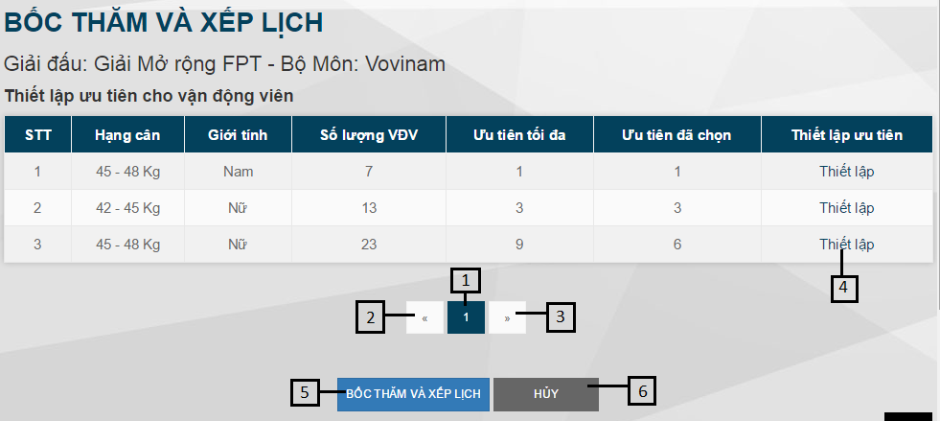

Figure 94: Draw number and Schedule League page

**Buttons/Hyperlinks**

|  |  |  |  |  |
| --- | --- | --- | --- | --- |
| **No** | **Function** | **Description** | **Validation** | **Outcome** |
| 1 |  |  | N/A |  |
| 2 |  |  | N/A |  |
| 3 |  |  | N/A |  |
| 4 | Set Priority | Set priority for athlete | N/A | Navigate to set priority page |
| 5 | Draw number and Schedule | Draw number and schedule the league | N/A |  |
| 6 | Cancel | Cancel draw number and schedule | N/A | Navigate to view created league list page |

#### Check Valid Subleague

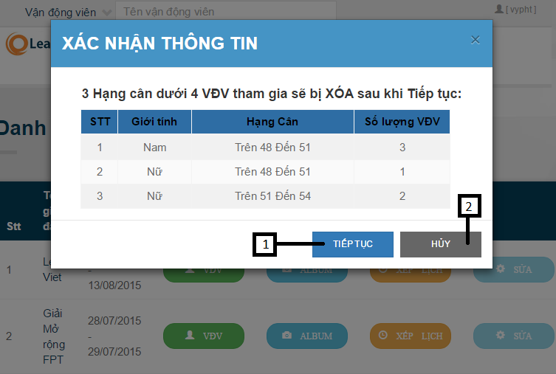

Figure 95: Check Valid Subleague popup

**Buttons/Hyperlinks**

|  |  |  |  |  |
| --- | --- | --- | --- | --- |
| **No** | **Function** | **Description** | **Validation** | **Outcome** |
| 1 | Check | Check the valid subleague before schedule the league. | N/A | Close pop-up |
| 2 | Cancel | Cancel check | N/A | Close pop-up |

#### Set Priority for Athlete

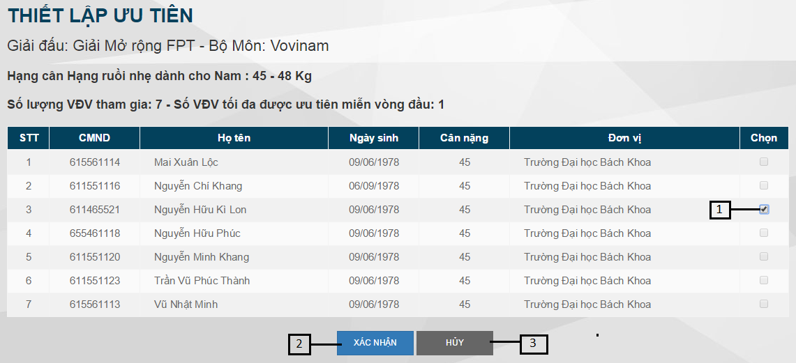

Figure 96: Set priority for Athlete page

**Fields**

|  |  |  |  |  |  |  |  |
| --- | --- | --- | --- | --- | --- | --- | --- |
| **No** | **Field Name** | **Description** | **Read only** | **Manda-tory** | **Control Type** | **Data Type** | **Length** |
| 1 | Choose | Choose athlete to set priority | No | N/A | Checkbox | boolean | N/A |

**Buttons/Hyperlinks**

|  |  |  |  |  |
| --- | --- | --- | --- | --- |
| **No** | **Function** | **Description** | **Validation** | **Outcome** |
| 1 | Set | Update new priority information. | N/A | Close pop-up |
| 2 | Cancel | Cancel set priority | N/A | Navigate to Draw number and schedule league page |

### Admin Interface Design

#### Create employee account

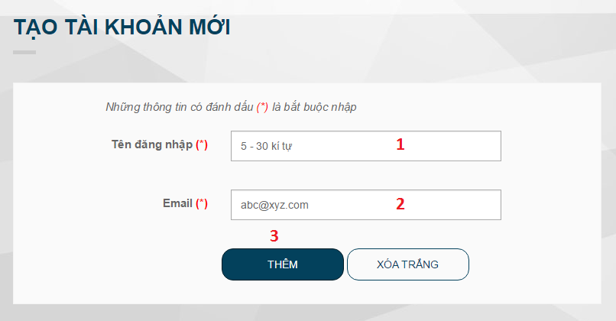

Figure 97: Create employee account page

**Fields**

|  |  |  |  |  |  |  |  |
| --- | --- | --- | --- | --- | --- | --- | --- |
| **No** | **Field Name** | **Description** | **Read only** | **Mandatory** | **Control Type** | **Data Type** | **Length** |
| 1 | Username | Fill user name | No | Yes | Textbox | String | 30 |
| 2 | Email | Fill email | No | Yes | Textbox | String | 50 |

**Buttons/Hyperlinks**

|  |  |  |  |  |
| --- | --- | --- | --- | --- |
| **No** | **Function** | **Description** | **Validation** | **Outcome** |
| 3 | Create account | Create a new employee account | N/A | Back to create account page with message |

#### Change account status

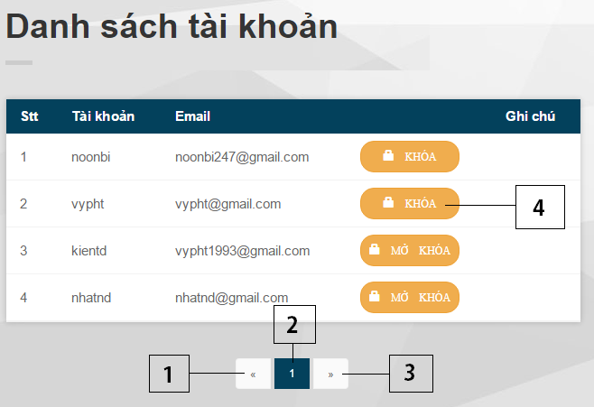

Figure 98: Change account status page

**Buttons/Hyperlinks**

|  |  |  |  |  |
| --- | --- | --- | --- | --- |
| **No** | **Function** | **Description** | **Validation** | **Outcome** |
| 1 | Next page | Go to next page | N/A | Transfer to next page |
| 2 | Specific page | Go to specific page | N/A | Tranfers to specific page |
| 3 | View Athlete Profile | Show profile of athlete | N/A | Show athlete profile pop-up |
| 4 | Change account status | Change status lock or unlock of account | N/A | N/A |

#### Change config system

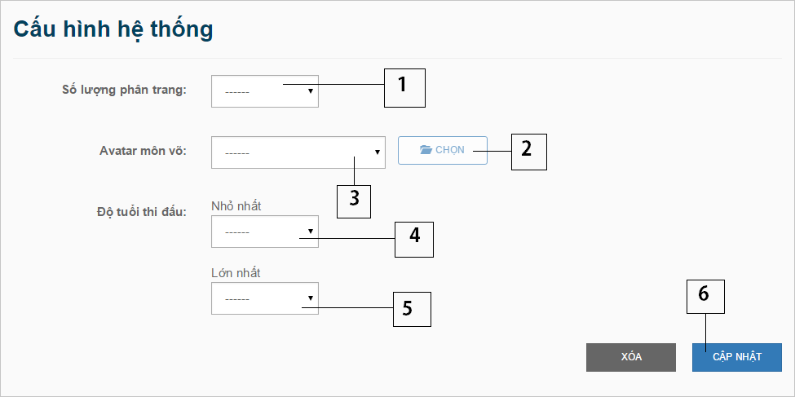

Figure 99: Change config system page

**Fields**

|  |  |  |  |  |  |  |  |
| --- | --- | --- | --- | --- | --- | --- | --- |
| **No** | **Field Name** | **Description** | **Read only** | **Mandatory** | **Control Type** | **Data Type** | **Length** |
| 1 | Page number | Number record in 1 page when page list. | No | No | Selectbox | int | N/A |
| 3 | Martial name | Name of martial | no | No | Selectbox | String | N/A |
| 4 | Min Age | Minimum Age to join league | No | No | Selectbox | int | N/A |
| 5 | Max Age | Maximum Age to join league | No | No | Selectbox | int | N/A |

**Buttons/Hyperlinks**

|  |  |  |  |  |
| --- | --- | --- | --- | --- |
| **No** | **Function** | **Description** | **Validation** | **Outcome** |
| 6 | Update | Update new config file | N/A | Show success pop-up |

## Database Design

### Logical Diagram

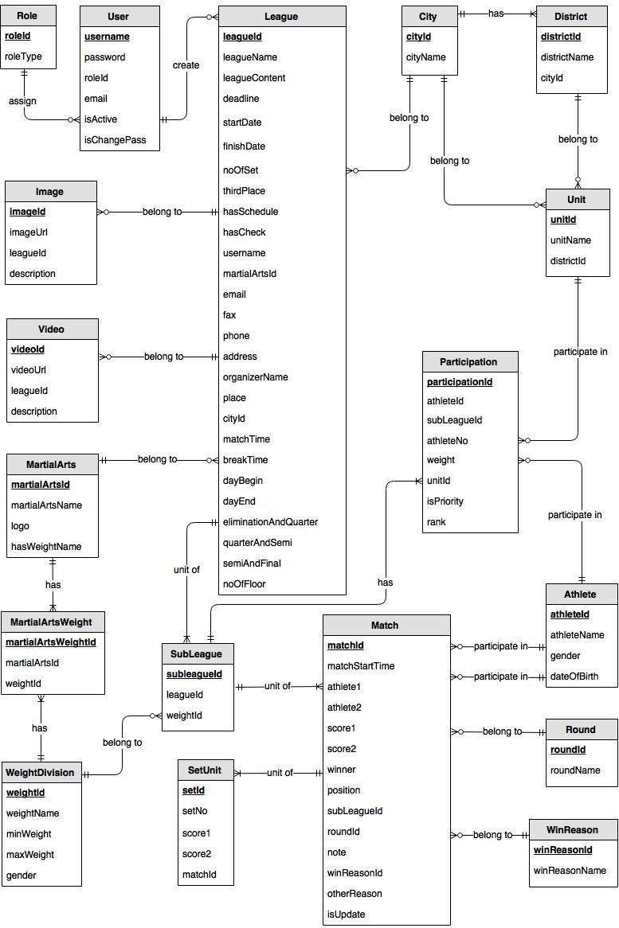

Figure 100: Logical Diagram

### Data Dictionary

|  |  |
| --- | --- |
| **Entity Data dictionary: describe content of all entities** | |
| Entity Name | Description |
| Role | Describe all roles in the system. |
| User | Describe all users in the system. Each user has only one account |
| League | Describe all leagues in the system. |
| MartialArts | Describe all martial arts in the system. |
| WeightDivision | Describe all weight division in the system. |
| MartialArtsWeight | Describe all weight division of each martial arts in the system |
| SubLeague | Describe all sub leagues in the system. Each sub league belongs to one weight division in one league. |
| Participation | Describe all athletes participate in each league, in each weight division |
| Unit | Describe all units in the system. |
| District | Describe all districts in the system. |
| City | Describe all cities in the system. |
| Athlete | Describe all athletes in the system. |
| Match | Describe all matches in the system. |
| Round | Describe all rounds in the system. |
| SetUnit | Describe all sets in the system. |
| Video | Describe all videos in the system. |
| Image | Describe all images in the system. |
| WinReason | Describe all win reasons of matches in the system. |

Table 9: Entity Data Dictionary

|  |  |  |  |  |
| --- | --- | --- | --- | --- |
| **Entity name** | **Attributes** | **Description** | **Domain** | **Null** |
| Role | roleId{PK} | Unique identifier of a role | int | No |
| roleType | Role name | varchar(10) | No |
| User | username{PK} | Unique identifier of an account | varchar(30) | No |
| password | Password of an account | varchar(20) | No |
| roleId{FK} | ID of account’s role | int | No |
| userEmail | Email address | varchar(50) | No |
| isActive | State of an account | bit | No |
| isChangePass | Account was changed password first time or not | bit | No |
| League | leagueId{PK} | Unique identifier of league, auto increment. | int | No |
| leagueName | Name of league | nvarchar(150) | No |
| leagueContent | Content of league | nvarchar(MAX) | Yes |
| deadline | Registration deadline | date | No |
| startDate | First round start date | date | No |
| finishDate | finish date of league | date | Yes |
| noOfSet | Number of set of each match | int | No |
| thirdPlace | League has third place match or not | bit | No |
| hasSchedule | League has schedule or not | bit | No |
| username{FK} | Username of employee who created that league | varchar(30) | No |
| martialArtsId{FK} | ID of martial arts which that league was held for. | int | No |
| email | Email address of organizers. | varchar(50) | No |
| fax | Fax of organizers. | varchar(50) | Yes |
| phone | Telephone number of organizers. | varchar(50) | No |
| address | Address of organizers. | nvarchar(MAX) | Yes |
| organizerName | Name of organizer. | nvarchar(50) | No |
| place | Place where league was held | nvarchar(MAX) | No |
| cityId{FK} | ID of city where that league belong to | int | Yes |
| matchTime | How long does each match take? | int | No |
| breakTime | How long does each break time (between 2 matches) take? | int | No |
| dayBegin | Point of time competition begins each day. | varchar(6) | No |
| dayEnd | Point of time competition ends each day. | varchar(6) | No |
| eliminationAndQuater | Number of day off between elimination round and quarter-final round | int | No |
| quarterAndSemi | Number of day off between quarter-final round and semi-final round | int | No |
| semiAndFinal | Number of day off between semi-final round and final round | int | No |
| noOfFloor | Number of floor each point of time can hold competition | int | No |
| hasCheck | Checked number of athletes of each weight division or not | bit | No |
| MartialArts | martialArtsId{PK} | Unique identifier of martial arts | int | No |
| martialArtsName | Name of martial arts | nvarchar(50) | No |
| logo | Logo image link of each martial arts | varchar(MAX) | Yes |
| hasWeightName | Weight division of martial art has weight name or not | bit | No |
| WeightDivision | weightId{PK} | Unique identifier of weight division | int | No |
| weightName | Name of weight division | nvarchar(50) | Yes |
| minWeight | Min weight of weight division | int | Yes |
| maxWeight | Max weight of weight division | int | Yes |
| gender | Gender of Athlete | nvarchar(3) | No |
| MartialArtsWeight | martialArtsWeightId{PK} | Unique identifier of MartialArtsWeight | int | No |
| martialArtsId{FK} | Id of Martial Arts | int | No |
| weightId{FK} | Id of Weight Division | int | No |
| SubLeague | subLeagueId{PK} | Unique identifier of a sub league | int | No |
| leagueId{FK} | ID of league which sub league belongs to | int | No |
| weightId{FK} | ID of weight division which sub league belongs to | int | No |
| numOfPriority | Number of priority athletes employee have to choose | int | Yes |
| numOfAthlete | Number of athletes in sub league | int | Yes |
| numOfRound | Number of rounds sub league has | int | Yes |
| chosenPriority | Number of priority athletes employee chose | int | Yes |
| Participation | participationId{PK} | Unique identifier of participation | int | No |
| athleteId{FK} | ID of athlete participates in that league | int | No |
| subleagueId{FK} | ID of sub league which participation belongs to | int | No |
| athleteNo | Candidate number of athlete when participate in that league | int | Yes |
| weight | Athlete’s weight when participate in that league | float | No |
| unitId{FK} | ID of unit which athlete belongs to when participate that league | int | No |
| isPriority | Athlete is priority or not | bit | Yes |
| Rank | Rank of the athlete in subleague | int | Yes |
| Unit | unitId{PK} | Unique identifier of a unit | int | No |
| unitName | Unit name | nvarchar(50) | No |
| districtId{FK} | Unit in District | int | Yes |
| cityId{FK} | Unit in city | int | No |
| District | districtId{PK} | Unique identifier of a District | int | No |
| districtName | District name | nvarchar(20) | No |
| cityId{FK} | District in City | int | No |
| City | cityId{PK} | Unique identifier of a City | int | No |
| cityName | City name | nvarchar(30) | No |
| Athlete | athleteId{PK} | Unique identifier of a Athlete | int | No |
| athleteName | Athlete name | nvarchar(50) | No |
| dob | Athlete’s date of birth | date | No |
| gender | Athlete’s gender | nvarchar(3) | No |
| avatar | Link of athlete’s avatar | varchar(MAX) | Yes |
| Match | matchId{PK} | Unique identifier of match | int | No |
| matchStartTime | Time start Match | datetime | No |
| athlete1{FK} | Id of Athlete 1 | int | Yes |
| athlete2{FK} | Id of Athlete 2 | int | Yes |
| winner | Winner of match. 1 for athlete 1 and 2 for athlete 2. | int | Yes |
| position | Position index of a match in play schedule diagram | int | No |
| subLeagueId{FK} | Id of SubLeague contain Match | int | No |
| roundId{FK} | Id of Round contain Match | int | No |
| note | Note of Match | nvarchar(MAX) | Yes |
| winReasonId | Id of win reason in a match | int | Yes |
| isUpdate | Match was updated or not | bit | No |
| score1 | Athlete 1’s final score in match | int | Yes |
| score2 | Athlete 2’s final score in match | int | Yes |
| otherReason | Other win reason not has in WinReason | nvarchar(MAX) | Yes |
| Round | roundId{PK} | Unique identifier of a round | int | No |
| roudName | Round name | nvarchar(50) | No |
| SetUnit | setId{PK} | Unique identifier of Set | int | No |
| setNo | Number of Set | int | No |
| score1 | Score for Athlete 1 | int | Yes |
| score2 | Score for Athlete 2 | int | Yes |
| matchId{FK} | Id of Match contain Set | int | No |
| Video | videoId{PK} | Unique identifier of a video | int | No |
| videoUrl | Link of video | varchar(MAX) | No |
| description | Description of video | nvarchar(MAX) | Yes |
| leagueId{FK} | ID of league video belongs to | int | No |
| Image | imageId{PK} | Unique identifier of an image | int | No |
| imageUrl | Link of an image | varchar(MAX) | No |
| leagueId{FK} | ID of league image belongs to | int | No |
| description | Description of image | nvarchar(MAX) | Yes |
| WinReason | winReasonId{PK} | ID of win reason | Int | No |
| winReasonName | Name of win reason | Nvarchar(MAX) | No |

Table 10: Detail Data Dictionary

## Algorithms

### Random swap

#### Definition

Random swap is the way to swap randomly elements of a list in specific range of index. It needs for draw number.

#### Define Problem

Given a list ***A***. Let swap randomly elements which are from index ***h*** to index ***f****.*

#### Solution

Input: h, f, list A

For i from h to f {

r = Random(i,f) “Random(i,f) is a random number within range [i, f]”

Swap A[i] and A[r]

}

#### Complexity

In total, the complexity of this algorithm is **O(n)** with **n** is the length of list A

#### Flowchart

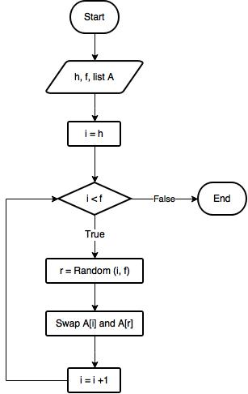

### Draw number

#### Definition

This is the way for the employee to draw number with specific athlete list before schedule league.

#### Define Problem

The athletes in a weight division need draw number to specify their position in the play diagram.

Structure of athlete list with ***n*** elements is as follows: The first ***p*** elements are athletes who have priority, remain elements are athletes who have no priority. (***p*** is number of athletes who have priority)

Requirement of output: athlete list with structure is as follows: The first ***e*** elements are athletes who are exempt from the first round, remain elements are athletes who are not exempt from the first round. (***e*** is maximum of athletes who can be exempt from the first round in a weight division)

#### Solution

Input: list A (athlete list), n, p, e

Random Swap A from p+1 to n “Random Swap: reference Algorithm 7.1”

Random Swap A from 1 to e

#### Complexity

In total, the complexity of this algorithm is **O(n)** with **n** is number of athletes who participate in the weight division.

#### Flowchart

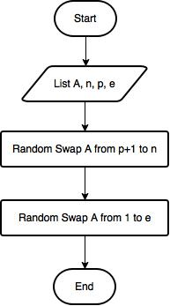

### Round number calculation

#### Definition

This is a formula to calculate the round number of the weight devision with specific athlete number.

#### Define Problem

Given a weight devision which **n** athletes participate in. Let calculate the round number of this weight division.

#### Solution

We use below formula to calculate round number:

*Round number* = Ceiling(**log2****n**)

with Ceiling (**x**) is the least integer that is greater than or equal to **x**.

#### Example

|  |  |  |  |  |  |  |  |
| --- | --- | --- | --- | --- | --- | --- | --- |
| Athlete number | 4 | 7 | 8 | 13 | 16 | 25 | 32 |
| **Round number** | **2** | **3** | **3** | **4** | **4** | **5** | **5** |

### Maximum exempt calculation

#### Definition

This is an algorithm to calculate the maximum of athletes who can be exempt from the first round in the weight division.

#### Define Problem

With specific athlete list has ***n*** elements of a weight division, the employee needs to know the maximum of athletes who can be exempt from the first round in the weight division. This maximum number is used for set priority, draw number and schedule league with play mode is knockout.

#### Solution

Call ***roundNumber*** is round number of the weight division.

When play diagram is shown by binary tree with root node is level 0, the number of exempt situation is the number of leaf nodes in level ***roundNumber – 1.***

Call **maxExempt** is the maximum of athletes who can be exempt from the first round in the weight division. Initial, **maxExempt = 0**

**Step 1:** We create a binary tree showing the play diagram:

* Create root node has value **n** and level 0
* For each **r** from 0 to **roundNumber – 2**:
  + For each fNode in level **r**
    - Set:
      * **fatherValue** = value of fNode
      * **leftChildValue** = Ceiling(fatherValue / 2)
      * **rightChildValue** = fatherValue – leftChildValue
      * **childLevel** = level of fNode + 1
    - Create left child node of fNode with value is **leftChildValue** and level is **childLevel**
    - Create right child node of fNode with value is **rightChildValue** and level is **childLevel**

**Step 2:** Count exempt situation in level **roundNumber – 1**

* For each fNode in level **roundNumber – 1**
  + If value of fNode is 1 that this is a exempt situation then **maxExempt = maxExempt + 1**

Finalresult is **maxExempt.**

#### Complexity

In total, the complexity of this algorithm is **O(n)** with **n** is athletes number of the weight division.

#### Flowchart

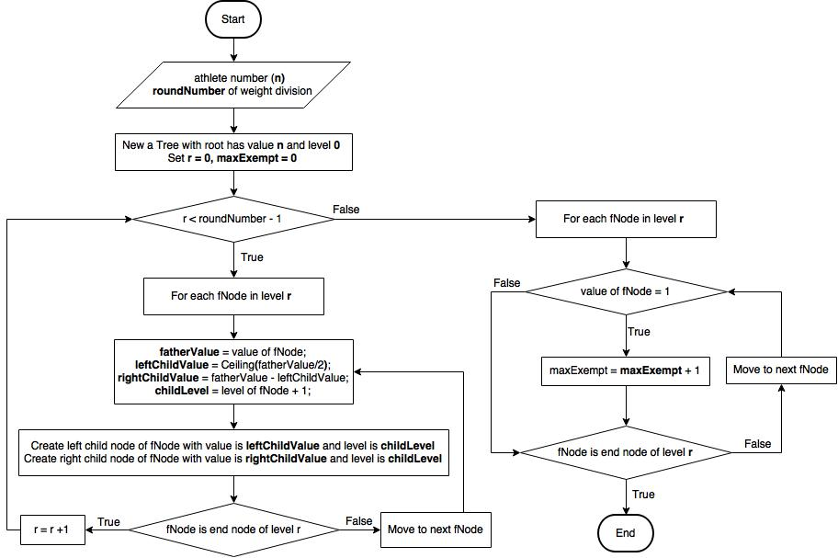

### League Schedule

#### Definition

This is an algorithm to schedule a league.

#### Define Problem

After all of weight divisions in a league are drawed number, the employee can schedule the league with play mode is knockout.

The athlete list in each weight division has structure is as follows: The first ***e*** elements are athletes who are exempt from the first round, remain elements are athletes who are not exempt from the first round. (***e*** is maximum of athletes who can be exempt from the first round in the weight division)

#### Solution

Call **Athletes** is athlete list in the weight division after draw number.

Call ***roundNumber*** is round number of the weight division.

When play diagram is shown by binary tree with root node is level 0, the leaf nodes in level ***roundNumber – 1*** are athletes who have exempt from the first round, the leaf nodes in level ***roundNumber*** are the remain athletes.

**Step 1:** Set **index** = 1

**Step 2:** We create a binary tree showing the play diagram:

* Create root node has value **n**, level 0 and position 1
* For each **r** from 0 to **roundNumber** :
  + - For each fNode in level **r :**
      * If value of fNode is 1 then
    - Set value of fNode = **Athletes** [index]
    - Index = index +1
      * Else
    - Set
      * **fatherValue** = value of fNode
      * **fatherPosition =** position of fNode
      * **leftChildValue** = Ceiling(fatherValue / 2)
      * **leftPosition =** 2 * fatherPosition
      * **rightChildValue** = fatherValue – leftChildValue
      * **rightPosition** =2 * fatherPosition +1
      * **childLevel** = level of fNode + 1
    - Create left child node of fNode with value is **leftChildValue**, level is **childLevel** and position is **leftPosition**
    - Create right child node of fNode with value is **rightChildValue**, level is **childLevel** and position is **rightPosition**

**Step 3:** Convert binary tree to match list and insert into Match Table in Database

* For each **r** from 1 to ***roundNumber***
  + For each pair of nodes in level **r** which having same father node
    - If value of left node is a athlete then set **leftAthlete** is value of left node else set **leftAthlete** is *NULL*
    - If value of right node is a athlete then set **rightAthlete** is value of left node else set **rightAthlete** is *NULL*
    - Insert new Match into Match Table in Database with value (position is father node's position, roundId is **r**, athlete1 is **leftAthlete** and athlete2 is **rightAthlete**)

#### Complexity

In total, the complexity of this algorithm is **O(n)** with **n** is athletes number of the weight division.

#### Flowchart

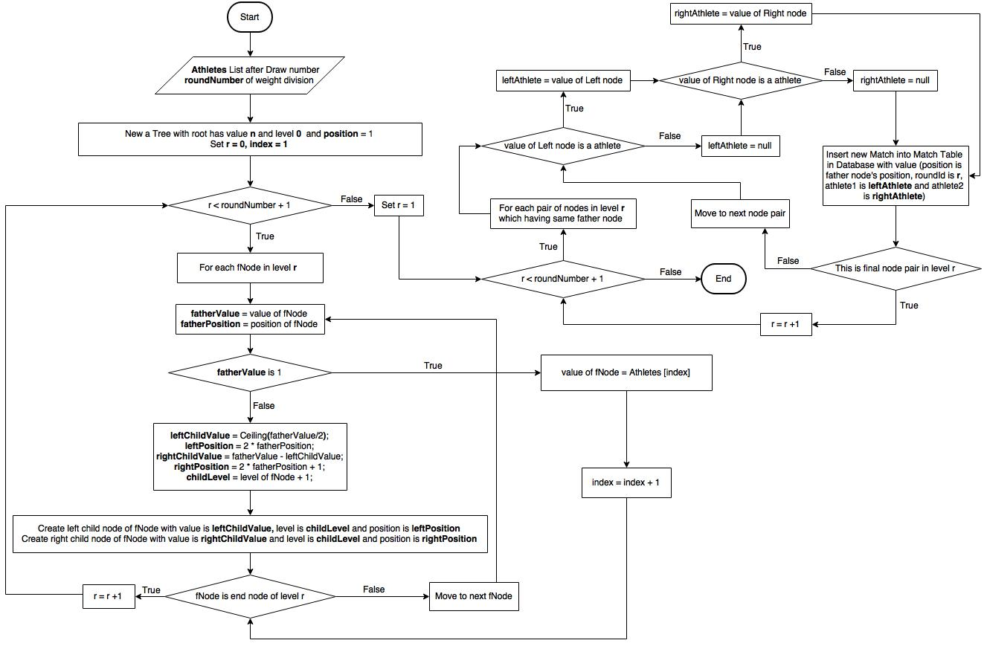

### Plan time

#### Define Problem

After arrange athletes to pairs, we have to arrange time for each match.

#### Requirement

* Arrange in order:
* Male first
* Weight divisions in ascending order
* First elimination round → second elimination round → quarter-final round → semi-final round → third place match → final round
* In elimination round, one or many matches happen at a same time, depend on number of floors.

#### Solution

* Step 1: set “*begin*” with day is league start date (gets from database) and time is league day begin (gets from database), “*end*” with day is league start date (gets from database) and time is league day end (gets from database).
* Step 2: get all matches in first elimination round with gender, weight divisions and position index of match in schedule diagram in ascending order.
* Step 3: if first elimination round has match:
* Step 3.1: set first match start time is “*begin*”
* Step 3.2: continue with next matches until reaching number of floors (gets from database).
* Step 3.3: update “*begin*”. New “*begin*” has time plus one match time and break time between 2 matches
* Step 3.4: set next matches start time if new “*begin*” has not equal “*end*” yet and time between new “*begin*” and “*end*” is enough for at least one more match, otherwise “*begin*” will be set again with day is the next day and time is day begin, and “*end*” will be set to next day too.
* Step 3.5: continue with another matches in first elimination round with above rules.
* Step 4: arrange similar with another rounds.

#### Complexity

In total, the complexity of this algorithm is **O(n)**

With **n** is number of matches in the league.

#### Flowchart

With:

* start date: day first round starts on, get from DB
* day begin: time first match on a day starts at, get from DB
* day end: time last match on a day must end at, get from DB
* day off: number of day off between 2 rounds
* no of floor: number of floors per time
* match time: time of a match
* break time: break time between 2 matches
* begin date: day of current “begin”

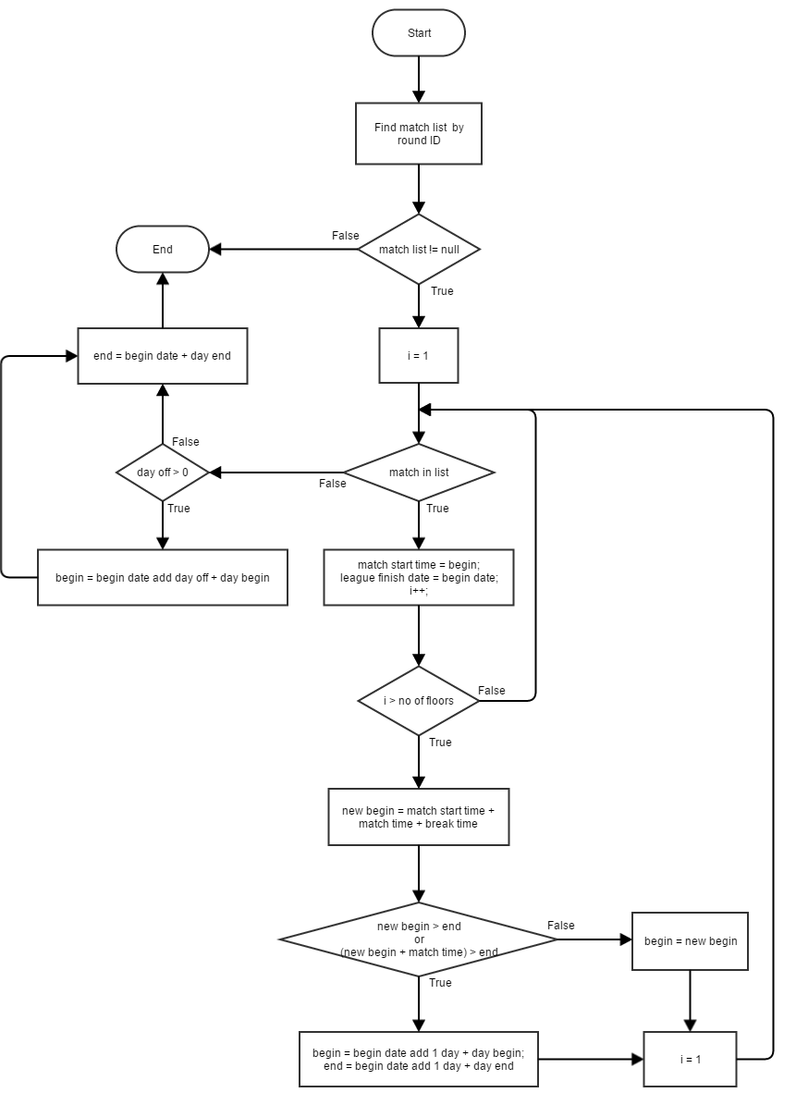

**Arrange time for a round**

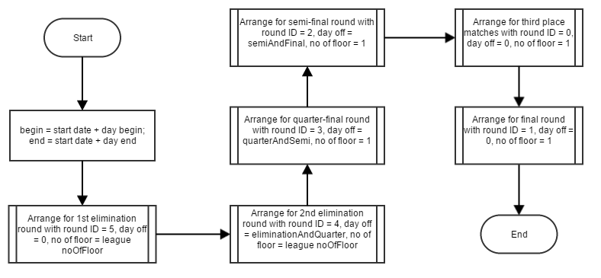

Plan time for a league

### Draw diagram

#### Define Problem

* Get list match and show in diagram follow assending order of round.

#### Solution

* If number of match > 15, divide list possion each round into 2 parts.  
  Else find highest round and get list possion in each round.
* Arrange possion match in highest round
* Print each round follow assending order

#### Complexity

#### Flowchart

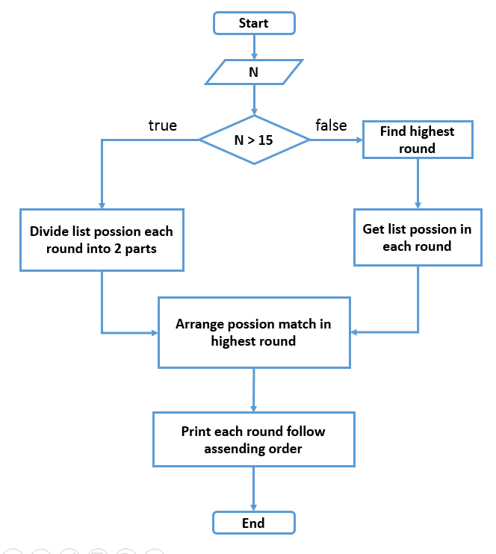

#### Example

List match get from database:  
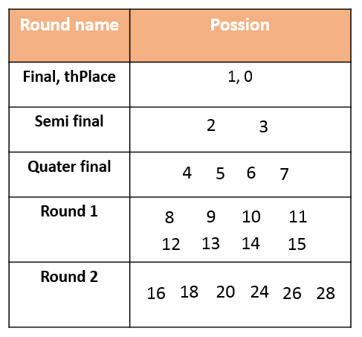  
After divided for two parts:  
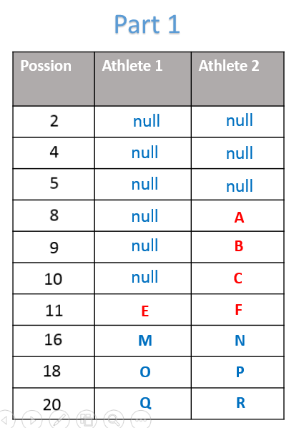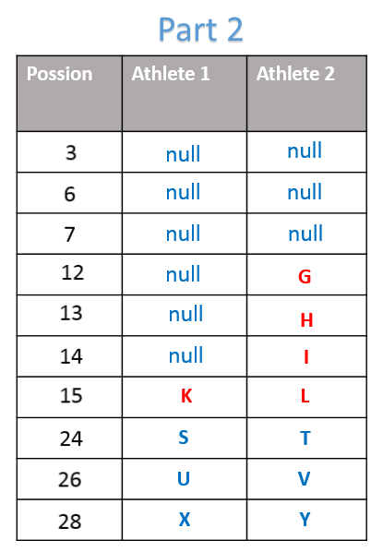  
Convert highest round and print result follow assending order:  
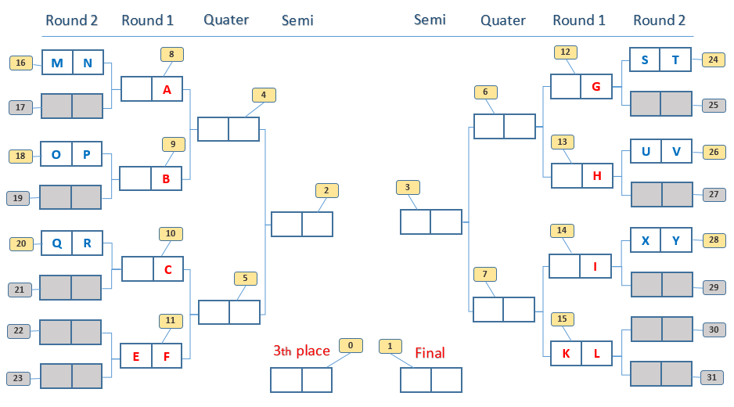

### Arrange possion match in highest round

#### Define Problem

Arrange possion match in highest round to draw diagram

#### Solution

* Given list A contain list possion match of highest round.
* Create list B depend on highest round.
* If (highest round > 4)   
   Begin  
   Check list A is part 1.  
   If(true) list B = {16 -> 23}  
   Else list B = {24 -> 31}  
   End
* Else if (highest round > 4)  
   list B = {8 -> 15}
* Else list B = {4 -> 7}
* Convert list B:  
   Foreach (element x in B)  
   If (x present in A) no change.  
   Else set x = 0.
* Return B

#### Complexity

- In total, the complexity of this algorithm is O(n2).

#### Flowchart

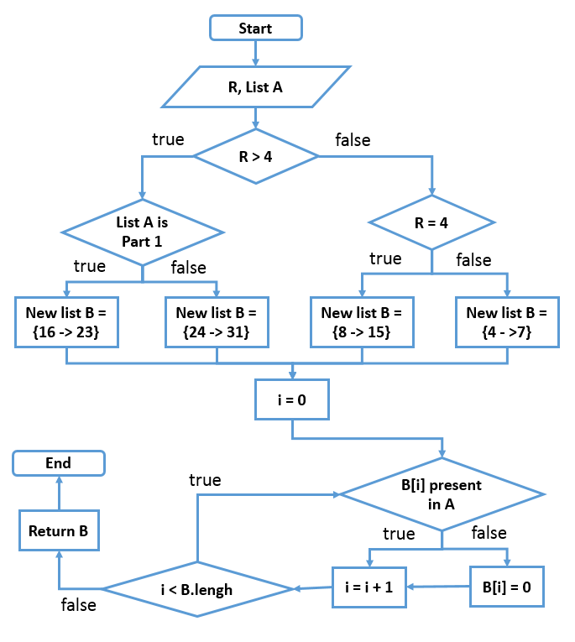

#### Example

* R = 4
* List B = { 8, 9, 10, 11, 12, 13, 14, 15 }
* List A = { 8, 10, 12 }
* After arrange possion: List B {8, 0, 10, 0, 12, 0, 0, 0}

# System Implementation & Test

## Introduction

### Overview

This section contains in detail of all necessary information about system implementation and testing of MATC includes test plans, test cases, test results.

### Test Approach

- Goal: To test the whole system based on the core flow.

- Method: System testing, Black box testing.

## Database Relationship Diagram

### Physical Diagram

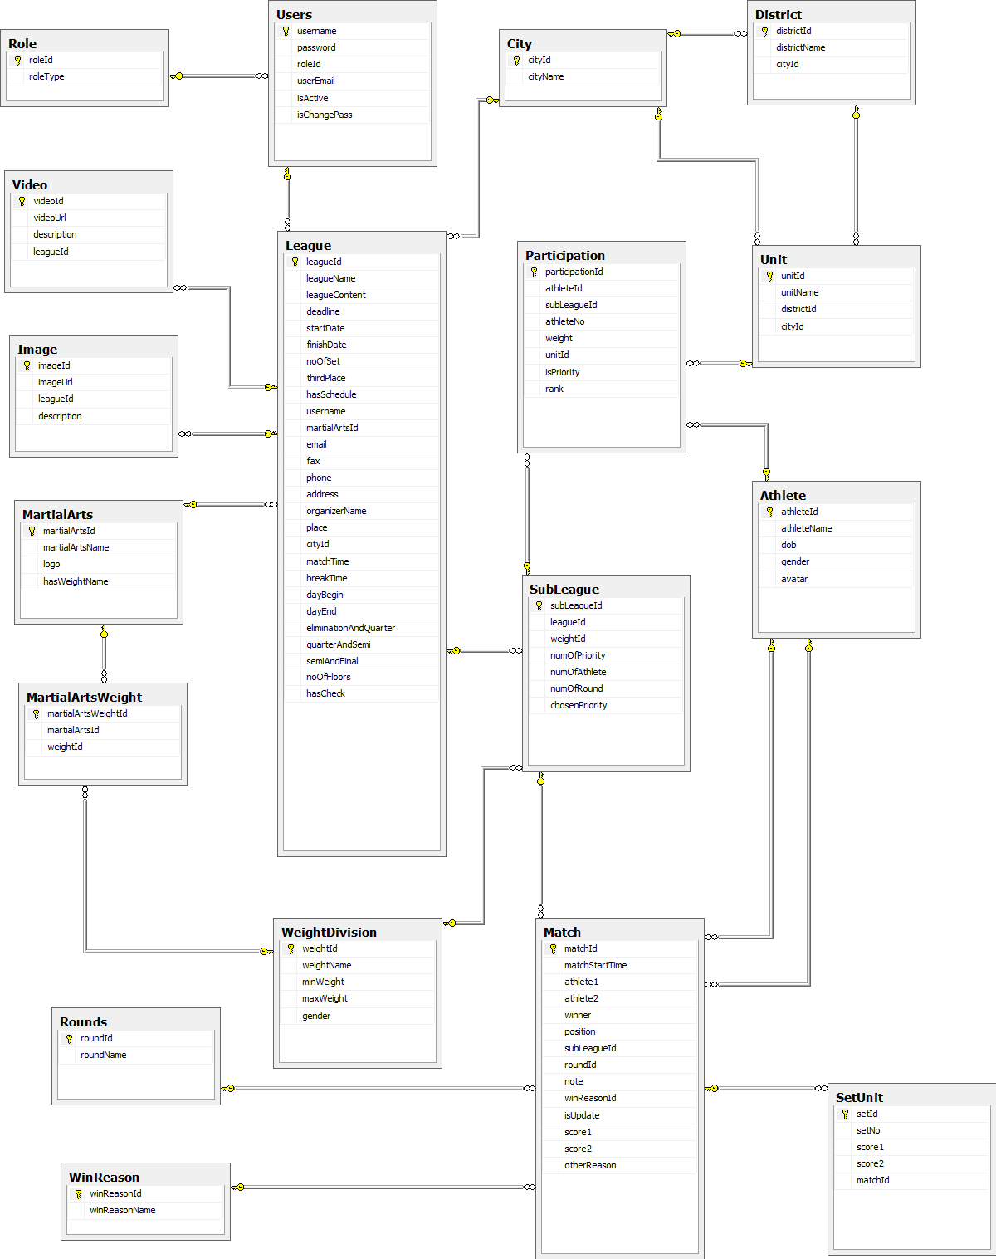

Figure 101: Physical Database Diagram

### Data Dictionary

|  |  |
| --- | --- |
| **Entity Data dictionary: describe content of all entities** | |
| Entity Name | Description |
| Role | Describe all roles in the system. |
| User | Describe all users in the system. Each user has only one account |
| League | Describe all leagues in the system. |
| MartialArts | Describe all martial arts in the system. |
| WeightDivision | Describe all weight division in the system. |
| MartialArtsWeight | Describe all weight division of each martial arts in the system |
| SubLeague | Describe all sub leagues in the system. Each sub league belongs to one weight division in one league. |
| Participation | Describe all athletes participate in each league, in each weight division |
| Unit | Describe all units in the system. |
| District | Describe all districts in the system. |
| City | Describe all cities in the system. |
| Athlete | Describe all athletes in the system. |
| Match | Describe all matches in the system. |
| Round | Describe all rounds in the system. |
| SetUnit | Describe all sets in the system. |
| Video | Describe all videos in the system. |
| Image | Describe all images in the system. |
| WinReason | Describe all win reasons of matches in the system. |

Table 11: Data Dictionary

|  |  |  |  |  |
| --- | --- | --- | --- | --- |
| **Entity name** | **Attributes** | **Description** | **Domain** | **Null** |
| Role | roleId{PK} | Unique identifier of a role | int | No |
| roleType | Role name | varchar(10) | No |
| User | username{PK} | Unique identifier of an account | varchar(30) | No |
| password | Password of an account | varchar(20) | No |
| roleId{FK} | ID of account’s role | int | No |
| userEmail | Email address | varchar(50) | No |
| isActive | State of an account | bit | No |
| isChangePass | Account was changed password first time or not | bit | No |
| League | leagueId{PK} | Unique identifier of league, auto increment. | int | No |
| leagueName | Name of league | nvarchar(150) | No |
| leagueContent | Content of league | nvarchar(MAX) | Yes |
| deadline | Registration deadline | date | No |
| startDate | First round start date | date | No |
| finishDate | finish date of league | date | Yes |
| noOfSet | Number of set of each match | int | No |
| thirdPlace | League has third place match or not | bit | No |
| hasSchedule | League has schedule or not | bit | No |
| username{FK} | Username of employee who created that league | varchar(30) | No |
| martialArtsId{FK} | ID of martial arts which that league was held for. | int | No |
| email | Email address of organizers. | varchar(50) | No |
| fax | Fax of organizers. | varchar(50) | Yes |
| phone | Telephone number of organizers. | varchar(50) | No |
| address | Address of organizers. | nvarchar(MAX) | Yes |
| organizerName | Name of organizer. | nvarchar(50) | No |
| place | Place where league was held | nvarchar(MAX) | No |
| cityId{FK} | ID of city where that league belong to | int | Yes |
| matchTime | How long does each match take? | int | No |
| breakTime | How long does each break time (between 2 matches) take? | int | No |
| dayBegin | Point of time competition begins each day. | varchar(6) | No |
| dayEnd | Point of time competition ends each day. | varchar(6) | No |
| eliminationAndQuater | Number of day off between elimination round and quarter-final round | int | No |
| quarterAndSemi | Number of day off between quarter-final round and semi-final round | int | No |
| semiAndFinal | Number of day off between semi-final round and final round | int | No |
| noOfFloor | Number of floor each point of time can hold competition | int | No |
| hasCheck | Checked number of athletes of each weight division or not | bit | No |
| MartialArts | martialArtsId{PK} | Unique identifier of martial arts | int | No |
| martialArtsName | Name of martial arts | nvarchar(50) | No |
| logo | Logo image link of each martial arts | varchar(MAX) | Yes |
| hasWeightName | Weight division of martial art has weight name or not | bit | No |
| WeightDivision | weightId{PK} | Unique identifier of weight division | int | No |
| weightName | Name of weight division | nvarchar(50) | Yes |
| minWeight | Min weight of weight division | int | Yes |
| maxWeight | Max weight of weight division | int | Yes |
| gender | Gender of Athlete | nvarchar(3) | No |
| MartialArtsWeight | martialArtsWeightId{PK} | Unique identifier of MartialArtsWeight | int | No |
| martialArtsId{FK} | Id of Martial Arts | int | No |
| weightId{FK} | Id of Weight Division | int | No |
| SubLeague | subLeagueId{PK} | Unique identifier of a sub league | int | No |
| leagueId{FK} | ID of league which sub league belongs to | int | No |
| weightId{FK} | ID of weight division which sub league belongs to | int | No |
| numOfPriority | Number of priority athletes employee have to choose | int | Yes |
| numOfAthlete | Number of athletes in sub league | int | Yes |
| numOfRound | Number of rounds sub league has | int | Yes |
| chosenPriority | Number of priority athletes employee chose | int | Yes |
| Participation | participationId{PK} | Unique identifier of participation | int | No |
| athleteId{FK} | ID of athlete participates in that league | int | No |
| subleagueId{FK} | ID of sub league which participation belongs to | int | No |
| athleteNo | Candidate number of athlete when participate in that league | int | Yes |
| weight | Athlete’s weight when participate in that league | float | No |
| unitId{FK} | ID of unit which athlete belongs to when participate that league | int | No |
| isPriority | Athlete is priority or not | bit | Yes |
| Unit | unitId{PK} | Unique identifier of a unit | int | No |
| unitName | Unit name | nvarchar(50) | No |
| districtId{FK} | Unit in District | int | Yes |
| cityId{FK} | Unit in city | int | No |
| District | districtId{PK} | Unique identifier of a District | int | No |
| districtName | District name | nvarchar(20) | No |
| cityId{FK} | District in City | int | No |
| City | cityId{PK} | Unique identifier of a City | int | No |
| cityName | City name | nvarchar(30) | No |
| Athlete | athleteId{PK} | Unique identifier of a Athlete | int | No |
| athleteName | Athlete name | nvarchar(50) | No |
| dob | Athlete’s date of birth | date | No |
| gender | Athlete’s gender | nvarchar(3) | No |
| avatar | Link of athlete’s avatar | varchar(MAX) | Yes |
| Match | matchId{PK} | Unique identifier of match | int | No |
| matchStartTime | Time start Match | datetime | No |
| athlete1{FK} | Id of Athlete 1 | int | Yes |
| athlete2{FK} | Id of Athlete 2 | int | Yes |
| winner | Winner of match. 1 for athlete 1 and 2 for athlete 2. | int | Yes |
| position | Position index of a match in play schedule diagram | int | No |
| subLeagueId{FK} | Id of SubLeague contain Match | int | No |
| roundId{FK} | Id of Round contain Match | int | No |
| note | Note of Match | nvarchar(MAX) | Yes |
| winReasonId | Id of win reason in a match | int | Yes |
| isUpdate | Match was updated or not | bit | No |
| score1 | Athlete 1’s final score in match | int | Yes |
| score2 | Athlete 2’s final score in match | int | Yes |
| otherReason | Other win reason not has in WinReason | nvarchar(MAX) | Yes |
| Round | roundId{PK} | Unique identifier of a round | int | No |
| roudName | Round name | nvarchar(50) | No |
| SetUnit | setId{PK} | Unique identifier of Set | int | No |
| setNo | Number of Set | int | No |
| score1 | Score for Athlete 1 | int | Yes |
| score2 | Score for Athlete 2 | int | Yes |
| matchId{FK} | Id of Match contain Set | int | No |
| Video | videoId{PK} | Unique identifier of a video | int | No |
| videoUrl | Link of video | varchar(MAX) | No |
| description | Description of video | nvarchar(MAX) | Yes |
| leagueId{FK} | ID of league video belongs to | int | No |
| Image | imageId{PK} | Unique identifier of an image | int | No |
| imageUrl | Link of an image | varchar(MAX) | No |
| leagueId{FK} | ID of league image belongs to | int | No |
| description | Description of image | nvarchar(MAX) | Yes |
| WinReason | winReasonId{PK} | Unique identifier of a win reason | int | No |
| winReasonName | Name of win reason | nvarchar(MAX) | Yes |

Table 12: Attribute Data Dictionary

## Performance Measures

### Schedule League

The complexity of Schedule League is **O(n * w)**

* w: number of weight divisions in a league
* n: number of athletes in the weight division

Because the number of weight divisions in a league is finite (about 30 weight divisions per a martial art) and the number of athletes in each weight division is small (less than 33 athletes), system will return result fast.

## Test Plan

The purpose of this section is to verify and ensure that MATC meets its design specification and other requirements from user. The following part will describe which features to be tested and which will not.

### Features to be tested

We will test the entire system based on the following core workflow (Reference: Figure **Core Flow**).

Based on the workflow, all following features will be tested, which can include one or more functions. These features will be focused and tested thoroughly during the test phase.

* + Guest: Search, View League Information, View Athlete Profile, View Play Schedule, View Play Diagram, View Match
  + Employee: Manage athlete, manage athlete in league, manage league, Drawnumber and Schedule League, Export excel, import excel, choose and create unit

### Features not to be tested

* + Guest: View Organnize Contact, View Result, View Image, View Video, login
  + Employee: manage video of league, manage image of league, change password, logout
  + Admin: manage account, config system, change password, logout

## System Testing Test Case

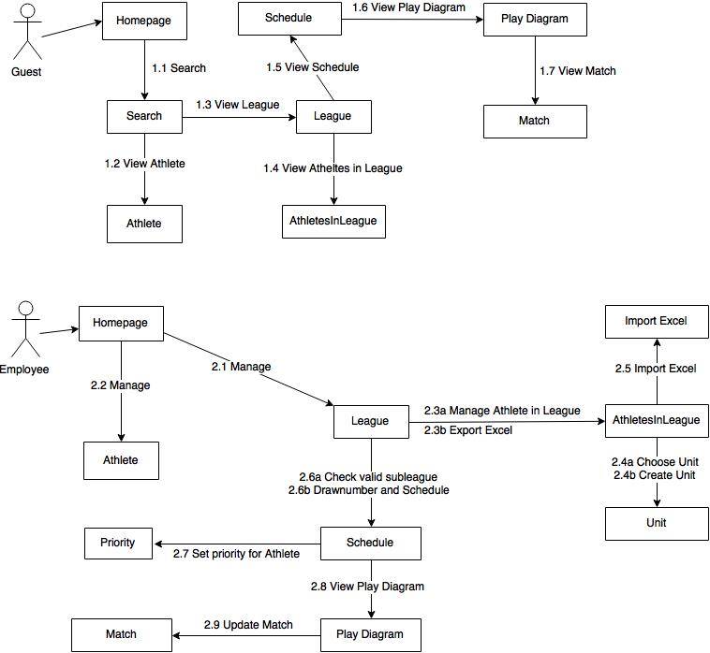

Figure 102: Core flow

### Guest Test Case

#### Search

|  |  |  |  |  |  |  |  |
| --- | --- | --- | --- | --- | --- | --- | --- |
| **ID** | **Test case Description** | **Test case Procedure** | **Expected output** | **Inter-test case dependence** | **Result** | **Test Date** | **Note** |
| S01 | Guest search athlete | 1 – On home page, select search athlete, enter search keyword and press enter | * Show search athlete result page |  | Passed | 20/07/2015 |  |
| S02 | Guest search league | 1 – On home page, select search league, enter search keyword and press enter | * Show search league result page |  | Passed | 20/07/2015 |  |
| S03 | No result match keyword | 1 – On home page, select search athlete or search league, enter search keyword and press enter | * Show search result page with message “Không có kết quả nào phù hợp!” |  | Passed | 20/07/2015 |  |

#### View Athlete

|  |  |  |  |  |  |  |  |
| --- | --- | --- | --- | --- | --- | --- | --- |
| **ID** | **Test case Description** | **Test case Procedure** | **Expected output** | **Inter-test case dependence** | **Result** | **Test Date** | **Note** |
| VA01 | Guest view athlete information | 1 – On search athlete result page, click “Xem thong tin” button | * Show athlete information popup | S01 | Passed | 20/07/2015 |  |

#### View League

|  |  |  |  |  |  |  |  |
| --- | --- | --- | --- | --- | --- | --- | --- |
| **ID** | **Test case Description** | **Test case Procedure** | **Expected output** | **Inter-test case dependence** | **Result** | **Test Date** | **Note** |
| VL01 | Guest view league information | 1 – On search league result page, click on league name link | * Show league information page | S02 | Passed | 20/07/2015 |  |

#### View Athlete in League

|  |  |  |  |  |  |  |  |
| --- | --- | --- | --- | --- | --- | --- | --- |
| **ID** | **Test case Description** | **Test case Procedure** | **Expected output** | **Inter-test case dependence** | **Result** | **Test Date** | **Note** |
| VA01 | Guest view list of athletes in league | 1 – On league information page, click “Danh sách VĐV” link | * Show athlete list in league page | VL01 | Passed | 20/07/2015 |  |
| VA02 | Guest search athlete in league | 1 – On athlete list page, enter name, select is priority or not, gender, weight division and click search button | * Show appropriate list of athletes in league | VAL01 | Passed | 20/07/2015 |  |

#### View Schedule

|  |  |  |  |  |  |  |  |
| --- | --- | --- | --- | --- | --- | --- | --- |
| **ID** | **Test case Description** | **Test case Procedure** | **Expected output** | **Inter-test case dependence** | **Result** | **Test Date** | **Note** |
| VS01 | Guest view play schedule | 1 – On league information page, click “Lịch thi đấu” link | * Show Play schedule page of the lightest weight division of male | VL01 | Passed | 20/07/2015 |  |
| VS02 | Guest view a specific weight division play diagram | 1 – On play schedule page, enter gender, weight division, round and click search button | * Show the appropriate play schedule | VS01 | Passed | 20/07/2015 |  |

#### View Play Diagram

|  |  |  |  |  |  |  |  |
| --- | --- | --- | --- | --- | --- | --- | --- |
| **ID** | **Test case Description** | **Test case Procedure** | **Expected output** | **Inter-test case dependence** | **Result** | **Test Date** | **Note** |
| VPD01 | Guest view play diagram | 1 – On play schedule page, click “Xem sơ đồ thi đấu” link | * Show appropriate play diagram page of that weight division | VS01 | Passed | 20/07/2015 |  |
| VPD02 | Guest view play diagram in different size | 1 – On Play diagram page, select zoom in 75% or 50% | * Zoom in or zoom out appropriately | VPD01 | Passed | 20/07/2015 |  |

#### View Match

|  |  |  |  |  |  |  |  |
| --- | --- | --- | --- | --- | --- | --- | --- |
| **ID** | **Test case Description** | **Test case Procedure** | **Expected output** | **Inter-test case dependence** | **Result** | **Test Date** | **Note** |
| VM01 | Guest view match information | 1 – On play diagram page, click on match box | * Show match information popup | VPD01 | Passed | 20/07/2015 |  |

### Employee Test Case

#### Manage League

|  |  |  |  |  |  |  |  |
| --- | --- | --- | --- | --- | --- | --- | --- |
| **ID** | **Test case Description** | **Test case Procedure** | **Expected output** | **Inter-test case dependence** | **Result** | **Test Date** | **Note** |
| ML01 | Employee create a new league | 1 – Employee click “Tạo giải đấu mới” link on menu bar  2 – Input data  3 – Click “Thêm” button | * After step 1: Show create league page * After step 3: show success message |  | Passed | 20/07/2015 |  |
| ML02 | Employee view list of created leagues | 1 – Employee click “Các giải đấu của bạn” link on menu bar | * Show manage league page |  | Passed | 20/07/2015 |  |
| ML03 | Employee has no league | 1 – Employee click “Các giải đấu của bạn” link on menu bar | * Show manage league page with message “Chưa có giải đấu nào do bạn tạo” |  | Passed | 20/07/2015 |  |
| ML04 | Employee update league information | 1 – Employee click “Sửa” button on manage league page.  2 – Input new data  3 – Click “Lưu” button | * After step 1: Show update league page * After step 3: Show success message | ML02 | Passed | 20/07/2015 |  |
| ML05 | Employee delete a league | 1 – Employee click “Xóa” button on manage league page  2 – Click “Có” button | * After step 1: Show confirm popup * After step 2: Reload manage league page, league was remove from list | ML02 | Passed | 20/07/2015 |  |

#### Manage Athlete

|  |  |  |  |  |  |  |  |
| --- | --- | --- | --- | --- | --- | --- | --- |
| **ID** | **Test case Description** | **Test case Procedure** | **Expected output** | **Inter-test case dependence** | **Result** | **Test Date** | **Note** |
| MA01 | Employee create a new athlete | 1 – Employee click “Tạo vận động viên mới” link on menu bar  2 – Input data  3 – Click “Thêm” button | * After step 1: Show create athlete page * After step 3: show success message |  | Passed | 20/07/2015 |  |
| MA02 | Employee view list of athletes | 1 – Employee click “Danh sách vận động viên” link on menu bar | * Show manage athlete page |  | Passed | 20/07/2015 |  |
| MA03 | Employee update athlete information | 1 – Employee click “Xem thông tin” button on manage athlete page.  2 – Input new data  3 – Click “Cập nhật” button | * After step 1: Show athlete information popup * After step 3: Show success message popup | MA02 | Passed | 20/07/2015 |  |
| MA04 | Employee delete a athlete | 1 – Employee click “Xóa” button on athlete information popup  2 – Click “Xóa” button | * After step 1: Show confirm popup * After step 2: Reload manage athlete page, athlete was remove from list, show success message popup | MA02 | Passed | 20/07/2015 |  |

#### Athlete in League

1. Manage Athlete in League

|  |  |  |  |  |  |  |  |
| --- | --- | --- | --- | --- | --- | --- | --- |
| **ID** | **Test case Description** | **Test case Procedure** | **Expected output** | **Inter-test case dependence** | **Result** | **Test Date** | **Note** |
| MAL01 | Employee add a new athlete into league | 1 – Employee click “Thêm vận động viên” link on athlete list in league page  2 – Input data  3 – Click “Thêm” button | * After step 1: Show add athlete into league page * After step 3: Show success message | VAL01 | Passed | 20/07/2015 |  |
| MAL02 | Employee update athlete information in league | 1 – Employee click “Cập nhật” button on manage athlete in league page.  2 – Select new unit and enter new weight  3 – Click “Cập nhật” button | * After step 1: Show update athlete in league page * After step 3: Back to Manama athlete in league page, show success message | MAL01 | Passed | 20/07/2015 |  |
| MAL03 | Employee delete an athlete in league | 1 – Employee click “Xóa” button on manage athlete in league page  2 – Click “Có” button | * After step 1: Show confirm popup * After step 2: Reload manage athlete in league page, athlete was remove from list | MAL01 | Passed | 20/07/2015 |  |

1. Export Excel

|  |  |  |  |  |  |  |  |
| --- | --- | --- | --- | --- | --- | --- | --- |
| **ID** | **Test case Description** | **Test case Procedure** | **Expected output** | **Inter-test case dependence** | **Result** | **Test Date** | **Note** |
| EE01 | Employee export list of athletes in league to excel file | 1 – Employee click “Tải danh sách” link on athlete list in league page | * List of athletes in league export to excel file | VAL01 | Passed | 20/07/2015 |  |

#### Unit

1. Choose Unit

|  |  |  |  |  |  |  |  |
| --- | --- | --- | --- | --- | --- | --- | --- |
| **ID** | **Test case Description** | **Test case Procedure** | **Expected output** | **Inter-test case dependence** | **Result** | **Test Date** | **Note** |
| CU01 | Employee choose an unit for athlete | 1 – Employee click “Tra cứu” link on add athlete into league or athlete information in league page  2 – Select city and district  3 – Select an unit  4 – Click “Chọn” button | * After step 1: Show lookup unit popup * After step 2: Show list of units in city and district has chosen * After step 4: Hide lookup unit popup and show unit name | MAL01 | Passed | 20/07/2015 |  |
| CU02 | City and district has chosen has no unit | 1 – Employee click “Tra cứu” link on add athlete into league or athlete information in league page  2 – Select city and district | * After step 1: Show lookup unit popup * After step 2: Show message “Chưa có đơn vị” | MAL01 | Passed | 20/07/2015 |  |

1. Create Unit

|  |  |  |  |  |  |  |  |
| --- | --- | --- | --- | --- | --- | --- | --- |
| **ID** | **Test case Description** | **Test case Procedure** | **Expected output** | **Inter-test case dependence** | **Result** | **Test Date** | **Note** |
| CRU01 | Employee create a new unit | 1 – Employee click “Thêm đơn vị” button on lookup unit popup  2 – Enter unit name  3 – Click “Thêm” button | * After step 1: Show create unit popup with city name and district name has chosen * After step 3: Hide create unit popup, show new unit in list of units on lookup unit popup | CU01 | Passed | 20/07/2015 |  |

#### Import Excel

|  |  |  |  |  |  |  |  |
| --- | --- | --- | --- | --- | --- | --- | --- |
| **ID** | **Test case Description** | **Test case Procedure** | **Expected output** | **Inter-test case dependence** | **Result** | **Test Date** | **Note** |
| IE01 | Employee add list of athletes into league | 1 – Employee click “Thêm bằng file excel” tab link on add athlete into league page  2 – Click “Tìm file” button  3 – Select a file  4 – Click “Lưu” button | * After step 1: Show import excel file tab * After step 2: Browse file * After step 3: Show file name * After step 4: Show message | MAL01 | Passed | 20/07/2015 |  |
| IE02 | Employee download template file | 1 – Employee click “Tải file mẫu” link | * Template file is downloaded | IE01 | Passed | 20/07/2015 |  |

#### Schedule

1. Check valid sub league

|  |  |  |  |  |  |  |  |
| --- | --- | --- | --- | --- | --- | --- | --- |
| **ID** | **Test case Description** | **Test case Procedure** | **Expected output** | **Inter-test case dependence** | **Result** | **Test Date** | **Note** |
| CVSL01 | Employee check if all of sub leagues in league is valid or not | 1 – Employee click “Xếp lịch” link on manage league page  2 – Click “Tiếp tục” button. | * After step 1: Show confirm popup * After step 2: Show draw number page | VAL01 | Passed | 20/07/2015 |  |

1. Draw number and Schedule

|  |  |  |  |  |  |  |  |
| --- | --- | --- | --- | --- | --- | --- | --- |
| **ID** | **Test case Description** | **Test case Procedure** | **Expected output** | **Inter-test case dependence** | **Result** | **Test Date** | **Note** |
| DNS01 | Employee draw number for all athlete and schedule for league | 1 – Employee click “Bốc thăm và xếp lịch” link on draw number page | * Show play schedule page and show success message | CVSL01 | Passed | 20/07/2015 |  |

#### Set priority for Athlete

|  |  |  |  |  |  |  |  |
| --- | --- | --- | --- | --- | --- | --- | --- |
| **ID** | **Test case Description** | **Test case Procedure** | **Expected output** | **Inter-test case dependence** | **Result** | **Test Date** | **Note** |
| SPA01 | Employee set priority for athlete before draw number and schedule | 1 – Employee click “Thiết lập” link on draw number page  2 – Select priority athlete  3 – Click “Xác nhận” button | * After step 1: Show View priority page * After step 3: Back to draw number page with number of priority athletes has chosen | DNS01 | Passed | 20/07/2015 |  |

#### View Play Diagram

Reference VPD01

#### Update Match

|  |  |  |  |  |  |  |  |
| --- | --- | --- | --- | --- | --- | --- | --- |
| **ID** | **Test case Description** | **Test case Procedure** | **Expected output** | **Inter-test case dependence** | **Result** | **Test Date** | **Note** |
| UM01 | Employee update match result | 1 – Employee click on match on play diagram page  2 – Input data  3 – Click “Cập nhật” button | * After step 1: Show match information popup. * After step 2: Hide match information popup and show result on play diagram page | VPD01 | Passed | 20/07/2015 |  |

# Software User’s Manual

## Installation Guide

### Setting up environment at server side

#### Hardware requirements

* **In order to run the website smoothly, you will need a computer with the following requirement:**
* Operating system: Window XP or later version of window
* Processor: 1GHz or above
* Memory: 256 MB or above
* Hard drive: 1 GB of free hard drive space or above
* Screen resolution: 1024 x 768 or higher
* Chrome, Firefox, IE...We recommend using the latest for any browser.

#### Software requirements

* **The following software must be installed the server machine:**
* Microsoft .Net framework version 4.0 or higher version  
  (download link: [*http://www.microsoft.com/en-us/download/details.aspx?id=17718*](http://www.microsoft.com/en-us/download/details.aspx?id=17718))
* Microsoft SQL Server 2008 R2 Express or higher  
  (dowload link: : [*http://www.microsoft.com/en-us/download/details.aspx?id=22973*](http://www.microsoft.com/en-us/download/details.aspx?id=22973))
* Install Internet Information Services (IIS)   
  (follow install guild here: [*http://msdn.microsoft.com/en-us/library/dd578622%28=vs.100%29.aspx*](http://msdn.microsoft.com/en-us/library/dd578622%28=vs.100%29.aspx))

### Deployment at server side

#### Prepare deployment package

* Database file: MATCDB.mdf
* Source code file: MATC.zip

#### Configure Server before deploy

* **Configure database:**

<connectionStrings>

<add name="ConnectionString" connectionString="Data Source=.\sql2008;Initial Catalog=MATCDB;Persist Security Info=False;User ID=sa;Password=123456" providerName="System.Data.SqlClient" />

</connectionStrings>

* Catalog: Database name.
* ID: Username database.
* Password: password.
* **Configure Mail server:**

<mailSetting>

<smtp deliveryMethod=”Network”>

<network

host=”smtp.gmail.com”  
 userName=”matcserver@gmail.com”

passwork=”123456”  
 enableSsl=”true”/>

</smtp>

</ mailSetting >

* Host: smtp of mail server
* Username: username (email) user to logon smtp server
* Password: password

#### Deploy web application on server

* **Deploy database:**
* Attack MATCDB.mdf to SQL server 2008 R2.
* **Deploy source code:**
* Open IIS Manager.
* If you don’t have default website yet: right click on Sites -> Add website... Enter Site name, Location to store the website, Port, Hostname.
* Right click on site has created, choose Deploy -> Import application.
* Browser to MATC.zip deployment package.
* Check all select rules.
* Change the Path of application.
* Change the connection string to database.
* Click Next and Finish.

### Setting up the environment at client side

#### Setting up for computer

* The client devices need to have one of the following browsers to launch the website:
* Mozilla Firefox (link dowload: <http://www.mozilla.org>)
* Google Chrome (link download: <http://www.google.com/Chrome>)
* Microsoft Internet Explorer (link download: <http://www.windows.microsoft.com/en-us/internet-explorer/downloads/ie>)
* We recommend using the latest for any browser.

## User Guide

### Guest

#### Search Athlete

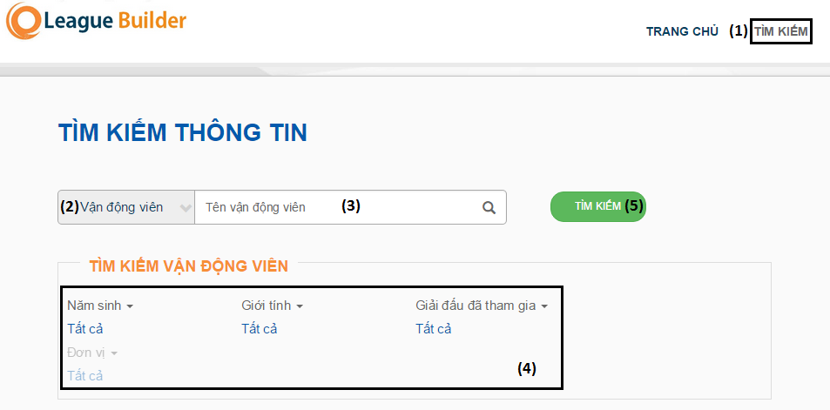

|  |  |
| --- | --- |
| **Step** | **Description** |
| 1 | Click “Tìm kiếm” link on layout menu |
| 2 | Select “Vận động viên” dropdownlist |
| 3 | Input “Tên vận động viên” |
| 4 | Select “Năm sinh”, “Giới tính”, “Giải đấu đã tham gia”, “Đơn vị” |
| 5 | Click “Tìm kiếm button” |

#### Search League

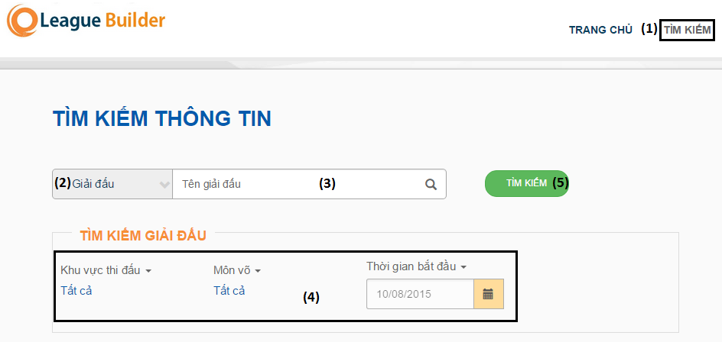

|  |  |
| --- | --- |
| **Step** | **Description** |
| 1 | Click “Tìm kiếm” link on layout menu |
| 2 | Select “Giải đấu” dropdownlist |
| 3 | Input “Tên giải đấu” |
| 4 | Select ”Khu vực thi đấu”, “Môn võ”, “Thời gian bắt đầu” |
| 5 | Click “Tìm kiếm” button |

### Employee

#### Login

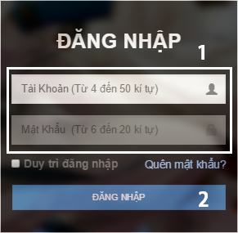

|  |  |
| --- | --- |
| **Step** | **Description** |
| 1 | Input account and password |
| 2 | Click “Đăng nhập” button |

#### Create League

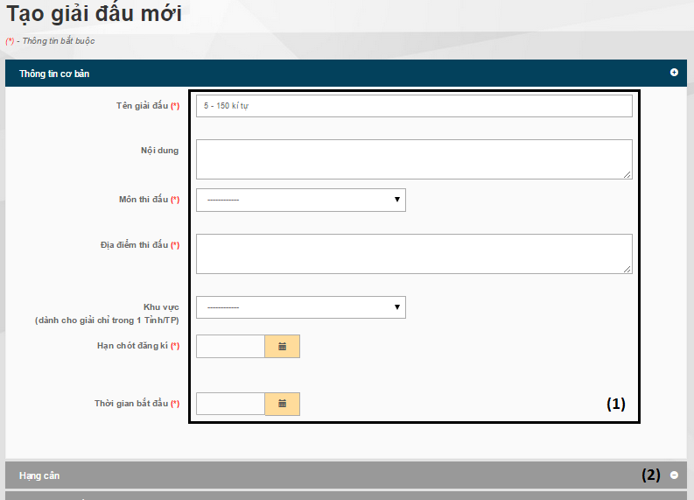

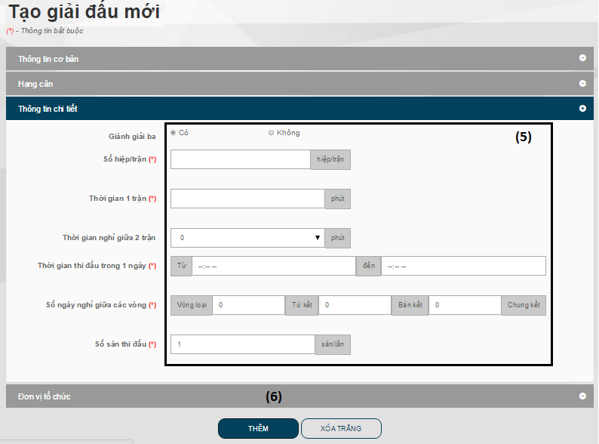

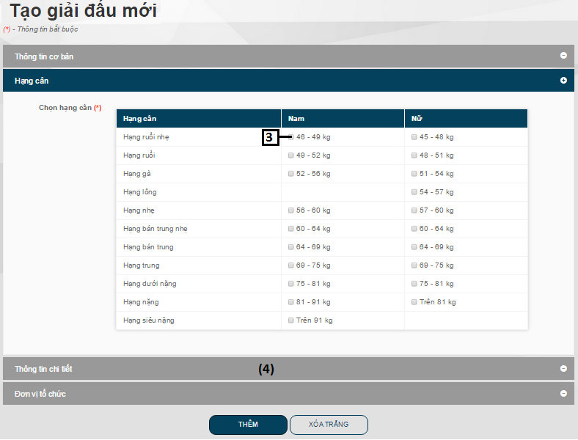

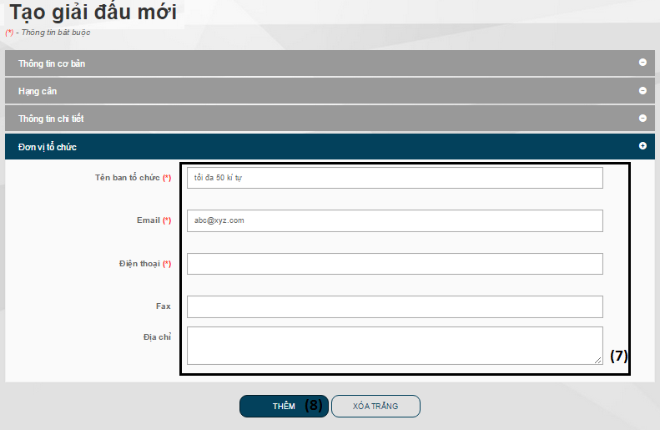

|  |  |
| --- | --- |
| **Step** | **Description** |
| 1 | Input basic information of League |
| 2 | Click “Thêm hạng cân” tab |
| 3 | Select weight division |
| 4 | Click “Thông tin chi tiết” tab |
| 5 | Input detail information of League |
| 6 | Click “Đơn vị tổ chức” tab |
| 7 | Input information of organization |
| 8 | Click “Thêm” button |

#### Add Athlete

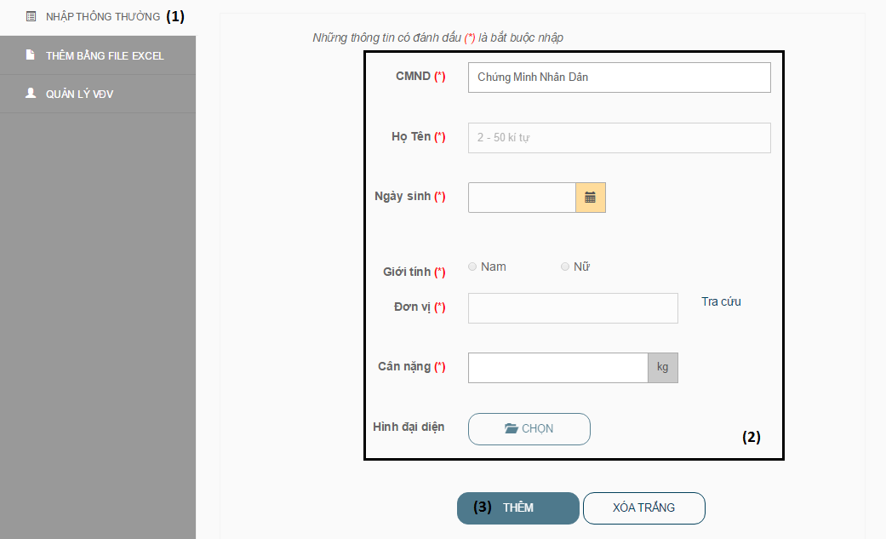

|  |  |
| --- | --- |
| **Step** | **Description** |
| 1 | Click “Nhập thông thường” link |
| 2 | Input athlete information |
| 3 | Click “Thêm” button |

#### Choose Unit

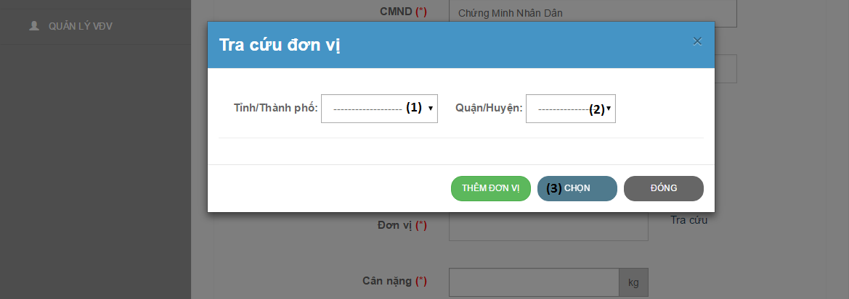

|  |  |
| --- | --- |
| **Step** | **Description** |
| 1 | Select City dropdownlist |
| 2 | Select district dropdownlist |
| 3 | Click “Chọn” button |

#### Import Excel

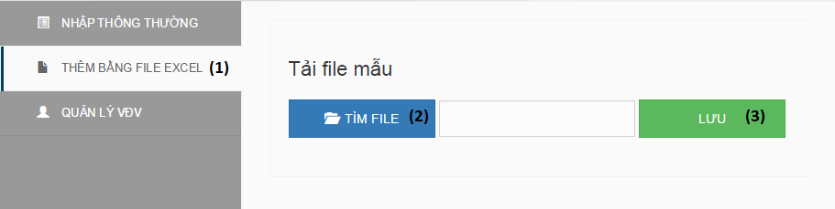

|  |  |
| --- | --- |
| **Step** | **Description** |
| 1 | Click “Thêm bằng file excel” link on Create Athlete page |
| 2 | Click “Tìm file” button |
| 3 | Click “Lưu” button |

#### Schedule

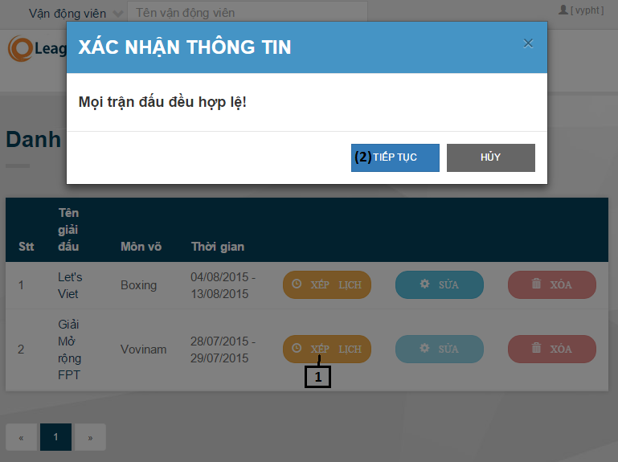

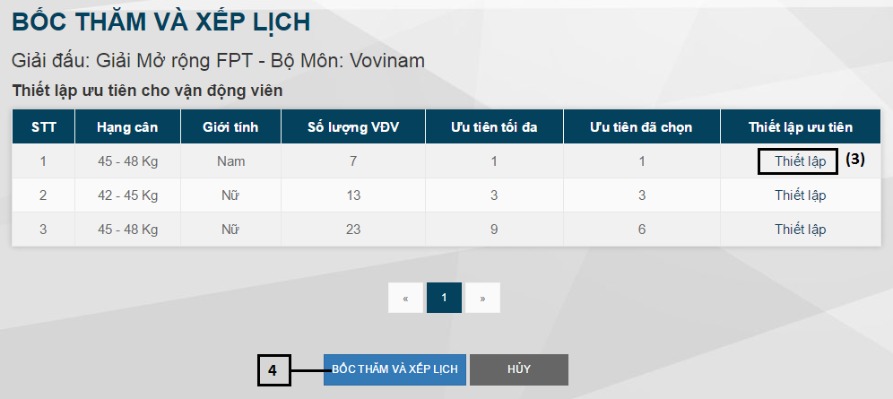

|  |  |
| --- | --- |
| **Step** | **Description** |
| 1 | Click “Xếp lịch” button on DrawNumberAndScheduleLeague page |
| 2 | Click “Tiếp tục” button on message pop-up |
| 3 | Click “Thiết lập” link |
| 4 | Click “Bốc thăm và xếp lịch” button |

#### Set priority

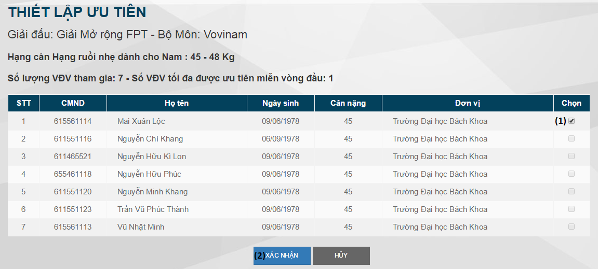

|  |  |
| --- | --- |
| **Step** | **Description** |
| 1 | Select priority Athlete |
| 2 | Click “Xác nhận” button |

#### Update Macth

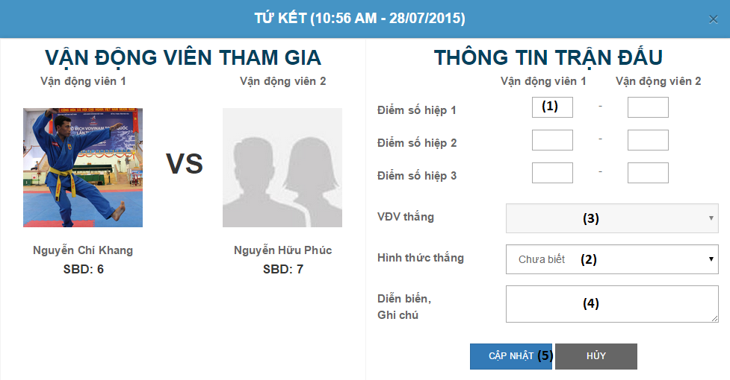

|  |  |
| --- | --- |
| **Step** | **Description** |
| 1 | Input score each set |
| 2 | Select win reason dropdownlist |
| 3 | Select winner |
| 4 | Input note of macth |
| 5 | Click “Cập nhật” button |

# ソフトウェアユーザーズマニュアル

## インストレーションガイド

### サーバ側の環境を設定

#### ハードウェア要件

* **スムーズにウェブサイトを実行するてめには、以下の要件を備えたコンピュータが必要になります:**
* オペレーティングシステム: ウィンドウXPまたはウィンドウのそれ以降のバージョン。
* プロセッサ：１GHｚ以上。
* メモリ：２５６MB以上。
* ハードウェア：1GB以上のハードドライブスペース。
* 画面解像度：１０２４ｘ７６８以上。
* クロム、Firefox、IE。。。どのブラウザも最新のを使用することをお勧めします。

#### ソフトウェア要件

* **以下のソフトウェアがサーバーマシンにインストールする必要があります：**
* Microsoft.Net　frameworkの4.0バージョン以上

（ダウンロードリンク：[*http://www.microsoft.com/en-us/download/details.aspx?id=17718*](http://www.microsoft.com/en-us/download/details.aspx?id=17718)）

* Microsoft SQL Server 2008 R2 Express　以上。

（ダウンロードリンク：[*http://www.microsoft.com/en-us/download/details.aspx?id=22973*](http://www.microsoft.com/en-us/download/details.aspx?id=22973)）

* Internet Information Services (IIS)インストールしてください。

（ここでギルドをインストール：[*http://msdn.microsoft.com/en-us/library/dd578622%28=vs.100%29.aspx*](http://msdn.microsoft.com/en-us/library/dd578622%28=vs.100%29.aspx)）

### サーバ側で展開

#### 展開パッケージの準備

* データベース　ファイル：MATCDB.mdf
* ソースコードファイル：MATC.zip

#### サーバーの構成前に展開

* **データベースの構成：**

<connectionStrings>

<add name="ConnectionString" connectionString="Data Source=.\sql2008;Initial Catalog=MATCDB;Persist Security Info=False;User ID=sa;Password=123456" providerName="System.Data.SqlClient" />

</connectionStrings>

* Catalog: データベース名。
* ID: ユーザ名データベース。
* Password:パスワード。
* **メールサーバーの構成**

<mailSetting>

<smtp deliveryMethod=”Network”>

<network

host=”smtp.gmail.com”  
 userName=”matcserver@gmail.com”

passwork=”123456”  
 enableSsl=”true”/>

</smtp>

</ mailSetting >

* Host:　メールサーバーの smtp
* Username: 　ユーザ名（電子メール）ｓｍｔｐサーバーにログオン
* Password: パスワード

#### サーバ側でWebアプリケーションの展開

* **データベース展開：**
* SQL server 2008 R2にMATCDB.mdfをアタックしてください。
* **ソースコードの展開：**
* オーペンIISマネージャ。
* まだデフォルトのウェブサイトを持ていない場合には：サイトを右にリックする→ウェブサイトを追加する。。。ウェブサイト、ポート、ホスト名を保存するためにサイト名、場所を入力してください。
* 作成したサイトを右にリックして、Deployを選択する→Import application。
* MATC.zip展開パッケージにブラウザしてください。
* すべての選択ルールを確認してください。
* アプリケーションのパスを変更してください。
* データベースへの接続文字列を変更してください。
* 「Next」と「Finish」をリックしてください。

### クライアント側の環境の設定

#### コンピュータのための設定

* クライアントデバイスは、ウェブサイトを起動するには、以下のbブラウザのいずれかを持っている必要があります：
* Mozilla Firefox (ダウンロードリンク： <http://www.mozilla.org>)
* Google Chrome (ダウンロードリンク： <http://www.google.com/Chrome>)
* Microsoft Internet Explorer (ダウンロードリンク： <http://www.windows.microsoft.com/en-us/internet-explorer/downloads/ie>)
* どのブラウザも最新のを使用することをお勧めします。

## ユーザーガイド

### ゲスト

#### 選手検索

写真：Search Athlete

|  |  |
| --- | --- |
| **ステップ** | **説明** |
| 1 | メニューバーにいる「Tìm kiếm」リンクをリックして |
| 2 | 「Vận động viên」ドロップダウンリストを選択して |
| 3 | 「Tên vận động viên」を入力して |
| 4 | 「Năm sinh」、「Giới tính」、「Giải đấu đã tham gia」、「Đơn vị」を選択して |
| 5 | 「Tìm kiếm」ボタンをリックして |

#### 大会検索

写真：Search League

|  |  |
| --- | --- |
| **ステップ** | **説明** |
| 1 | メニューバーにいる「Tìm kiếm」リンクをリックして |
| 2 | 「Giải đấu」ドロップダウンリストを選択して |
| 3 | 「Tên giải đấu」を入力して |
| 4 | 「Khu vực thi đấu」、「Môn võ」、「Thời gian bắt đầu」を選択して |
| 5 | 「Tìm kiếm」ボタンをリックして |

### 従業員

#### ログイン

写真：Login

|  |  |
| --- | --- |
| **ステップ** | **説明** |
| 1 | 口座とパスワードを入力して |
| 2 | 「Đăng nhập」ボタンをリックして |

#### 大会作成

写真：Create League

|  |  |
| --- | --- |
| **ステップ** | **説明** |
| 1 | 大会の基本的な情報を入力して |
| 2 | 「Thêm hạng cân」タブをリックして |
| 3 | 重量部門を選択して |
| 4 | 「Thông tin chi tiết」タブをリックして |
| 5 | 大会の詳細情報を入力して |
| 6 | 「Đơn vị tổ chức」タブをリックして |
| 7 | 創立者の情報を入力して |
| 8 | 「Thêm」ボタンをリックして |

#### 選手追加

写真：Add Athlete

|  |  |
| --- | --- |
| **ステップ** | **説明** |
| 1 | 「Nhập thông thường」リンクをリックして |
| 2 | 選手の情報を入力して |
| 3 | 「Thêm」ボタンをリックして |

#### 単位選択

写真：Choose Unit

|  |  |
| --- | --- |
| **ステップ** | **説明** |
| 1 | 都市を選択して |
| 2 | 区を選択して |
| 3 | 「Chọn」ボタンをリックして |

#### エクセルインポート

写真：Import Excel

|  |  |
| --- | --- |
| **ステップ** | **説明** |
| 1 | 選手追加ページにいる「Thêm bằng file excel」タブをリックして |
| 2 | 「Tìm file」ボタンをリックして |
| 3 | 「Lưu」ボタンをリックして |

#### スケジュール

写真：Schedule

|  |  |
| --- | --- |
| **ステップ** | **説明** |
| 1 | 数抽選と大会スケジュールページにいる「Xếp lịch」ボタンをリックして |
| 2 | メッセージポップアップにいる「Tiếp tục」ボタンをリックして |
| 3 | 「Thiết lập」リンクをリックして |
| 4 | 「Bốc thăm và xếp lịch」ボタンをリックして |

#### 優先順位設定

写真：Set priority

|  |  |
| --- | --- |
| **ステップ** | **説明** |
| 1 | 優先選手を選択して |
| 2 | 「Xác nhận」ボタンをリックして |

#### 試合アップデート

写真：Update Macth

|  |  |
| --- | --- |
| **ステップ** | **説明** |
| 1 | 各セットの点を入力して |
| 2 | 勝利理由を選択して |
| 3 | 勝者を選択して |
| 4 | 注意の試合を入力して |
| 5 | 「Cập nhật」ボタンをリックして |

# Appendix

For rule of conterveiling martial art tournament, such as: weight division, schedule, compete, score…

* <https://sites.google.com/site/xuanld/vo-thuat/luat-va-cham-thi/luat-thi-thau-moi>
* <https://www.facebook.com/vocotruyenthcsdongthanh/posts/443472325779541>
* <https://vi.wikipedia.org/wiki/Quy%E1%BB%81n_Anh#Quy.E1.BB.81n_Anh_chuy.C3.AAn_nghi.E1.BB.87p>
* <http://dh7.tdtt.gov.vn/>